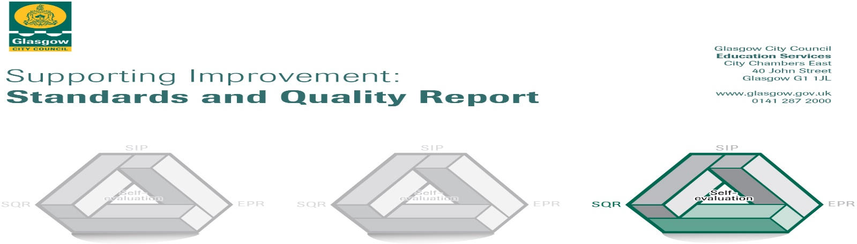

The summary report is provided for parents/carers and partners to outline our achievements this session and our priorities for next session. Throughout this session we have taken forward our priorities as detailed in our school improvement plan. Through our processes of self-evaluation, we have identified how we can improve outcomes for our children and young people.

Our achievements and improvements this year.
We would like to highlight the following improvements/achievements:
The current refurbishment programme will come to an end on returning to school in August. Every part of the school will have been upgraded bringing it into line with every other school building in Glasgow.

Although this work has taken up a considerable amount of staff time, Elmvale continued to focus on Maths & Numeracy as part of our curricular development.

The school progressed using information gathered from last year’s maths assessments. Some of the support for learning workers provided additional support to children who were finding maths & numeracy challenging. All staff and children from P2-7 received support from our Maths Leader of Learning which involved team teaching and focussed support for children in each of these classes for approximately 8 weeks in the academic year. Parents were invited to support meetings assisting them with their understanding of the strategies being used by their children.

There is evidence to show that most of the children took the opportunity to use strategies they had learned to help them solve problems in the MaLT test and in their maths activities in class. More children are now on track to achieve expected levels. This work across the school has resulted in teachers and SFL workers being more confident in number approaches. The SFL workers can demonstrate that the pupils, who are being supported, are making progress. MaLT assessments are demonstrating that children are outperforming the national average.

Nurture is embedded within the school and there are a variety of effective positive behaviour strategies in place. Afternoon sessions provided by the Nurture class (Turus Room) support children needing emotional support from the upper school classes. Peer mediation has now been running for 5 years and this continues to be a well-established part of pupil’s involvement in the running of the school. Restorative approaches are used in managing behaviour The Wednesday lunchtime social group, continues to support children with a variety of social and emotional needs. All of these strategies combined have been very effective and have led to a significant drop in exclusions.

Children have the opportunity to take part in a wide range of school committees, such as Health, Pupil Council, Eco and JRSO. The JRSO group successfully worked with the Council Roads department & the Parent Council on a project to discourage parents from parking on the yellow zig zag lines.

There are many opportunities for the children to participate in Expressive Arts activities. We have a very successful school choir which has established many links within the community. Children have shown great creativity and talent in two very successful school productions, ‘Alice in Wonderland’ and ‘Aladdin Trouble.’

Caledonian University have continued to work closely with classes from Nursery to P7 on various projects which also included visits to the university for staff, children and their parents.

The introduction of the Masterclass which takes place on a Friday afternoon and involves staff working with a class group of children who have selected a skill or theme eg origami/ basketball and then work over a period of six weeks to achieve success in that area. All children have expressed their enjoyment of this event.
Nursery Class
Partnership with parents with the nursery lending library has been a great success with many of the parents responding positively with this initiative. Polish and Manderin speakers took part in Literacy week and read stories to children in these languages.
Fundraising activities continue with the aim of improving the nursery playground environment. The children are being consulted on what they think would make this area better.

Here is what we plan to improve next year.
Consistency of assessment is for learning across the whole school which means that children will be more involved in their own learning and assessment.
Continuing to develop maths & numeracy strategies in every class and this will be carried out by a full time leader of learning.
Literacy – Reading strategies P1-7 Develop a whole school approach to improve attainment in reading and this will be carried out by a full time leader of learning.
Digital Learning – Develop a whole school approach in this area.
Nursery Class
Outdoor Learning
Emotional Literacy
Improving Care Plans

How can you find out more information about our school?
Please contact us directly if you require further information or if you wish to comment on the report.

The contact e-mail address is: Headteacher@elmvale-pri.glasgow.sch.uk

Our telephone number is: 01415585238

Our school address is: 712 Hawthorn Street Springburn Glasgow G22 6ED

Further information is available in: newsletters, the school website, and the school handbook

