Frequently Asked Questions – Starting Elmvale Primary
Blast off to Learning at Elmvale
We have put together a series of questions we think many parents new to our school would like answered.
You can help your child get to know the school by looking at our website/Twitter page and discuss all the photos of the exciting things that Elmvale children take part in.
What are the school times?
Normally, children line up at 9am and the school day ends at 3:00pm. Morning interval is from 10:30-10:45am and lunch is from 12:15-1:00pm. The children have 5 hours teaching each day. Starting the school day on time is really important as often the children go over very important learning first thing in the morning. A handy holiday sheet is provided at the back of this pack for important dates.
On the first day of school, P1s start at 9.15am. P1 finish at 12.15pm for the first week or so. The exact date this changes will be confirmed at the induction day.
What do I do if my child is unable to attend school?
You should contact the pupil absence reporting team on: 0141 287 0039 to report your child absent from school. You can call the line every school day from 8:00am. You should call the absence reporting line on the first day of your child's absence. The pupil absence service is provided by a dedicated team of experienced Education support staff. The information you provide to the team is updated in the school’s system when you call, so the school is immediately aware of all absence information. The pupil absence reporting line has been created to provide an efficient flexible way for parents/carers to report absence. We recognise that in some circumstances, for example, to report or discuss a sensitive issue, you may still require to speak directly with the school. The following guidance should be applied:
Please phone the absence team to report the following absences:
- Sickness absence: if the absence lasts more than one day, parents and carers are required to call on subsequent days to provide an update. A letter should be provided to the school when the child returns from their absence.
- Medical or dental appointments: Parents and carers should call the team to report absences for medical or dental appointments. The school requires a letter or appointment card as evidence of the appointment to ensure permission is given to be absent from class.
Please phone the school directly to report the following absences:
To make sure you receive the right support you require, parents and carers should still contact the school directly on 0141 558 5238 to report absences of a sensitive or personal nature, for example:
- Bereavement
- Serious illness, for example, an absence which is going to last more than one week
- Injury, for example, broken limb
- Contagious diseases or illness
Children should not be kept off unless it is essential. Our Head teacher monitors attendance and we aim to have an average attendance of +95%. If your child has an unexplained absence our school office will text you. That is one of the reasons we need you to ensure your contact numbers are up to date. If the text does not yield a response we will ask our attendance officer to visit. These procedures form part of our Duty of Care responsibilities. We also monitor late comings.
Sometimes parents/carers need to request leave of absence for their child. This should be done by writing to or emailing the Head teacher. If the request is granted a form, obtained from the school office, should be completed. If the absence is scheduled to be over 2 months then we may have to remove the child from the register.
How does the Dinner Hall work?
Children from Primary 1-3 are entitled to a free meal from our Fuel Zone or can bring a packed lunch.
The P1 children always come along to the dinner hall first and a weekly rota operates for the other children.
Cordia are the Council Service responsible for operating the Dinner Hall and the Breakfast Club. Menus, based on a week one and week two structure, are distributed on a regular basis.
The latest lunch menus can always be found on the Cordia website and there is a link on the homepage of our school website.
All food served in the Dinner Hall is compliant with the guidelines from the Scottish Government in their “Hungry for Success” policy. A vegetarian option and a halal menu are always available. Any child with a medical diet can be accommodated.
Parents/carers are asked to ensure that children are not given nuts or nut products for their lunch or snack.
We have a number of staff present in the Dinner Hall and they check that children are eating. If you are concerned that your child is not eating his/her lunch let his/her class teacher know and the Department Head will arrange for the situation to be monitored.
Children with packed lunches
All P1 children eat their packed lunch in the Dinner Hall.
Who teaches my child?
All classes have a designated class teacher. There may on occasion be two teachers when a job share arrangement is in place. In addition to the class teacher at least one and more likely two other teachers will be responsible for some aspects of the curriculum during the week. This is because class teachers have a contractual agreement that means the maximum they can teach in any one week is 22.5 hours.
If there is more than one class in each stage then the teachers may organise the teaching groups across the stage and so your child could have a different teacher, other than his/her class teacher, for maths as an example.
We also have English as an Additional Language Teachers who work throughout the school. On occasion the Department Head will time table herself into a class to support learning. Finally we have infant and upper school assemblies every week. The Principal Teacher, Department Heads, Head Teacher take assemblies.
What are Assemblies and when are they held?
Assemblies take place every Monday with P1-P7 going to the Gym Hall. Each class prepares a presentation on a rotational basis; we sing songs, discuss school rules, celebrate achievements and promote our school ethos and values.
What are SfLWs?
SfLWs stands for Support for Learning Workers. We have a number of SfLWs in our school. These are skilled individuals who work under the direction of the class teacher to support learning in the class. They also supervise the children in the playground, accompany children on trips and help with resources and display work.
What happens in the playground?
We have a number of play spaces. We have a nursery playground, infant playground for P1 - P3 and a middle/senior school playground designated for our P4 – P7 pupils.
The play areas are separated out for safety reasons and to give the children space to play.
Each play area is supervised by a number of Support for Learning Workers, the janitor and, in the case of the infant playground, Buddies. Members of senior management are also out in the playground at both interval and lunchtimes.
Buddies are P7 children who have been trained to play with, support and help our infant children in the playground. They work very well with our younger children and help promote a sense of community. Every P1 child will have a 'big buddy'.
A number of games, activities and stations are provided for the children in both the infant and upper school.
We also have a football area which is situated in the upper school playground.
What is a wet interval?
We aim to ensure that our children can go out to their play areas as much as possible at break times and children should come to school dressed appropriately for the weather. However, if it is very wet or exceptionally cold then we would keep the children in. That is a wet interval. The children will remain in their class and their teachers arrange for them to choose from a range of activities. SfLWs, Buddies and members of the senior leadership team supervise the children.
How do you deal with Medical Issues?
Parents complete a medical consent form when their child is enrolled and the office keeps a note of all of the medical conditions made known to us. Parents/carers of children who require to use an inhaler should ensure that they have a spare one in school. These will normally be labelled and stored in the school medical office available for use by the child as required.
We should be informed of any changes in medical conditions immediately.
Who deals with First Aid?
We have a number of designated First Aider's at Elmvale. They are also responsible for the storage and management of medicines, the assessment of a child’s injury or condition and the administration associated with First Aid.
If a child sustains a minor injury in school then it will be treated by our First Aider. If a child has a head bump, even if it is minor, then the parent will be informed either by a phone call or a note. If a child has a serious injury or is unwell then the parent will be contacted and the situation discussed. If it is a very serious injury the school office would contact the parent. If we were unable to make contact with a parent or if the child needed immediate medical care we would arrange for the child to be taken to Yorkhill Hospital. It is absolutely vital that we have accurate emergency contact details for all of our parents.
We have clear procedures if a child soils himself/herself at school. This involves contacting and informing the parent that the child has had an accident and needs to be changed. The school would not change a child (unless in exceptional circumstances) for reasons of cross contamination, personal dignity of the child and possible child protection considerations. We would move the child to a toilet and provide wipes and a change of clothing. Again this highlights the need for up to date emergency contact details.
What is the policy on Home Learning?
Home Learning provides an important link between the school and the home. We acknowledge that parents and children lead busy lives and we try, for our older pupils in particular, to hand out home learning at the beginning of the week and collect it back in at the end of the week. This enables families to plan when home learning can be done so that it does not interfere with other arrangements.
Home learning consists of reading practice, spelling/phonics practice, maths, topic work and individual projects. The length of time to complete tasks varies but as a general rule infant homework takes about 10 minutes per session and older children would expect to spend 20-30 minutes on their home learning.
How do I know how my child is doing?
We hold two parents’ evenings per session (usually October and March) and produce an annual report (send out at the beginning of June). For many parents that, plus the information gained from working with their child on home learning, provides sufficient information and reassurance on their child’s progress.
However if you have any concerns or require any further information you can either request a meeting with your child’s class teacher or you can contact the Department Head and arrange a meeting.
The Department Heads Are:
Nursery, P1E, P1H, P2/1, P2H, P3K, P3W and Nurture Ms Vicky Kytzia (Acting)
P4M, P5/4, P5C, P6S, P7/6 and P7F Mrs Mairi Baker
They are happy to meet with you at any time.
Who do I complain to?
If you wish to make a complaint, please contact the Department Head through the school office on 0141 558 5238. We will try and resolve any complaint fairly and effectively. If you remain dissatisfied you can complain directly to Glasgow City Council, Education Services who have a Customer Liaison Unit.
We would hope that all issues can be resolved at a local level and work hard to ensure this is the case.

Do Pupils have a Voice?
Yes they do! We actively encourage pupil participation in our school. We have a Pupil Council, Website Committee, Eco Committee, Outdoor Learning Committee, Social Enterprise Committee, Health and Wellbeing Committee and Brilliant Book Club. Children are elected to these committees. We also have our Junior Road Safety Officers and a Peer Mediators Group for all of our infant school stages.
In addition we have an open mike session at every school Assembly where pupils can raise issues or make suggestions.
Do Parents have a Voice?
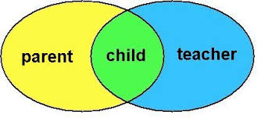
We are very fortunate to have an active and supportive Parent Council in our school. Everyone is welcome to get involved.
Is there After Care / Out of School Provision?
Elmvale is fortunate in having after school care facilities in the school building. This is provided by a company separate from the school. They are open from 3-6pm daily. They are also open during the school holidays. This provides much needed support for our working parents. Please contact Linda McLaren (team leader) on 07740116242 or our aftercare head office on07940973396 for information.
Breakfast Club
We offer breakfast club in our dining room. It is open from 8:05 – 8:40am and offers a healthy breakfast to all. Price is currently £2.00 per pupil. If you have more than one child, the eldest pays £2 and siblings pay £1.00 only.
Lost Property
We store lost property in the janitors office at the front of the school. We would ask all parents to help reduce the amount of lost property by ensuring that their child’s clothing and property has his/ her name on it. Children should not bring valuable items to school.
When is PE?
Each class has two hours of Physical Education every week. There is a time table drawn up to accommodate all classes. Our policy is that children should bring their PE Kit in on a Monday and take it home for washing on a Friday. That way they will always have their PE kit. The PE kit is a T shirt or long sleeved top, shorts or joggy bottoms and sand shoes or trainers. There are changing rooms near the gym and each child has a coat hook and shoe box outside their class from where their PE kit can be stored. For Health and Safety reasons all jewellery must be removed. If you are going to let your child have his/her ears pierced please arrange to do this at the start of the summer holidays as they have to be kept in for six weeks. Swimming lessons are provided for our P7 children.
When appropriate PE will be taken outdoors.

Working in Partnership

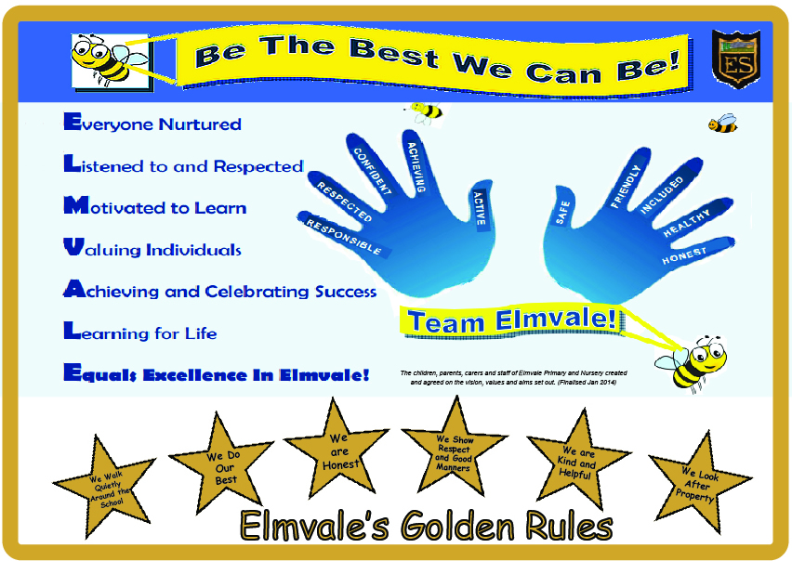

Handy Holiday Sheet 2017-2018
Proposed School Holidays 2017/18
Return date for teachers Friday 11 August 2017
Return date for pupils Tuesday 15 August 2017
September weekend Friday 22 and Monday 25 September 2017
First mid-term Monday 16 to Friday 20 October 2017 (inclusive)
Christmas/New Year Thursday 21 December 2017 to Wednesday 3 January 2018 (inclusive) * Please note that schools will close at 2.30pm on the last school day before the holiday
Return to school Thursday 4 January 2018
Second mid-term Monday 12 and Tuesday 13 February 2018
Spring Holiday (Easter)
- Good Friday 30 March 2018
- Easter Monday 2 to Friday 13 April 2018 (inclusive)
* Please note that schools will close at 2.30pm on the last school day before the holiday
May Day Monday 7 May 2018
May Weekend Friday 25 and Monday 28 May 2018
School close Tuesday 26 June 201
In-Service Days
- Wednesday 15 February 2017
- Thursday 4 May 2017 (To coincide with Election)
- Friday 11 August 2017
- Monday 14 August 2017
- Friday 13 October 2017
- Wednesday 14 February 2018
- Tuesday 8 May 2018

