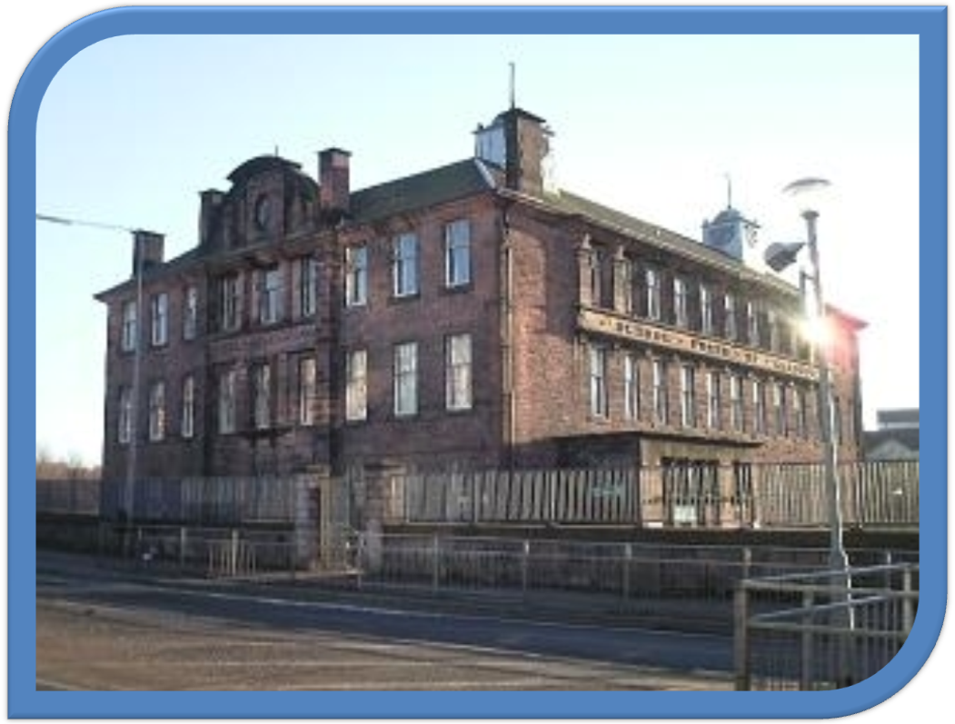
Handbook
2017-2018
Elmvale Primary School
712 Hawthorn Street
Springburn
Glasgow G22 6ED
Telephone 0141-558-5238
Fax 0141-557-5511
E-mail headteacher@elmvale-pri.glasgow.sch.uk
Website www.elmvale-pri.glasgow.sch.uk



Introduction by the Head Teacher

Dear Parents/ Carers and Friends

Welcome to Elmvale Primary School. Elmvale has been serving the community of Springburn for over 100 years. It prides itself on being a safe, welcoming and friendly learning environment where staff, children and parents work together for the benefit of all. High standards of behaviour, manners and punctuality are expected and high levels of attendance are actively encouraged to ensure every child maximises their potential at Elmvale.

We work hard to make sure your child receives the very best education by providing learning experiences which are targeted at an appropriate level, fully involve your child and are as enjoyable as possible. We also strongly believe in providing a wide range of experiences such as educational visits, outdoor education residential visits and involvement in a variety of sporting activities and competitions as well as fundraising for the school, charities and local community. We believe in supporting children to learn outside and benefit physically, socially, mentally and emotionally from regular access to the outdoors.

We pride ourselves in our positive links with the local community. Brian Casey from Springburn Parish Church speaks at our termly celebrations. The community police visit us regularly and often attend our end of term celebrations. Local businesses support us through their generous donations for our fundraising activities. North Glasgow College students assist us on developing various projects. We work closely in partnership with Caledonian University.

We are fortunate in our central location being close to Springburn Academy, Springburn Park, The Leisure Centre, Springburn Shopping Centre and Library. We are also able to make use of Springburn Academy’s mini bus, the local buses and trains in order to transport children to various events and sights in the city centre.

Elmvale primary has a large library; huge playground with permanently fixed activities, dinner hall and gym hall. The school shares the playground area with its nursery class, The nursery class aims to provide the best start for many of our children: A separate handbook is available on the website and on request. We also have a Breakfast and After School Club on our premises.

We work hard to develop and maintain strong links with parents and carers who organise various social events for both parents and children during the evenings throughout the year. Elmvale has a valued parent council.

Our roll includes children from out-with our area – everybody is welcome in Elmvale!

We are looking forward to welcoming you and your child and we know that they will have many happy and enjoyable years with us. Please don’t hesitate to contact us at any time on any matter. We are here to help and take pleasure in doing so.

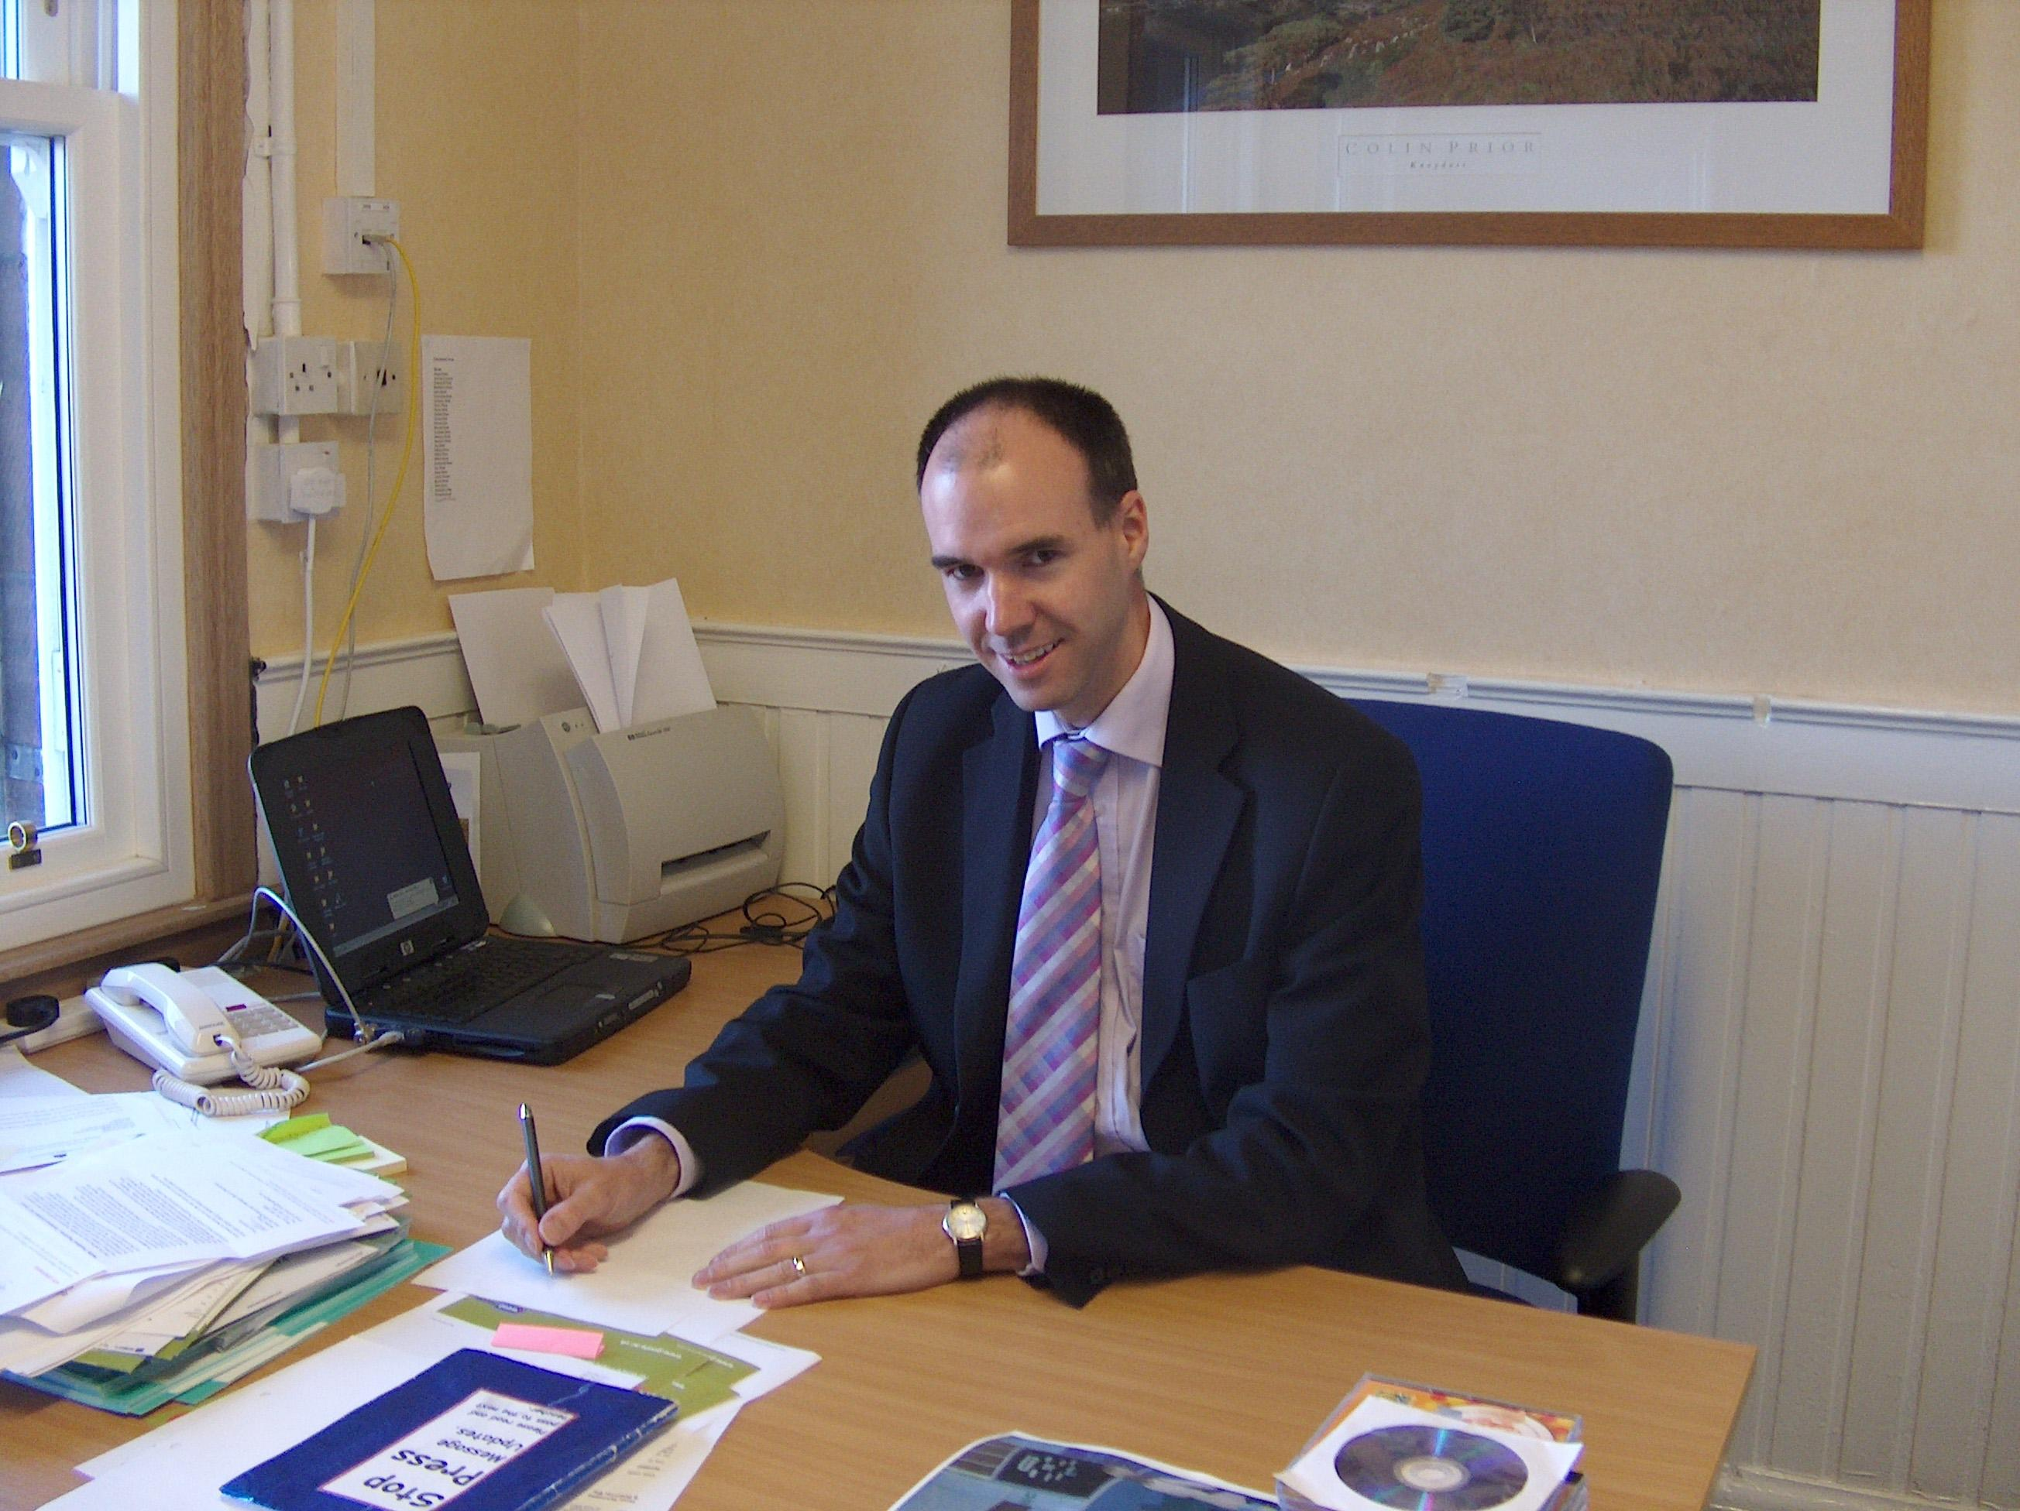
Yours sincerely
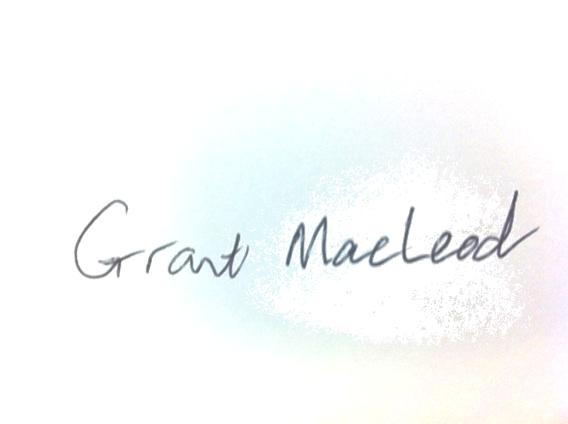

Grant MacLeod Head Teacher

ELMVALE PRIMARY & NURSERY CLASS School Vision & Values

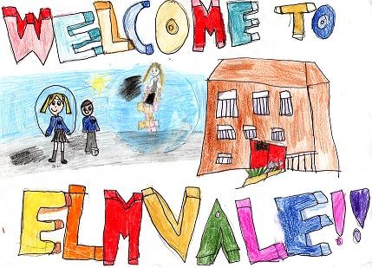

SCHOOL INFORMATION
Elmvale is a non-denominational school for girls and boys and is part of the Springburn Learning Community. It can accommodate 512 children, including our nursery children, which caters for 40 children in the morning and 40 in the afternoon. Elmvale Primary was opened in 1901 and is now a listed building of architectural interest. Children spend 7 years at Elmvale from Primary 1 to Primary 7 before transferring to Secondary.

You can cut out the following information and have it on your fridge, purse or work desk etc. for ease of finding the numbers required.

Contact Details:

712 Hawthorn Street
Springburn
Glasgow
G22 6ED
Phone: 0141 558 5238
Email: headteacher@glasgow-pri.glasgow.sch.uk
www.elmvale-pri.glasgow.sch.uk

Layout of School
Basement The Dining Hall, Nursery Play Room

Ground Floor The Nursery Class, P.E. hall, General Purpose Classroom and Administration areas

First Floor Primaries 1-4, Turus Room

Top Floor P5-7, Library and ICT Suite

The school is surrounded by a large playground, half of which is for the sole use of our P1-3 children and P4-7 play in the other half. Both playgrounds have been significantly upgraded in recent years and now have adventure play equipment, climbing walls, places for playing football and basketball and opportunities to explore nature in our mini orchard and garden area. The Head Teacher, Depute Head Teachers, Pupil Support Assistants and the Janitor patrol the playground in the morning and at lunchtime. Children have easy access to a member of staff if they feel unwell or hurt.

Members of Staff
We are very fortunate in Elmvale to have an excellent team of staff who are all extremely hard working, nurturing, dedicated and always strive to make our vision, values and aims a reality!

(Accurate in 2016)
Head Teacher Mr Grant MacLeod

Depute Head Teacher P4-7 Mrs Mairi Baker
Acting Depute Head Teacher Nursery-P3 Ms Vicky Kytzia

Acting Principal Teacher Mrs Claire Rowan

Teaching Staff Miss Gillian Hopkins
Miss Sharon Hoy
Mrs Jennifer Lang
Miss Theanie Thomas
Miss Melissa Kelly
Miss Emily Walmsley
Mr Daniel McDade
Miss Shannon Holmes
Miss Janine Caulfield
Mr Donald Feist
Ms Pauline McMullan
Ms Angelina Lamberton
Ms Joan McCallum
Mrs Claire Rowan
Mrs Zoe Higgins
Miss Stefanie Szula
Ms Fiona Blevins
Miss Catriona Fenton

Nurture Teacher Mrs Alyson Renwick
Nurture Assistant Mrs Caroline McClune

Pupil Support Assistants
Mrs Angela Donohue
Mrs Elsie Kemp
Mrs Lori O’Dell
Ms Gwen Hocknull
Mrs Janis Paterson
Mrs Janice Thomson

Clerical Assistants

Mrs Elizabeth Miller
Mr Sean Hanlon
Mrs Sarah Harris

Dining Staff
Ms. Avril Black, Ms. Elaine Ross, Ms. Michelle Gallacher,
Ms. Julie Devlin and Ms. Elsie Reid are our catering assistants. These ladies serve the school meals and provide a very friendly service to the children. They encourage the children to eat well and sensibly.

Cleaning Staff
Elmvale Primary and Nursery has a team of very efficient cleaners led by Mrs Moira Murray. Her team members are, Ms. Yolanda Currie, Sandra and Ms. Isabel Turner

Janitor
Our whole establishment is kept in superb order by our Janitor, Mr Stevie Ronaldson.

Elmvale Nursery Class
Elmvale Nursery Class provides education and care for children from their 3rd birthday to school age. Application forms are available at the School Office and at the Nursery Class. Elmvale Nursery Class is situated just off the main Hall. It has a separate entrance to the rear of the school. A separate handbook is available from the nursery.

Staff in the Nursery are as follows:

Head Teacher Grant MacLeod
Acting Depute Head Teacher Vicky Kytzia
Team Leader Maura MacArthur
Child Development Officers Lesley Gibson
Norma More
Elaine Clark
Margaret Brown

Enrolment
Registration of Primary 1 children takes place in November and is advertised widely in local press etc. Prospective parents are welcome to visit the school and should contact the school office.

Families living outwith the catchment area are welcome to make a placing request to attend Glasgow Primary School but must enrol their child at their local school as a first step. Further information is available using the following
https://www.glasgow.gov.uk/index.aspx?articleid=18426

Organisation of Classes

The following guidelines set by Scottish Government apply.
P1 maximum 25
P2&3 maximum 30
P4-7 maximum 33
Composite classes maximum 25

Composite classes have pupils from more than one stage.

School Hours
The School Day

Morning 09.00 -10.30
Interval 10.30 - 10.45
10.45 - 12.15
Lunch 12.15 - 13.00
Afternoon 13.00 - 15.00

P1 children are dismissed at lunchtime until the first Monday in September after which they will remain in school until 15.00.

School Holidays
School Holidays 2016-2017

Details of holiday dates are available on the Glasgow City Council website: https://www.glasgow.gov.uk/index.aspx?articleid=17024

Pupil Absence

Within Glasgow Primary School good attendance is encouraged at all times and children rewarded accordingly. Parents are asked to advise if their son or daughter is going to be absent. This should be done as early as possible on the first day of absence. If the young person is going to be absent for some time, it would be helpful to know at the earliest opportunity. The school uses daily text messaging to inform parents and carers of absence if no contact is made. All unexplained absence is investigated by the school and appropriate action taken. All calls must be made to the Pupil Absence Reporting Line on 0141 287 0039. The line is open between 08.00-15.30 Monday to Friday.

Medical & Healthcare

The school nurse visits at various times during the year for routine health checks, vaccinations and medical examinations. Parents are kept informed by letter.

If a child becomes ill during the course of the school day, he/she may require to be sent home. Please ensure that you keep the school informed of all contact details.

Parents should inform the school of any medical requirements relating to their child. If a child requires medication during the school day, parents must complete the appropriate medical form. This is available on request from the school office.

Information in Emergencies
We make every effort to maintain a full educational service, but on some occasions circumstances arise which lead to disruption. Schools may be affected by, for example, severe weather, temporary interruption of transport, power failures or difficulties of fuel supply. In such cases we shall do all we can to let you know about the details of closure or re-opening. We shall keep you informed by texting, using letters, notices in local shops and community centres, announcements in local places of worship and announcements in the press and on local radio.

It is crucial that emergency contact details are kept up to date in school records at all times. Parents and carers should inform the school of any changes immediately by contacting the office.

Clothing and Uniform
The school uniform is:
- Yellow polo shirt
- Navy blue school sweatshirt
- Navy blue/black trousers
- Navy blue/black skirt
- Or Elmvale Primary School tie with white/blue shirt, v-necked navy blue jumper
- Spare Indoor shoes

Sweatshirts. jumpers and polo shirts with the school logo are available for purchase at the school office. We also supply fleeces, blazers and waterproof jackets. Our uniform was agreed in consultation with pupils and parents. It is expected that all children attending Elmvale Primary School will adhere to this dress code.

Clothing for P.E. and Swimming
It is important that pupils come prepared to learn and for PE this requires appropriate clothing. All jewellery should be removed. Pupils who are not participating in PE must have a note or a medical certificate. Pupils who are unable to participate in practical PE should still bring their kit to allow them to assist in the lesson by refereeing, keeping scores or assisting with the distribution of equipment. This ensures that they are still able to take part in some way in the work of the class and do not miss out on the knowledge and understanding of the course.

There are forms of dress that are unacceptable in school, such as items of clothing which:

- Potentially encourage factions (such as football colours)
- Could cause offence (such as anti-religious symbolism or political slogans)
- Could cause health and safety difficulties (such as loose fitting clothing, jewellery)
- Could cause damage to flooring
- Carry advertising particularly for alcohol or tobacco
- Could be used to inflict damage on other pupils

Clothing & Footwear Grants

Parents/Carers receiving Income Support, Job Seekers Allowance (Income Based), Working Tax Credit (with a total annual income of less than £15,050*), Housing Benefit, or Council Tax Benefit will normally be entitled to monetary grants for footwear and clothing for their children. Information and application forms may be obtained from schools and at
- https://www.glasgow.gov.uk/index.aspx?articleid=17885

Meals
Our school provides a lunch service which offers a variety of meals and snacks. Special diets for children with medical requirements can be provided. Please inform the Headteacher.

Children who prefer to bring packed lunches are accommodated in the dining hall.

All children in P1-3 are entitled to a free school meal.

Children and young people of parents/carers receiving Income Support, income-based Job Seekers Allowance, Working Tax Credit (where income is less than £6,420), Child Tax Credit only (where income is less than £16,105*) and income-related Employment and Support Allowance are entitled to a free midday meal. Information and application forms for free school meals may be obtained from schools and at
https://www.glasgow.gov.uk/index.aspx?articleid=17885

Transport

The education authority has a policy of providing free transport to all pupils who live outwith a certain radius from their local school by the recognised shortest walking route. This means that the provision of transport could be reviewed at any time. Parents/Carers who consider they are eligible should obtain an application form from the school or at
https://www.glasgow.gov.uk/index.aspx?articleid=17882

Transfer from Primary School to Secondary School
Children and young people normally transfer between the ages of 11 ½ and 12 ½, so that they will have the opportunity to complete at least 4 years of secondary education. Parents and carers will be informed of the school arrangements no later than December of P7.
Children from our school normally transfer to:

Springburn Academy
151 Edgefauld Rd
Glasgow
G21 4JL
Phone 0141 582 0230
Email: Headteacher@springburn-academy.sch.uk

Springburn Academy staff work with our pupils from Primary 6 onward to prepare them for the transfer to secondary school.

Communication with Parents

At Elmvale Primary School we use a variety of ways to keep in touch.

Open Door Policy – the senior leadership team are available for all parents and carers at any time providing they are not teaching or in another meeting. Please either pop in to the school office or phone for an appointment.

Newsletters – will be sent out on a regular basis to keep parents informed about the work of the school.

Letters – further information which requires a response may be sent out in letter form.

School website & Twitter – will contain a great deal of information about the school. It is a good idea to check this regularly.

Text messaging – You may also receive text reminders about events/school closures etc.

Meetings - Parents and carers are welcome in the school to discuss any aspect of their child’s development and progress. To avoid disappointment, it is advisable to make an appointment. There are various opportunities throughout the year when parents can discuss their child’s progress with the class teacher and view the child’s work.
Parents and carers are welcome at other events throughout the school year e.g. workshops, information evenings, class performances, religious and other assemblies. The school newsletter and website will keep you informed.

Emergency Contact Information

At the start of each school session, parents will be issued with the annual data check form. Please ensure that this is completed and returned to the school. It is also important that you let us know if there are changes to your telephone number(s) or to those of your emergency contacts throughout the year.

Data Protection – use of information about children and parents/carers

We collect information about children attending school (and also about parents/carers, emergency contacts etc. provided in the annual data check) to allow us to carry out the Council’s functions as the education authority for the City of Glasgow. This may sometimes involve releasing personal information to other agencies and other parts of the Council, particularly in relation to child protection issues or criminal investigations, and it may also be used for research purposes (see the link below for more details regarding this).

Information held by the school is, in legal terms, processed by Glasgow City Council. The Council is registered as a data controller under the Data Protection Act 1998 (number Z4871657) and all personal data is treated as confidential and used only in accordance with the Data Protection Act and the Information Use and Privacy Policy approved by the City Council. For more information on how we use personal information, or to see a copy of the Information Use and Privacy Policy, see www.glasgow.gov.uk/privacy

Appointments during school hours

If your child has an unavoidable appointment, please give them a letter for their class teacher and then collect them from the school office at the specified time.

Comments & Complaints

In Glasgow Primary School we aim to have positive relationships across our school community. However, if you have a comment or complaint about any aspect of school life, please contact the Headteacher in the first instance.

Glasgow City Council complaints procedures are available : https://www.glasgow.gov.uk/index.aspx?articleid=16133

Customer Care Team
Customer & Business Services
Glasgow City Council
City Chambers
Glasgow G2 1DU

Tel: 0141 287 0900
e-mail: customercare@glasgow.gov.uk

The above website also includes information on data protection and freedom of information.

Curriculum
Curriculum for Excellence 3-18

Curriculum for Excellence has been introduced to raise standards of learning and teaching for all 3 to 18 year olds. It aims to help prepare children and young people with the knowledge and skills they need in a fast changing world. As part of Curriculum for Excellence all children from pre-school to the end of S3 will receive a rounded education known as a Broad General Education(BGE). Curriculum for Excellence is all about bringing real life into the classroom and taking lessons beyond it. Through the experiences we provide at Glasgow Primary School we want our children to become Successful Learners, Confident Individuals, Responsible Citizens and Effective Contributors. We are committed to providing children with a broad general education and focus on eight curriculum areas.

Expressive Arts | Health & Wellbeing | Languages | Mathematics
Religious & Moral | Sciences | Social Studies | Technologies

Progress in learning is indicated through curriculum levels as detailed below.

Level | Stage
Early | The pre-school years and P1 or later
First | To the end of P4, but earlier or later for some
Second | To the end of P7, but earlier or later for some
Third & Fourth | S1-S3, but earlier for some

Expressive arts: The inspiration and power of the arts play a vital role in enabling our children and young people to enhance their creative talent and develop their artistic skills.

Health and wellbeing: Learning in health and wellbeing ensures that children and young people develop the knowledge, understanding and skills which they need now and in the future to help them with their physical, emotional and social wellbeing.

Science: Science and its practical application in healthcare and industry is central to our economic future, for our health and wellbeing as individuals and as a society.

Social Studies: Through social studies, children and young people develop their understanding of the world by learning about other people and places both past and present, societies, their beliefs and values.

Religious and moral education: Religious and moral education includes learning about Christianity, Islam and other world religions, and supports the development of beliefs and values.

Languages: Knowing other languages and understanding other cultures is a 21st century skill set for students as they prepare to live and work in a global society.

Mathematics: Mathematics equips us with the skills we need to interpret and analyse information, simplify and solve problems, assess risk and make informed decisions.

Technologies: The range of subjects in technical education has changed significantly over the last two decades and now includes craft, design, engineering and graphics.

There will be opportunities throughout the year for parents and carers to learn more about aspects of the curriculum and to be consulted about significant changes if appropriate.

Useful websites

www.curriculumforexcellencescotland.gov.uk
www.educationscotland.gov.uk/parentzone/index.asp

Religious and Moral Education
Religious Observance

Our school is fortunate to have a close link with the local church. The minister (Mr Casey) assists with the Christianity element of Religious and Moral Education and provides opportunities for religious observance. Parents have the right to withdraw their child from religious observance and should inform the school in writing.

Assessment and Arrangements for Reporting to Parents and Carers
All children are assessed both formally and informally throughout the year. This allows children and their teachers to identify their strengths and areas for improvement. A variety of assessment methods are used to enable staff to pass on information to parents about the progress of their child. Assessment records are kept by the class teacher and form the basis of discussion at Parents’ Evenings in November and March. An annual report is sent to parents towards the end of each school year.

If you have any concerns about your child’s progress do not hesitate to contact the school.

Pupil Profiles
Every child leaving primary school in Scotland has their key achievements in school, at home and in the community documented within a P7 profile. The content of the profile is decided by the young person. The profile is a positive record of their achievements and emphasis their strengths. The profile provides a valuable way for learners to share valuable information about their achievements with their parents and teachers in secondary school.

Support for Pupils
The school has a duty to ensure that all pupils have equal access to the curriculum, with appropriate support for their needs if required. This applies to the content of lessons, teaching strategies and minor adaptations to the school environment. There are a wide range of factors which may act as a barrier to learning. We are committed to working closely with parents and carers to ensure that they are fully involved in any decisions about support for their children’s needs.

Any parent or carer seeking further advice regarding this policy should contact the Headteacher in the first instance.

Further information relating to additional support needs is available on the Glasgow City Council website –
https://www.glasgow.gov.uk/index.aspx?articleid=18941

Information on the Glasgow City Councils’ Parental Involvement Strategy can also be found at https://www.glasgow.gov.uk/index.aspx?articleid=17870

The Named Person

GIRFEC stands for ‘Getting It Right For Every Child’. This is the Scottish Government-led approach to making sure that all our children and young people – and their parents or carers – can get help and support when needed from birth through to age 18 (or beyond if still in school).

The vast majority of Scotland’s children and young people get the love and support they need from within their families and their wider, local communities. But even the most loving and caring families can sometimes need extra support. The GIRFEC approach aims to make it as easy as possible for any child or young person (and their parents) to get that help or support when they need it.

To access support when needed, part 4 of the Children and Young People Act (Scotland) 2014, states that every child in Scotland has a Named Person, as a single point of contact. This Named Person has a responsibility to provide help and support when asked and can draw together other services if needed, co-ordinating help for the child or parents.

The Named Person will be a promoted teacher within the school your child attends. The name of the individual Named Person for your child(ren) will be provided.

Please do not hesitate to contact the school if you want to speak with your child’s Named Perso

School Improvement

On an annual basis, you will receive a copy of our Standards and Quality report. Copies from previous years are available on the school website. The Standards and Quality report highlights progress in key curricular areas such as literacy, numeracy and health & wellbeing. Our priorities for improvement are detailed in our School Improvement Plan which is discussed with our Parent Council. Any parent or carer seeking a copy of the plan can contact the school office or check out our website.

Promoting Positive Behaviour

Children’s Rights as outlined in the UNCRC (United Nations Convention on the Rights of the Child) are fundamental to a good school ethos. Adults in our school will work with children to ensure they are aware of their rights and fully respect the rights of others. Therefore, the approach within Elmvale Primary School is to build a positive ethos that demonstrates care and respect for all. Positive behaviour is recognised and celebrated. Our school operates a system of Golden Rules to set out expected behaviour. This is celebrated through Masterclass Experiences, awards at assemblies and certificates sent home to parents etc.

The highest standards of behaviour are expected of pupils at all times. Where this is not the case, a variety of sanctions are used. Parents are asked to co-operate with the school in encouraging a sense of responsibility and good behaviour in their children.

Home learning
Continuing to learn at home helps children to achieve more and is a vital part of our partnership with parents. Please check your child’s schoolbag for communication about home learning and specific tasks. A copy of our home learning policy is available on the website and on request from the school office.

Parent Council

We have a very active Parent Council that represents the views of all parents. All parents are welcome to attend Parent Council meetings and can become members at the AGM. Parent Council minutes are available on the Parent Council noticeboard on Hawthorn Street and on request from the school office. A list of current members is also available on the website.

The Elmvale Parent Council can be contacted on

elmvaleparentcouncil@gmail.com

Pupil Council and Eco Committee

Our Pupil Council is actively involved in making changes for the better in Elmvale. The council consists of two children from across the school. They meet with Ms Blevins regularly and give updates to the rest of the children at our weekly assemblies. The eco committee was formed in hard to ensure Elmvale is as eco friendly as possible. We will soon be establishing a health committee to take forward issues relating to this important area.

Extra-Curricular Activities
We regularly have afterschool clubs. These clubs change and reflect our children’s interests. Some examples include:
- Football
- Netball
- Drama
- Home learning
- ICT

Useful addresses:

Education Services
City Chambers East
40 John Street
Glasgow G1 1JL
Tel: 0141 287 2000
www.glasgow.gov.uk

School Lets
Any enquiries about lets of school premises should be made to:-
Glasgow Life
20 Trongate
Glasgow G1 5ES.
Tel 0141 302 2814/2815

Local City Councillor
The names of the local City Councillors are Mr Allan Stewart and Mr James Todd.

After School Care
Elmvale hosts an after school group, staffed and organised by Milton Out of School Care. This group provides care for children from 3.00 pm to approx 6.00 pm. and also opens during school holidays. Children from P1-P7 can attend by arrangement.
For further details and enquiries please contact:
Linda 07740116242
Head Office 07940973396

