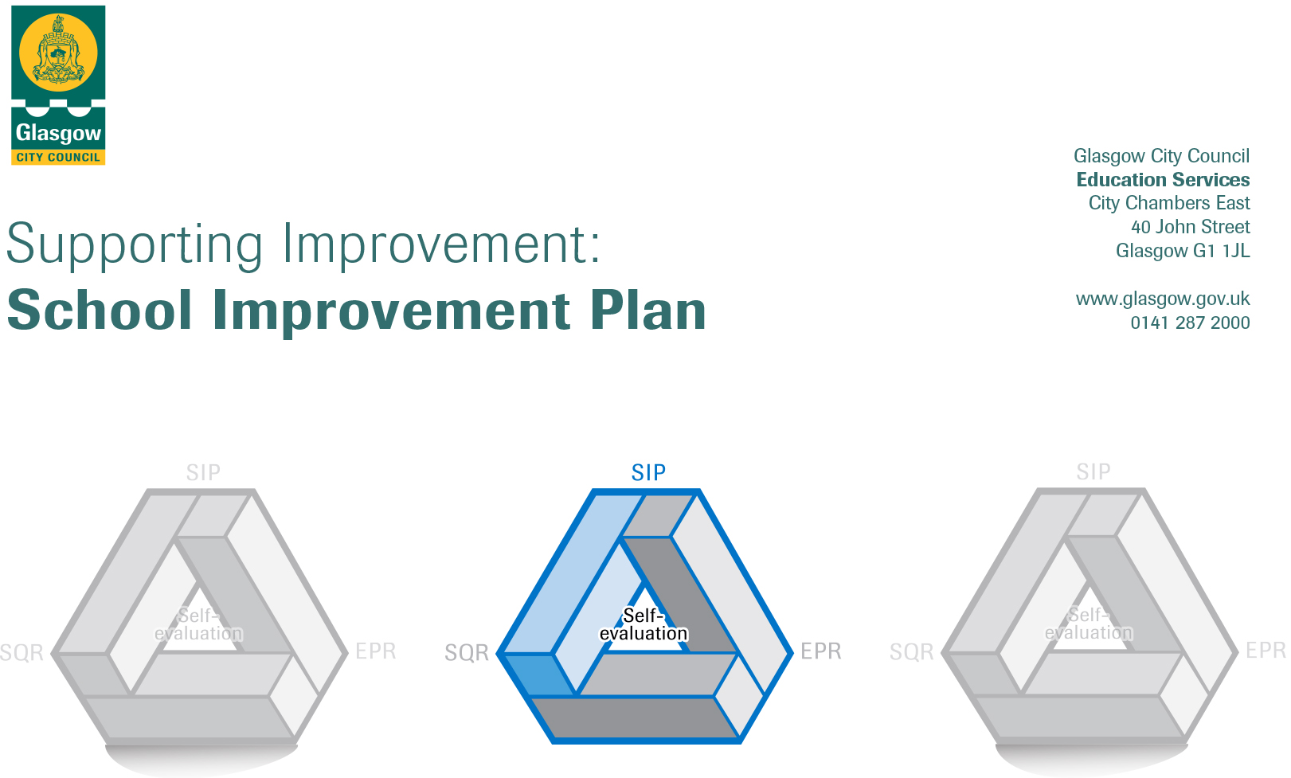

Session: 2018-19

Establishment |  | Elmvale Primary School
Head of Establishment |  | Grant MacLeod
Area/Local Improvement Group |  | NE Lig1
Head of Service |  | Colin Crawford
Area Education Officer/  Quality Improvement Officer |  | Andrea Reid / Stephen Watters

CONTENTS
1. Vision, Values and Aims
2. Summary of Self-Evaluation Process / Priorities for Improvement in the current session
3. Action Planning

Action Plan Summary for Stakeholders

1. Our Vision, Values and Aims
This will change as a result of consultation with parents, children, staff and partners and will be in place by the end of term 1, 2018-19

2. Summary of our self-evaluation process.
HMIe report March 2015
Consultation with parents, staff, children and partners re reviewing vision, values & aims
Strengths identified:
Almost all children targeted by PEF funded interventions (excluding PEF teacher) have made progress from prior levels of attainment/social & emotional behaviour
Increasing use, recording and analysis of data is helping to target interventions to close the attainment gap.
Increasing quantities of evidence are available to show impact of interventions
Many opportunities have been provided for staff to work closely together and this has led to greater consistency across the school
All P1 staff are providing learning experiences through play and all staff are using aifl strategies to involve children more often in their learning. Both approaches are having a positive impact on children’s attainment.
Most children have improved their social and emotional behaviour and most parents have engaged well with the supports.
Most staff have a greater understanding of children and use this understanding well to implement alternative interventions.

Priorities for development:
1: Health & Well Being

2: Literacy, Aifl & Digital Learning

3: Numeracy, Maths, Aifl & Digital Learning

3. Action Planning

No. | Quality Indicator | Priority
1 | 2.3 | To improve how we support and meet the health and wellbeing needs of all of our children.

Tasks to achieve priority | Timescale  and checkpoints | Evidence of Impact > (data, observation, views)
To implement and review the PATHS programme from Nursery to P7 in order to improve our children’s development of self-control, emotional awareness and interpersonal problem-solving skills. | Inset 1 5hrs | Inservice Evaluation  Barnardos data  Observation
All staff to complete Glasgow City Council training All Behaviour is Communication: Nurturing Approaches; Risk Assessment; and Restorative Approaches. | Inset 2 1 1/2 | Evaluation  Views
Continue to review the social and emotional needs of all our children and families in partnership with The Spark children’s counselling service (play therapy) and our Barnardos Family Support Worker. Promote these initiatives with parents to extend opportunities for more families to become involved. | Spark 2 days per week  Barnardos – Full time  Aug 18- March19 | Spark data  Barnardos data/report  Views of parents & children
Agree Health and Wellbeing practice from Nursery to Primary 7 to have regular dialogue with pupils around their emotions and mental health e.g. a daily emotions check-in, greeting every pupil before entering the classroom, whole-school assemblies explicitly teaching SHANARRI indicators. | Daily Aug18- Jun19 | Views of children, staff
Embed restorative approaches to managing conflict e.g. Peer Mediators and all staff using restorative dialogue script. | Termly  Inset 3 ½ catch up | Views of children, SFLWs, staff
Extend work started in 2017/2018 to revisit and promote our school values e.g. new House System underpinned by five School Values, extended leadership opportunities for pupils such as House Captains and Vice Captains, approaches to promote our values across the school community – Value Hunters at assembly, Values display in every classroom. | Weekly assemblies | Views of children & staff, observations
Review and agree practice in Promoting Positive Behaviour Policy – Masterclasses, consistency of loss of Golden Time etc. | Inset 2 1 1/2 | Evaluation/ observation
Extend opportunities for class leadership and enterprise to provide contextualised and relevant experiences for our children to work together, problem solve and use interpersonal skills. | Aug 18-Jun19 | Evaluation

Staff leading on this priority – including partners | Resources and staff development
Denise McGroarty (PT), Barnardos, The Spark | Brian Donnelly, DHT & Mindfulness training

No. | Quality Indicator | Priority
2 | 2.2, 3.2 | To raise attainment in Literacy and English through embedded high quality learning and teaching approaches with appropriate pace, support and challenge for all.

Tasks to achieve priority | Timescale  and checkpoints | Evidence of Impact > (data, observation, views)
Trial North Lanarkshire Active Literacy approaches and resources in P1-P7 to improve Spelling. Agree practice established. | Inset 4 review | Data
Enhance the range of reading materials available in school through the introduction of Project X resources in P3-P7 | Dept CAT 22 Aug 1 1/2 | Children & staff views
Develop and agree practice in relation to Reading for Enjoyment (development of school library and class visits, Everyone Reads in Class/ Stop and Read times on timetable). | Inset 3 1 ½ hr | Staff evaluation, children views
Challenge Leader of Learning (CLOL) modelling/coaching/ team teaching reading strategies in P1-P7 to improve consistency of before, during and after reading strategies. | Aug18-Jun19  Inset 3, CAT catch ups | Staff evaluation, data
Trial and review West Lothian progression frameworks in Listening and Talking, Writing and Reading to track pupil learning more effectively with appropriate progression and challenge in place. | Inset 2 introduction, Inset4 review | Staff views
CLOL to provide training to Support for Learning Workers on effective reading strategies | Term 1 | Staff evaluation
Extend Reading Wise intervention to 30 pupils in P4-P7 to develop decoding and word attack skills | Aug 18-Jun19 | Data
Embed and develop learning through play in Literacy for P1 and P2. | Aug 18 – Jun 19  Dept CATs catch up | Data, staff evaluation, children views
Open Afternoon in Term 4 for parents and carers focused on North Lanarkshire Active Spelling strategies | Term 4 | Parent views
At P1, P4 and P7 develop effective use of national assessments to support diagnostic evaluation of learner progress and identification of next steps (SNSAs). | Term 3 & 4 | Data
Moderate teacher professional judgement of Writing at P1-P3 and P4-P7 departmental meetings | Dept meetings | Staff views

Staff leading on this priority – including partners | Resources and staff development
Fiona Blevins  Literacy For All | Literacy for All training  Reading Wise programme  North Lanarkshire Resources

No. | Quality Indicator | Priority
3 | 2.2, 3.2 | To raise attainment in Numeracy and Maths through embedded high quality learning and teaching approaches with appropriate pace, support and challenge for all.

Tasks to achieve priority | Timescale  and checkpoints | Evidence of Impact > (data, observation, views)
Embed and review Glasgow Counts methodology and progression frameworks within approaches to teaching, learning and assessment. | Inset 2 1 ½ | Staff evaluation
Introduce and review new numeracy and maths resources to support Glasgow Counts and consolidation of learning e.g. concrete materials resource boxes per stage/ Teejay Maths resources in P3-P7 | Dept CAT 22 Aug 1 ½ | Staff & children views, data
Complete multi-level moderation of Numeracy and Maths approaches. Staff and learners engage in planning of numeracy and maths experiences, learning visits/walks and review pupil work against progressions and Benchmarks | Moderation CATs 6hrs | Staff views
Develop Family Learning opportunities linked to Numeracy and Maths e.g. Open Learning afternoons for Glasgow Counts strategies and family learning workshop for targeted children in P4-P7 | Term 1 | Parent views
Embed and review agreed approaches to play in P1 and P2 | Aug 18 – Jun19 | Data, staff and children views
At P1, P4 and P7 develop effective use of national assessments to support diagnostic evaluation of learner progress and identification of next steps (SNSAs) | Term 3, 4 | Data

Staff leading on this priority – including partners | Resources and staff development
Catriona Fenton (Acting PT), Barnardos family worker  Glasgow Counts | Teejay maths, CAT, Inset days

