Primary News

Dear Parents/Carers
We seem to have started this session quite well with very few Covid19 interruptions. Hopefully this will continue. Please continue to wash hands and we will continue to wear masks while walking inside the building.

School Clothing
As many of the classrooms continue to have their windows open as stated in our risk assessment, please send your child(ren) to school with warm clothes and a warm jacket.

Enrolment week
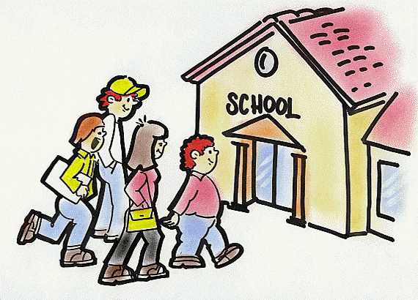
This took place week 1-5 November. If you have a child or know someone who has a child who is 4 on or before 28th February 2022 please make sure that they register their child for school.

Fundraising
All classes will be involved in making Christmas type decorations to raise money for our school fund. Please support us.
Christmas Raffle Prizes donated by staff and local businesses 20p a raffle ticket – drawn before the end of term
School Show

Each class will be singing a song and it will be put together for our Elmvale You Tube channel. This remains the nearest to a Christmas Show that we are able to create at the moment. We hope that you enjoy it! P1-3 Nativity and P4-7 Christmas songs
December
2 Football game Springburn Park 3.30-4.30 – all welcome
6-10 P7 at Blairvadach Outdoor Centre
13 P3, P4/3, P6, P6/5 party pm
14 P1, P2, P3/2 party pm
15 P4, P5, P7, P7/6 party pm
16 1.45pm Digital Pantomime (P4-7)
17 Santa all day (Nursery-P3)
Christmas Lunch – Turkey dinner or sandwich
21 Whole school Elmvale Christmas film on You Tube
22 School closes at 2.30pm

Your child can wear party clothes on their party day.

Communication
Follow us on Twitter @elmvaleprimary for latest updates and links to useful websites.

Pedestrian Zone
Thank you to those parents who continue to be a good example to their children and are ensuring the roads outside the school gates remain a pedestrian zone in the morning and at 3pm.

Grant and the Primary Team

Nursery News
Dear Parents/Carers
I would like to thank the parents and carers for their continued patience and cooperation during these times. We are missing having our parents and carers in our playrooms and look forward to the future when we can have you all back into our building. We hope that you were all happy with the interim reports that key workers created to inform you of your child’s progress so far. In the meantime, if you require to speak to anyone please do not hesitate to call the nursery 0141 558 5238.

Warm clothing
The playroom windows are open every day to provide good circulation of fresh air and in line with the current recommendation from the Government to prevent the spread of Covid 19. Can you please make sure you child has a jumper or cardigan on every day to prevent them from becoming cold.

Outdoor Education
Outdoor learning is still a very important part of your child’s learning and we will continue to spend lots of time outdoors as it’s one of the safest places to be and it provides lots of opportunities for your children to learn and have fun. This also teaches them resilience by improving their health and wellbeing and encourages their curiosity and appreciation of nature outdoors. We are now in a new season ‘winter’ so please provide your child with appropriate footwear and outdoor clothing.

Toy Fund
I will like to thank all our parents/carers who contribute to our £3 toy fund every week. This money contributes to a range of resources, which is provided every day. The money also pays for baking ingredients and the malleable learning experiences we provide for the children like play dough, gloop and shaving foam. It also helps with special items such as birthday gifts and at this time of year towards Christmas parties and presents for each child.

Christmas activities
The children will be involved in a wide range of learning experience this month related to Christmas. The staff are planning a special ‘fun week’ beginning the 13th December.
Some dates for you diary:
Christmas jumper day on the 10th. Christmas magic show and Santa On Friday 17th.
Our annual Christmas party is on Tuesday 22nd.
Party clothes at the ready!

Christmas holidays
Nursery closes on Wednesday 22nd Dec at 2.30pm please pick your child up before this time to prevent any congestion at the nursery and school entrance and we return on Wednesday 5th January 2022.

Julieann will be returning to Elmvale Nursery Class on the 8th December just in time to share all our lovely Christmas activities. Therefore, I will be moving on to pastures new. I would like to thank everyone on for being so welcoming and having me here for these past few months.
Deborah

Wishing you all a very Merry Christmas and a Prosperous New year

Deborah, Julieann & Nursery Team

