Literacy and English Policy

Elmvale Primary

August 2015

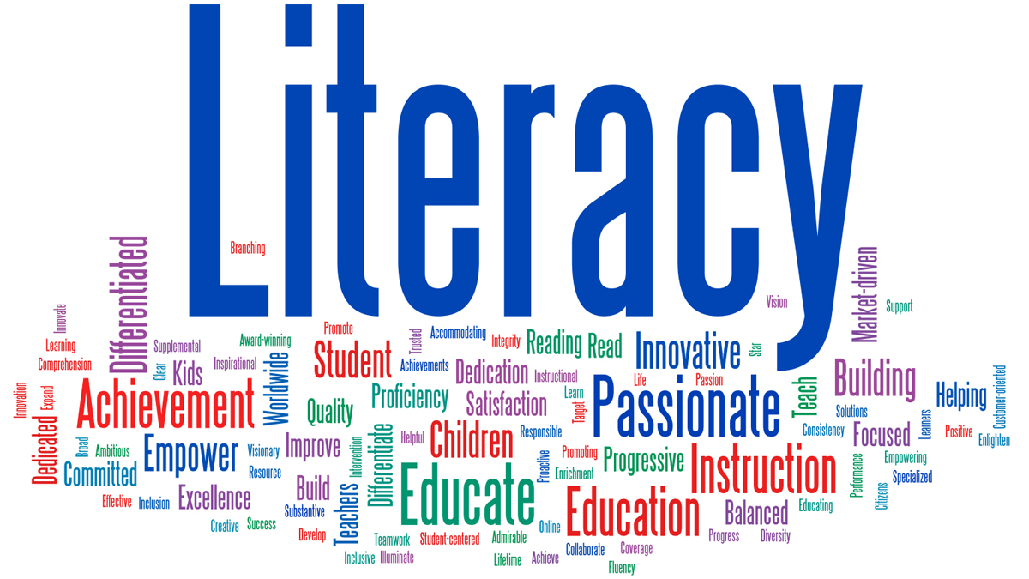



Contents

* Overview & Background to Policy
* Elmvale Literacy Rationale
* Elmvale Literacy Aims
* Teaching and Learning – Planning, Moderation and Assessment
* Reading
* Grammar
* Writing
* Listening and Talking
* Appendix 1 – Sound/Blend/Word and Rhyme Progression Primary 1
* Appendix 2 – Sound/Blend/Word and Rhyme Progressions Primary 2
* Appendix 3 – Sound/Blend/Word and Rhyme Primary 3
* Appendix 4 – Multisensory Approaches to Spelling
* Appendix 5 – Phonological Awareness (Mainly taught in Infants and also for struggling older readers)
* Appendix 6 – Jump Starters (P4 – P7)



Overview

## What is meant by literacy?

*Literacy development starts from birth. Early years settings and schools develop children and young people's basic and advanced literacy skills and in adulthood the ongoing development of literacy skills helps to advance personal achievements, employment prospects and participation in society.*

(Scottish Government Literacy Action Plan Oct 2010)

The ability to read, write and interpret written language is a fundamental skill needed for accessing all other areas of the curriculum and is an essential lifelong skill. **Our goal is to nurture children who read and write with confidence, fluency, understanding and enjoyment.**

*In defining literacy for the 21st century, we must consider the changing forms of language which our children experience and used within Curriculum for Excellence. Therefore, literacy is defined as; the set of skills which allows an individual to engage fully in society and in learning, through the different forms of language, and the range of texts which society values and finds useful.*

*(CfE Principles and Practice, Literacy and English, p.3)*

Background to policy

In 2013-2014, as part of the School Improvement Plan, departmental working parties (nursery-P7) were formed to take a closer look at the teaching of literacy. These groups looked at recent developments, current practice, Elmvale literacy resources and areas for development. This information was used to write this Literacy policy which will outline the practice and guidelines for the delivery of literacy from the Nursery-P7. This policy is intended and to ensure smooth transition, continuity and challenge for children. The group gathered their information from their own practice and experiences, audits of phonics, grammar, spelling and review of departmental models such as and P1-P3 ‘Zones’ p4-7 “Jumpstarters.”

Elmvale Literacy Rationale

In Elmvale, Literacy is considered and planned to enable all children to develop the four capacities and become Successful Learners, Confident Individuals, Responsible Citizens and Effective Contributors throughout all 4 contexts of *Curriculum for Excellence*:

* **Life and Ethos of the Setting (Ethos)**
* **Opportunities for Personal Achievement**
* **Experiences and Outcomes (Es and Os)**
* **Interdisciplinary Learning (IDL)**

**This diagram represents our rationale for our whole curriculum. Literacy and Numeracy are at the heart of our curriculum. These are developed on strong foundations of health and wellbeing for all.**

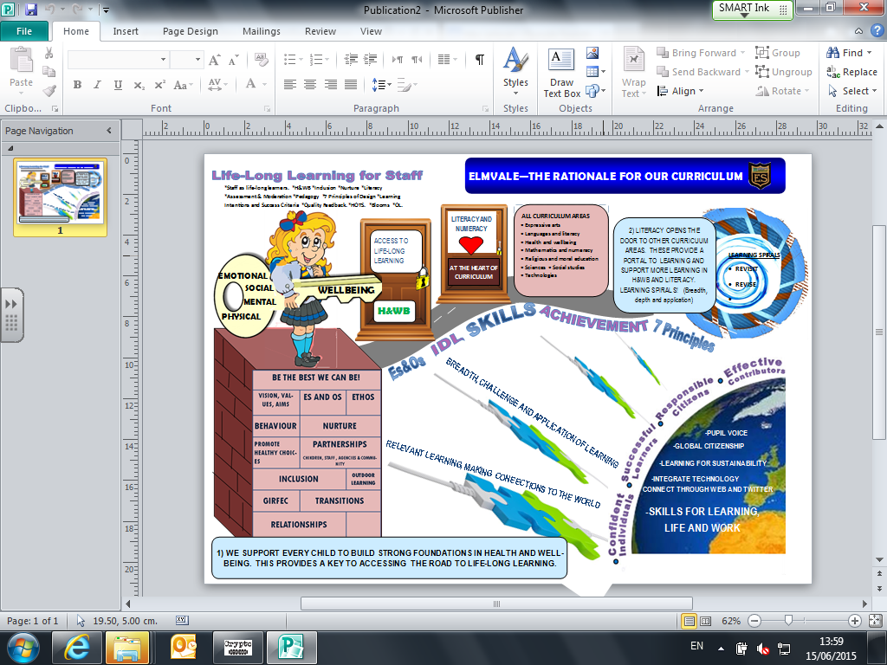

Elmvale Literacy Aims

* Provide an effective framework for the delivery of high quality learning and teaching in literacy across the four contexts, in a variety of settings and contexts.
* Increase staff skills and confidence in teaching literacy and ensure that the whole school community understands its role in developing literacy.
* Ensure all learners are provided with maximum opportunities to acquire knowledge and understanding in the use of literacy skills and can apply these skills effectively and with confidence across the curriculum.
* Promote progression and continuity at all stages and across areas of transition to ensure a seamless, coherent and relevant literacy curriculum for all.
* Raise levels of achievement and attainment in literacy for all learners.
* Commitment to the 1+2 approach to language learning. Children will have the opportunity to learn a further language which will give additional opportunities to build on children’s literacy skills so that they develop a greater understanding of how language works. (P4-7 French and current pilots on Spanish, German and Gaelic across other stages)

Teaching and Learning –

Planning, Moderation and Assessment

The planning, assessment and moderation cycle in Elmvale is based on Curriculum for Excellence Guidance. This cycle should be considered across all four contexts: **ethos, personal achievement, Es and Os, IDL.** Some important points to consider:

* The experiences and outcomes are organised into three main areas: **Listening and Talking**, **Reading** and **Writing.**
* Staff should also enrich children’s experience of language by recognising the diversity of Scotland’s culture and identity.
* Active learning opportunities and multi-sensory teaching approaches such as jolly Phonics and spelling should be planned for to ensure *challenge and enjoyment*.
* A wide range of resources are available in Elmvale to enhance learning experiences and some will be detailed within this policy. It is recognised that staff have a wealth of their own resources, internet based resources and techniques that can enhance lessons.

# Planning

* At the heart of all literacy planning, staff take into account **children’s prior learning**, personal targets and next steps. This information is gathered through a variety of methods, including transition notes, children’s own prior assessments and current assessments.
* Planning is mainly based on Experiences and Outcomes and the consideration of learning intentions and success criteria, taking into account interdisciplinary learning, personal achievement and the life and ethos of the setting.
* The 7 principles of design are considered in planning, assessment and moderation to ensure **breadth, depth, challenge and enjoyment, personalisation and choice, relevance and progression.**
* Active learning approaches such as Jolly Phonics and Multi sensory spelling are planned for.
* Children must be given opportunities to make connections in learning apply knowledge and skills in new contexts.
* Staff are encouraged to plan together and time for moderation and collegiate planning is built in to the working time agreement.
* Staff should use reflective questions to support self-evaluation and improvement:

**Questions to consider how well staff support learners to progress and achieve in literacy.**

* How confident are we in using the literacy experiences and outcomes?
* How well do we discuss the standards and expectations within the literacy experiences and outcomes to help develop a shared understanding?
* To what extent do we provide a broad range of experiences to develop learners’ skills in literacy across learning?
* How well do we provide opportunities for learners to engage with a wide variety of different types of text in different media?
* To what extent do we put in place strategies and approaches to intervene and provide personal support to enable all learners to make the best possible progress in literacy?

**Questions to consider how staff are using information and data**

* To what extent do we use range of evidence from day-to-day learning as well as from specifically designed assessment tasks, activities and tests and examinations to arrive at their overall judgements about achievement of a level?
* How good are we at taking account of significant aspects of learning that are pre-requisites to ensure successful progression to the next level?
* To what extent do we use benchmarking materials and moderation activities to support our judgements?
* How do we monitor and track achievement and progress of individuals and groups using assessment data and trends in achievement over time to support improvement?
* To what extent do we record information relating to learners’ progress in literacy; strengths and areas for improvement?

**Question stems to explore how well learners can apply their literacy skills**

* Can you think of an example…
* Can you explain….
* Where/when have you used…..
* In what ways have you applied……

# Differentiation

At all stages, differentiation must be provided through skilled consideration of approaches. This ensures *personalisation* of learning, appropriate *challenge* and *progression* in learning. This should be provided through:

* success criteria
* choice of resources
* organisation structures such as cooperative learning, flexible ability groups depending on task
* additional support and challenge

# Assessment

Further information about assessment can be found in the Elmvale Assessment and Target Setting policy document. In summary:

* Staff gather a wide range of evidence to provide a snapshot of learning in Reading, Writing, Listening and Talking. (Do, Write, Make, Say)
* Two cold pieces of writing should be added to the yellow literacy assessment jotter in October and April (which moves with the child as they progress through the stages). These cold pieces are assessed against the ‘Scottish Criterion Scale’. The Glasgow City Council ‘Achieving a Level’ document should be taken into account when planning, analysing progress and developing next steps.
* In addition to the two cold pieces, there will four more writing assessments in the writing assessment jotter which will highlight coverage of genres. These should be marked using quality formative assessment strategies e.g. two stars and a next step.
* In reading, staff are required to have at least one assessed reading task recorded per block.
* Weekly spelling assessments are expected of every child and the results are recorded in the assessment folder.
* There should be at least one talking and listening assessed piece per block.
* It is important to assess application of literacy skills and knowledge across the four contexts of the curriculum. For example, individual/group/class presentation skills at assemblies; through IDL topics; or in outdoor learning experiences such as use of the theatre.
* Both formative and summative assessments are used to inform learning, teaching and next steps.
* NRGT (Standardised test in reading) was piloted across P2-P6 in November 2014. Results from these helped develop next steps in learning. These tests will be undertaken on an annual basis and class teachers will be informed of which stages.
* Staff and the Senior Leadership Team (SLT) work together to record if a child is on track to achieve the level they are working towards.
* Scottish Criterion Scale is from the ‘Big Writing’ Programme (Autumn and Spring).
* HOTS should be embedded in planning, teaching, learning and assessment. Examples can be found below.

HOTs **Sample question stems for higher-order thinking skills**

|  |  |
| --- | --- |
| **Remembering**  What is ………?  Where is……?  How did ………. happen?  Can you outline……?  Can you explain / describe…….?  What happened after……..? | **Understanding**  How would you compare...?  How would you summarise...?  What example could you give of……?  What do you think could have happened next...?  Can you clarify / illustrate…?  What is the main idea of...? |
| **Applying**  How would you solve ………. using what you've learned...?  What would happen if...?  What information would you select to show...?  Can you sort/group by features such as…?  Which factors would you change if…?  How is …….. an example of ……..? | **Analysing**  What conclusions can you draw...?  What evidence can you list for...?  Can you explain what must have happened when...?  What was the problem with...?  What was the purpose of……?  In what ways would you group/sort/categorise these…..? |
| **Evaluating**  Do you agree with the actions/outcome….?  What influence will....have on our lives?  How could ……. be improved?  What would you say is the importance of…..?  Based on what you know, how would you explain...?  What information would you use to support the view...? | **Creating**  What would be a possible solution to...?  Can you develop a proposal which would...?  What theory can you come up with for…..?  Can you predict the outcome if…..?  How many ways can you….?  How can you improve/develop….? |

## Big Writing Assessment

* Don’t correct their work
* Give them a context which allows an individual response
* Check the length of piece the assessment requires and share with children
* Assess what you see in front of you
* If a child is assessed at a level significantly different from other class work, discuss with SLT, other writing will be used
* If work is legible don’t let handwriting be a barrier
* Name written correctly. Capitals and full stops in correct place and not anywhere else

## Target Setting

There is a school wide target setting system in place, where every child set and evaluate their own personal targets for literacy and numeracy in their target jotter (P1-P3) or Home/School Journal (P4-P7) Please see Elmvale Assessment and Target Setting Policy for additional information:

* All children should be aware of their literacy target(s) and how they are going to achieve it.
* SMART (specific, measurable, attainable, relevant and timed) targets should be short term, specific and achievable. They should develop meaningfully from literacy work. As a general guide, children should only be focusing on 2 or 3 personal literacy targets at a time. For example, the class may have a target of writing in paragraphs, most children will accomplish this as a class, but some need additional reinforcement. This is when it would become a personal target.
* Learning logs are currently being developed and could be the place to record these targets. This written record should be kept safe and should be used as a reflection tool at times.
* Discussion of targets should take place in class with class teacher and during “Learning blethers” with SMT. (Further target setting information can be found in Elmvale Assessment Guidance)
* Methods of involving parents more in targets are currently being developed but children should be encouraged to make parents and guardians of their targets and how they are working towards achieving them.

# Transition Information

The ‘literacy progression’ sheets will be passed on to classes with transition information. This will provide a clear starting point for progression of spelling and phonics in addition to the Nelson Baseline Assessment.

## Nelson Baseline Assessment

The Nelson Baseline Assessment should be used at the beginning of the school session in every stage to assess the children’s next steps for the learning of spelling rules and patterns. This will be used in conjunction with transition information. These assessments allow for differentiation and grouping. It should be recognised however, that is possible for children to move groups. This should be recorded in planning. (The master of this assessment can be found in Our Establishment ‘Literacy’)

# ASN and EAL

Children with Additional Support Needs should be aware of their specific targets, how they are being supported and what they need to do to achieve them. Parents and guardians should also be aware of these targets, how they will be achieved and what they can do to support their child’s learning and development. The class teacher has responsibility of meeting the child’s needs. The school ASN coordinators (DHT’s) have the responsibility of overseeing these targets and how they will be met.

Where possible, support staff are timetabled to support children with a variety of additional needs including behaviour support, learning support, more able students and promotion of active learning.

Additional support and training is offered to all staff with regards to support for learning. The school has an on-going history of training and support from Glasgow Dyslexia Service and The Autism Resource Centre. The school’s Educational Psychologist provides training, advice and support for children and their families with additional support needs.

Children for whom English is an additional language will receive additional support as necessary and appropriate to allow them full access to the curriculum by removing the ‘barrier’ of language.

Support will recognise the priority of promoting the child’s mastery of his/her first language. A key aim will be to develop social language and the language of the curriculum in collaboration between SLT, class teacher and EAL staff. The competences outlined in the *Stages of English Acquisition Levels* (please see folders on ASN and EAL on Our Establishment for further information), will be used as a framework for this development.

Staff can approach both DHT’s for support, advice and guidance for supporting children with additional support needs.

# Home Learning

As written in the Home Learning Policy, the Literacy home learning tasks should enhance and compliment literacy work being completed in school. Literacy home learning should include a variety of meaningful tasks to support the significant aspects of learning in Talking and Listening, Writing and Reading.

The Nursery focuses on Rhyme and sends ‘Rhyme of the week home’ so parents/carers can support learning. All children in P1 should take home sounds, common and tricky words to practise. Duplicates of each are helpful for games such as snap and pairs. P2 upwards should consider sending sound or word tubs (or similar) for children who would benefit from extra practise.

In Primary, spelling words are issued weekly following the teaching of the spelling rule in class. Practise is given using active learning strategies during active and multi- sensory workshops in the infants and Jumpstarters for P4-P7, but children should also be given spelling tasks for home for consolidation and extension. Children will be assessed on their spelling words once a week. Please see the Home Learning Policy for more information.

# Literacy Week/World Book Day

World book day takes place in Elmvale within ‘Literacy Week’ on an annual basis. This enables children to make connections in their literacy learning to the wider world, apply skills and knowledge across a variety of experiences and take part in special planned events such as:

* Whole school celebration events
* Author visits
* Planned workshops
* Paired Reading
* Shared learning experiences
* Exploration and appreciation of a variety of texts and authors e.t.c.

Reading

## Every child should be given a range of reading opportunities. These should be differentiated to meet the needs of the child. It is recognised that the more opportunities children have to read, the more experienced and confident they will become.

#### The following illustrates opportunities which should be embedded to promote progression in each of the significant aspects of learning in reading. Through all stages, children should have opportunities to:

* demonstrate comprehension and ideas about the texts they read, such as: focused discussion, mind mapping, making notes and use these to create a new text, reading logs, journals, book reviews and blogging etc.
* identify and discuss language features and aspects of the writers style.
* have regular opportunities for reading aloud, developing expression and fluency.
* read fiction, non-fiction and poetry
* read visual, digital media and printed texts through the school library, the internet and home and school environment, to develop the ability to explain why they have chosen a certain type of text or genre. (All children must have easy access to a library book on a regular basis)
* promote and encourage a love of reading individually and collectively to develop skills that will allow children to share, interpret, analyse, evaluate and enjoy different types of texts.
* become confident individuals when reading aloud, demonstrating self-awareness by observing and reflecting on audience feedback
* develop higher order reading skills, including questioning and forming opinions about texts and authors

# Progression in Reading

During session 2014-2015, all staff were involved in writing ‘progression pathways’ for reading (See Progression Pathways on Our Establishment, Literacy folder). All staff should refer to these throughout the year when planning, moderating and assessing.

It is important to ensure that texts are appropriately challenging and enjoyable for all children at all stages. Pace is important to maintain interest as well as encourage progression.

* **In the nursery** children develop early reading skills by introducing children to environmental print, a variety of texts, oral storytelling and developing phonological awareness. The nursery focus on embedding elements of phonological awareness through meaningful experiences. See Appendix 3 on phonological awareness.
* **From P1,** phonics is introduced through Jolly Phonics. Most children learn the mechanics of reading and build, consolidate and extend reading fluency and understanding using the Oxford Reading Tree scheme. Children should progress through one or two books a week to maintain interest and engagement. Children do not have to complete every book at every stage. It is crucial that the focus is on ensuring the children have reading material at the correct level of challenge. ORT provides ‘running records’ in the teaching guides which should be used regularly across the year to inform teaching and learning. All infant classes should also undertake Rhyme and Analogy book studies at least 3 times across the year.
* Session 2015-2016: Pilot of new **Active Literacy Programme** in P1 and P3. This will be evaluated in June 2016 and the impact of this programme will be reported with the intention of further implementing and embedding into the infant department for session 2016-2017.
* **From P4**, every child should be given the opportunity to experience **Literacy Links**, **Literacy World**, novel studies and poetry in addition to other resources including teacher made resources. Resources should be shared between stages, in order that teachers may moderate and plan together. The management team will discuss with moderation groups which reading resources are used each block to ensure there is an even distribution of reading materials for all children.

To ensure that all classes have access to reading and literacy schemes, an overview/yearly timetable for the distribution of these resources has been created, and included for P4-7 (see Literacy folder). A blank grid will be added to the forward plan folder where staff will add what reading material for each block they intend to use. Please see Elmvale Reading Scheme Record in the Forward Plan folder on Our Establishment to highlight record of reading resources being used.

Reading for children with Additional Support Needs

There are additional resources within the school to support reading for children that require more specific support. These include Wellington Square and Wolf Hill.

The majority of support staff have received additional training from Strathclyde University to help support reading in the classroom. Teaching staff and support staff should discuss regularly how children are progressing to ensure children’s progress is being recorded and next steps planned for.

All staff are aware of GDSS strategies and resources and these can be found on Our Establishment. Following Glasgow City Council guidelines, screening for possible Dyslexic type tendencies begins in the nursery. From Primary 4 onwards a child can be diagnosed with a Dyslexic type tendency.

# **Paired Reading**

Paired reading sessions are planned for throughout the school year. Senior school classes are paired with an infant class for paired reading sessions and opportunities for reading together. This aids literacy experiences for all children as well as promote the strong sense of positive ethos and active citizenship.

Paired reading gives practice and consolidation for infant children’s reading, promotes children’s enthusiasm for stories and encourages better communication and listening skills for all children involved. Please see further information found in the Literacy folder in Our Establishment.

# Drop Everything and Read (DEAR)

Following the audit of current practice, it was agreed that DEAR will take in two blocks across the year (block 1 and block 4). This will take place for fifteen minutes twice a week. During this time the children and all staff are invited to ‘**Drop Everything and Read’**.

P7 children will take the responsibility of organising this and will decide an appropriate sound that will signal the start and conclusion of this. The school will be made aware of this sound at an assembly. DEAR has been adopted to encourage reading for pleasure, allow time for children to see all adults around the school reading, model independent reading and the pleasure of reading.

# **Reading Resources Organisation**

If taking a class set of ORT/novels from the resource room, only the books should be taken and not the box from which they came. This allows other staff to see that they have been taken for use, and also makes it easier to manage the return of the books into their correct place in the resource room.

A list of current reading materials has been collated and can be found in the Literacy folder in Our Establishment. It details the number of each novel available in the school. A list of suggested stages for each novel is also included, to ensure that there are appropriate and enjoyable texts available to each stage throughout the school.

English: Spelling, Grammar and Punctuation

Care must be taken not to hinder skill development in personal, imaginative and functional writing by placing too much focus on the correction of all spelling, punctuation or grammar. Correction should relate primarily to the learning outcomes/success criteria of the task. Only when the lesson is specifically related to the development of spelling skills, should maximum correction, appropriate to the age and stage of the child, be undertaken.

# Jolly Grammar

In response to the audit, it has been agreed that, in addition to other grammar-learning opportunities, we will use ‘Jolly Grammar’ as a key resource to ensure progression in grammar from the infants learning of ‘Jolly Phonics’.

We are aware that children learn at their own pace; however, the following is a guideline for the majority of children in the class:

Early level – Jolly Grammar 1/2

First level – Jolly Grammar 2/3

Second level – Jolly Grammar 3/4

For each lesson, there is a photocopiable activity sheet for the children to complete; however, the activity should be adapted to be completed in a more active way if more appropriate. Each grammar lesson has its own particular focus and is intended to be followed systematically. If a suggestion seems inappropriate to a particular class situation it can be adapted.

Information of coverage of this progression will be passed on in transition notes in addition to assessment about rules to be revisited.

Writing

# Writing is a major part of the curriculum and along with reading, listening and talking, makes a significant contribution to the development of children as thinkers and learners.

# Writing involves a set of complex skills that will not develop without structured teaching and practice. In Elmvale our approach to writing is based on child centred, interactive learning with a focus on four core targets of Vocabulary, Connectives, Openers and Punctuation (V.C.O.P).

# Big Writing

Elmvale Primary School introduced BIG Writing in 2011, piloting it in the upper school and rolling it out to the infant department in 2014. Staff are aware that Big Writing lessons are not the only writing experience offered to pupils and additional writing opportunities should be planned for and detailed in forward planning. Staff should ensure that all genres appropriate to their stage are covered across the school year.

Every year, Block 1 should be used to deliver the six high impact lessons as outlined in the Big Writing Pack. Each class has a Big Writing box of resources and a folder of information. The box should be added to as the year progresses.

As well as other assessed writing pieces, there are two cold pieces of writing that should be assessed each year. Please see the Assessment and Target Setting Policy for more information. One should be written around the October week break and the second after the Spring break. Each cold piece should be assessed using the Scottish Criterion scale. This should be kept in the children’s writing assessment jotter.

Other cold pieces of writing should be written in the writing assessment jotter each term. (As outlined in Elmvale Primary assessment guidelines) These are not assessed using the Scottish Criterion Scale.

It is **imperative** that writing opportunities should be provided contextually across the curriculum in areas such as Science, IDL, RME etc.

**NON-FICTION OVERVIEW of GENRE DEVELOPMENT (P3-7)**

|  |  |  |
| --- | --- | --- |
| **GENRE** | **POSSIBLE FORMATS** | **EXAMPLES of**  **POSSIBLE CONTEXTS** |
| **RECOUNT**  **To re-tell events to inform/entertain others** | Letter  Book  Magazine article  Newspaper article  Book  Minutes | Letter to a friend retelling an event  Autobiographical accounts  Sharing events of a school trip  Eye-witness accounts  Recounting a familiar story from the point of view of a character |
| **REPORT**  **To present factual information about a topic** | Booklets  Handbook  Table  Bulletin  Fact File  Information sheet  Presentations, CV’s | Compiling reports about different sports  Essential school information  Bird-watching report  Weekly weather report  All about dinosaurs  Facts about European countries |

|  |  |  |
| --- | --- | --- |
| **PERSUASIVE**  **To persuade the reader** | Placard  Letter  Radio advert  Poster  Brochure  List | Save the Whale  Please don’t build houses on our park  Advertise new shampoo  Come and see our school play  Advertising new theme park  Why I deserve a pocket money rise |
| **PROCEDURAL**  **To describe how to do something through a series of sequenced steps** | Recipe  Leaflet  Flow-chart  Instructions  Poster  Set of rules | Making soup  How to order a pizza by phone  Instructions for making a model  How to operate a video recorder  Buying a train ticket  How to play a game |
| **EXPLANATION**  **To explain how something works/why things are** | Interview: question and answer  Cartoon strip  Annotated diagram  Flow-chart  Holiday brochure  Poster  Book | Children interview each other about their favourite things  My day  How a lift works  How we digest food  Explaining features of different resorts/hotels  Customer info – why the trains will be late today  How the ______________ got it’s name |
| **ARGUMENT / DISCUSSION**  **To promote one particular point of view or argument / To consider both sides of an argument and draw reasoned conclusions** | Letter  Poster  Newspaper article  Magazine article | To a shop complaining about faulty goods  Arguing for a ban on smoking  Cars: should they be allowed in our cities?  Which makes the best pet, a cat or a dog? |

### Developing the Craft of Writing Skills: A Structured Approach

Teachers should use a clear structure when teaching writing:

|  |  |  |
| --- | --- | --- |
|  | **Teacher’s Role** | **Children’s Role** |
| Pre-Writing | Help pupils get ideas:   * allow thinking time * provide model texts * guide discussions through open questioning * provide contexts | Take account of purpose & audience:   * talk, think, rehearse * discuss – class/group/partner * draw, make, list * generate ideas eg brainstorm, web * remember/re-organise thoughts |
| Planning for Writing | * teach aspects of different styles of writing – language, structure, layout etc * model writing for children * analyse/discuss model texts * construct a writing frame together (where appropriate) * set clear criteria with pupils for writing tasks | * make notes * select, sort, reject ideas * talk through and complete planning page (where appropriate) * gain/offer advice on partner’s work |
| Writing | * allow space/time to write * help children ask appropriate questions * conference with children – focus discussion on strengths/development needs * highlight good examples | * make decisions during process about: content, organisation, language * read aloud (or to themselves) at intervals, during writing – ask themselves “Is this how/what I want to say?” * amend/add detail |
| Editing and Proof-Reading | Encourage pupils as writers to respond to text as a reader:   * help pupils make alternatives i.e. remove ambiguity, irrelevancies and omissions etc * remind children of technical targets | Proof-reading is often better done by, or with, others:   * pupils read own and others’ drafts to clarify meaning and amend * children ask questions of each other, seek responses, make suggestions * check for omission, repetition, detail * check technical aspects and correct |
| Publication/Celebration | * help pupils decide on what/how to publish * make materials available * give opportunity to share with an audience * praise, acknowledge writing | * make final copy (where appropriate) * make simple decisions on layout eg illustrations etc * listen and respond positively to others’ writing |

# Handwriting

It is recognised that handwriting is an important aspect of the children’s learning and can improve attainment in spelling. The cursive handwriting programme will be introduced in 2015. There is evidence to prove that this handwriting programme can aid spelling as children think about phonics and blends as they write. It is particularly helpful for children with barriers to learning such as Dyslexic type tendencies.

Historically, Nelson Handwriting has been used at Elmvale Primary School as the basis for guidance. Cursive writing is to be introduced. P2 and P3 will write initial cursive letters and P4 onwards will be taught cursive joins. High expectations of handwriting should be applied and transferred in all areas of the curriculum.

Handwriting jotters and cursive handwriting booklets should be used for these lessons. Children should be encouraged at all times to use their best handwriting in all written work. High expectations of presentation and layout is expected at all times with children taking pride in their work. Teachers should seek opportunities to provide effective feedback during learning to improve writing continuously. For example, highlight letters or words needing corrected and ask children to practise at the bottom of the page several times or for home learning.

# Spelling

In Primary 1-3 the children will use Jolly Phonics tricky words and common words. The children will follow the progression of these as outlined in the Jolly Phonic scheme. When they are at the appropriate level they will move on to Nelson Spelling and Jolly Grammar. From September 2015, several classes will also pilot the new Active Literacy Programme.

**Nelson Spelling and Resources**Following discussion of the audit of the teaching of spelling of P4-7 in Elmvale in March 2014, a need for progression of rules and words as a baseline assessment was required for teaching spelling.

It is suggested that Nelson Spelling is an appropriate resource for this. e.g. Nelson Spelling placement scheme test. It is imperative that prior knowledge is taken into account and is married with information from the assessment. These words should be used in addition to topical spelling words, additional words to provide further challenge and development of vocabulary.

Nelson Spelling resources can be located in the resource room, and the placement test (baseline assessment) accurately indicates the book most appropriate to the student. A copy of the baseline assessment can be found in the Literacy folder on Our Establishment.

In 2015 Jolly Grammar has been introduced to P3-7 as a spelling and grammar scheme.

**Additional Resources**

Other resources within the school are Jolly Phonics, Hand for Spelling as well as a wealth of teacher made web resources, which can be found in the resource room and on Our Establishment.

It is also recognised that teaching staff have a wealth of their own resources, internet sourced resources and techniques that can enhance grammar lessons.

Listening and Talking

The first literacy skills acquired by children are listening and talking. These aspects of language must be further developed as a first priority, and built upon to support the development of reading and writing skills. As reading and writing are complementary, their development should be linked wherever relevant and appropriate.

Activities and opportunities should be planned for and recorded in forward planning.

Following the review of current practice it was agreed that each child should have at least one assessed talking and listening activity per block.

Listening and Talking: Cooperative learning, keys to literacy, discussion, debating and listening activities through all curricular areas and contexts are used to:

* provide opportunities to participate in discussions through listening and sharing ideas
* develop skills in listening and talking to others, clarifying their ideas and understanding
* develop the skills, knowledge and understanding to create and develop arguments, opinions and viewpoints linked to a wide variety of texts and situations
* develop the skills which will allow them to listen attentively, talk clearly and coherently and respond appropriately in different contexts and situations

Appendix 1 – Sound/Blend/ Word and Rhyme

Progression Primary 1

As we are all aware children learn at their own pace.  
The following is a guideline for the majority of children in your class.

Sounds/Blends to be covered

(highlight sounds to be covered each block)

|  |  |  |  |  |  |
| --- | --- | --- | --- | --- | --- |
| 1. s | 1. a | 1. t | 1. i | 1. p | 1. n |
| 1. c | 1. k | 1. e | 1. h | 1. r | 1. m |
| 1. d | 1. g | 1. o | 1. u | 1. l | 1. f |
| 1. b | 1. ai | 1. j | 1. oa | 1. ie | 1. ee |
| 1. or | 1. z | 1. w | 1. ng | 1. v | 1. oo |
| 1. y | 1. x | 1. ch | 1. sh | 1. th | 1. qu |
| 1. ou | 1. oi | 1. ue | 1. er | 1. ar | 1. wh |

Once confident with all 42 sounds progress to initial blends.

|  |  |  |  |  |  |
| --- | --- | --- | --- | --- | --- |
| 1. bl | 1. br | 1. cl | 1. cr | 1. fl | 1. fr |
| 1. gl | 1. gr | 1. pl | 1. pr | 1. sc | 1. sk |
| 1. sm | 1. sn | 1. sl | 1. st | 1. sp | 1. sw |
| 1. tr | 1. tw | 1. dr |  |  |  |

(P1 continued…)

Common Words to be covered (**to read and spell**)

(combination of Jolly Phonics Tricky Words and Fry’s Word List)

(highlight words to be covered each block)

|  |  |  |  |  |  |
| --- | --- | --- | --- | --- | --- |
| 1. a | 1. the | 1. in | 1. is | 1. it | 1. I |
| 1. you | 1. he | 1. she | 1. me | 1. we | 1. be |
| 1. at | 1. as | 1. an | 1. and | 1. was | 1. are |
| 1. on | 1. or | 1. of | 1. to | 1. do | 1. my |
| 1. by | 1. with | 1. have | 1. from | 1. go | 1. no |
| 1. so | 1. come | 1. some | 1. said | 1. like | 1. here |
| 1. there | 1. that | 1. this | 1. they | 1. for | 1. his |
| 1. all | 1. your | 1. one | 1. live | 1. give | 1. went |

Rhyme and Analogy to be covered – ‘First Story Rhymes Pack A and B’

(highlight books to be covered each block – 1 per block minimum)

|  |  |
| --- | --- |
| 1. The Snowman (at) | 1. Kitty Kit (it) |
| 1. The Magic Pot (ot) | 1. The Shark (in) |
| 1. Fox Cub (ub) | 1. Whizz-bang Gran (an) |
| 1. Sam and the Baby Bug (ug and am) | 1. Dustbin Fred (ip and ed) |
| 1. Wishing Well (et and ar) | 1. The Dancing Hen(en and ap) |
| 1. Jumping Jill (un and ill) | 1. Behind the Wall (og and all) |
|  |  |

Appendix 2 – Sound/Blend/ Word and Rhyme Progression Primary 2

As we are all aware children learn at their own pace.

The following is a guideline for the majority of children in your class.

Sounds/Blends to be covered

(highlight sounds to be covered each block)

|  |
| --- |
| 1. Revise all single sounds and assess |

**Revisit** double sounds from P1

|  |  |  |  |  |
| --- | --- | --- | --- | --- |
| 1. ai | 1. oa | 1. ie | 1. ee | 1. or |
| 1. ng | 1. ch | 1. sh | 1. th | 1. ou |
| 1. oi | 1. ue | 1. er | 1. ar | 1. ph |

**Revisit** initial blends from P1

|  |  |  |  |  |  |
| --- | --- | --- | --- | --- | --- |
| 1. bl | 1. br | 1. cl | 1. cr | 1. fl | 1. fr |
| 1. gl | 1. gr | 1. pl | 1. pr | 1. sc | 1. sk |
| 1. sm | 1. sn | 1. sl | 1. st | 1. sp | 1. sw |
| 1. tr | 1. tw | 1. dr |  |  |  |

Final Blends

|  |  |  |  |  |  |
| --- | --- | --- | --- | --- | --- |
| 1. nd | 1. nk | 1. nt | 1. mp | 1. ft | 1. lt |
| 1. st | 1. ld | 1. ck | 1. sk | 1. sp | 1. tch |

(P2 continued) Alternative Spellings (from Jolly Phonics)

(children should be aware of alternative spellings and attempt when spelling)

|  |  |  |  |
| --- | --- | --- | --- |
| 1. ai/ay/a-e | 1. oa/ow/o-e | 1. ue/ew/u-e | 1. ie/y/igh/i-e |
| 1. ee/ea | 1. oi/oy | 1. ou/ow | 1. au/aw |

Common Words to be covered (**to read and spell**)

(combination of Jolly Phonics Tricky Words and Fry’s Word List)

**NB: P1 common words to be revisited where necessary**

(highlight words to be covered each block)

|  |  |  |  |  |  |
| --- | --- | --- | --- | --- | --- |
| 1. but | 1. not | 1. can | 1. had | 1. did | 1. get |
| 1. day | 1. if | 1. word | 1. use | 1. each | 1. how |
| 1. will | 1. up | 1. about | 1. out | 1. her | 1. him |
| 1. has | 1. into | 1. look | 1. see | 1. make | 1. time |
| 1. write | 1. then | 1. them | 1. these | 1. than | 1. been |
| 1. only | 1. old | 1. little | 1. down | 1. what | 1. when |
| 1. why | 1. where | 1. who | 1. which | 1. any | 1. many |
| 1. more | 1. before | 1. other | 1. were | 1. because | 1. want |
| 1. saw | 1. put | 1. could | 1. should | 1. would | 1. right |
| 1. two | 1. four | 1. goes | 1. does | 1. made | 1. their |

Rhyme and Analogy to be covered – ‘Story Rhymes Pack A’

(highlight books to be covered each block – 1 per block minimum)

|  |  |
| --- | --- |
| 1. Supersonic engine juice   (Word families: tub, net, zip, fan) | 1. Scat, cat!   (Word families: cat, pin, bed, dog) |
| 1. The Mungle Flap   (Word families: cap, hen, nut, lid) | 1. Bad day, good day   (Word families: sad, hit, leg, sun) |
| 1. Who wants to play with a troll?   (Word families: wig, jam, shop, hay) | 1. The Spell Shell   (Word families: swim, crab, knot, bell) |

Appendix 3 - Sound/Blend/ Word and Rhyme Primary 3

## As we are all aware children learn at their own pace.

## The following is a guideline for the majority of children in your class.

Sounds/Blends to be covered

(highlight sounds to be covered each block)

**Revisit/Revise** (from P2)

(children should now be attempting more accurate spellings using rules below)

|  |  |  |  |
| --- | --- | --- | --- |
| 1. ai/ay/a-e | 1. oa/ow/o-e | 1. ue/ew/u-e | 1. ie/y/igh/i-e |
| 1. ee/ea | 1. oi/oy | 1. ou/ow | 1. au/aw |

Others

|  |  |  |
| --- | --- | --- |
| 1. all   e.g ball, fall, small.. | 1. alk   e.g walk, talk, chalk… | 1. wa   e.g was, wanted, water… |

Common word endings

|  |  |  |  |
| --- | --- | --- | --- |
| 1. y(i)/y(I)   e.g. happy/shy | 1. ly   e.g. slowly, happily | 1. ing   e.g. singing, working | 1. le   e.g. little, candle |
| 1. s/es   e.g. birds/glasses | 1. ed   e.g. shouted, walked | 1. er   e.g. faster, longer | 1. est   e.g. fastest, longest |

(P3 Continued) Silent Consonants

|  |  |  |  |  |
| --- | --- | --- | --- | --- |
| 1. wr   e.g wrong | 1. kn   e.g knee | 1. gn   e.g gnome | 1. gh   e.g ghost | 1. rh   e.g rhyme |
| 1. st   e.g castle | 1. sc   e.g scene | 1. alf/alm   e.g calf/calm | 1. mb/bt   e.g lamb/doubt |  |

Soft c and g

|  |  |  |
| --- | --- | --- |
| 1. c   e.g race, mice, ceiling, slice… | 1. g   e.g cage, gerbil, orange… | 1. dge   e.g budget, dodge, nudge… |

Common Words to be covered (**to read and spell**)

(from Fry’s Word List)

**NB: P2 common words to be revisited where necessary**

(highlight words to be covered each block)

|  |  |  |  |  |  |
| --- | --- | --- | --- | --- | --- |
| 1. number | 1. way | 1. people | 1. first | 1. water | 1. call |
| 1. oil | 1. now | 1. find | 1. long | 1. may | 1. great |
| 1. part | 1. over | 1. new | 1. sound | 1. take | 1. work |
| 1. know | 1. place | 1. year | 1. back | 1. most | 1. very |
| 1. after | 1. thing | 1. our | 1. just | 1. name | 1. good |
| 1. sentence | 1. man | 1. think | 1. say | 1. help | 1. much |
| 1. through | 1. line | 1. too | 1. mean | 1. same | 1. tell |
| 1. boy | 1. follow | 1. came | 1. show | 1. also | 1. form |
| 1. around | 1. three | 1. small | 1. set |  |  |

From P1-P3 children will learn to read and spell the first 150 common words (Fry’s) along with Jolly Phonics Tricky words. If you feel a child is ready to learn more please refer to the Second Hundred words (Fry’s list).  
  
(P3 Continued)

Rhyme and Analogy to be covered – ‘Story Rhymes Pack B’

(highlight books to be covered each block – 1 per block minimum)

|  |  |
| --- | --- |
| 1. That’s nothing!   (Word families: bag, hill, mum, duck) | 1. Rockpool rap   (Word families: knob, ball, snow, star) |
| 1. The King’s socks   (Word families: clock, king, plug, flash) | 1. Gran, Gran!   (Word families: sack, long, brush, dress) |
| 1. How to kick-start a dragon   (Word families: puff, cross, bang, chick) | 1. My home   (Word families: grass, stung, kiss, cliff) |

Appendix 4 - Multisensory Approaches to Spelling

This leaflet master can be found in our establishment. These techniques should be embedded in infant literacy teaching and learning. This leaflet should be sent to all parents and explained if possible.

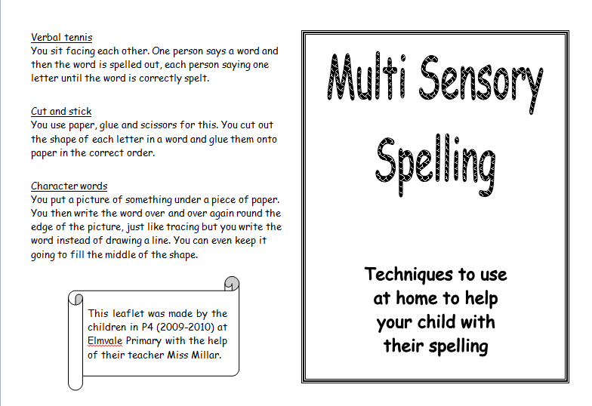

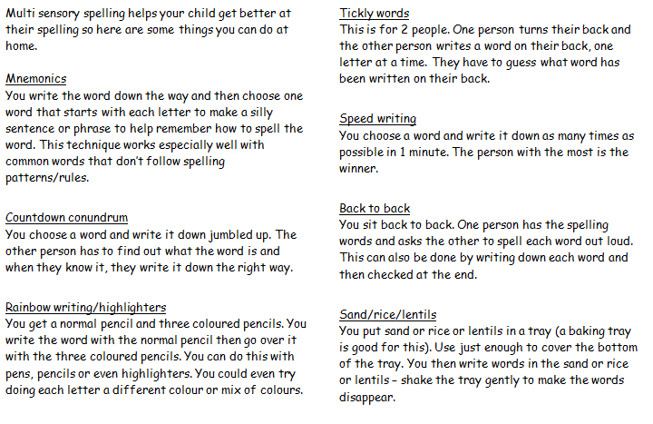

Appendix 5 – Phonological Awareness

(Mainly Taught in Infants and also for struggling older readers)

Information for all staff. Phonological awareness forms the foundations of reading. It is the main focus in nursery and infants. It is where to start with struggling older readers.

## What is “Phonological Awareness?”

Phonological awareness is the ability to listen to, recognise, and manipulate sounds of language. The development of good phonological awareness in the early years provides a sound basis for the development of spelling, reading and writing skills in later years.

#### Curriculum for Excellence – Literacy Outcome

#### I enjoy exploring and playing with the patterns and sounds of language and can use what I learn.

## Listening skills:

Listening is a key skill for all of us. In order to learn about different sounds, children need to practise and refine their listening skills.

## Activity Ideas

* Sound walks indoors and outdoors
* Matching sounds of percussion instruments
* Listening for hidden sounds
* Listening to instructions ( use puppets)
* Sound lotto
* Simon Says
* Nursery rhymes – deliberate mistakes e.g. Jack and Jill went up the mountain

## Syllable Segmentation:

Syllable segmentation refers to the splitting up of words into the correct number of sounds e.g. “Ham-bur-ger” (3), “Ver-on-i-ca” (4), “cat” (1). Practice in syllable segmentation activities provides children with a good strategy for spelling when this becomes appropriate.

## Activity Ideas:

* Daily opportunities for children to engage in musical activities, encouraging children to clap or use instruments to tap rhythm of nursery rhymes and songs.
* Clap or tap out syllables in children’s names, favourite food, colours, animals etc
* Instruments are another good way to teach syllable segmentation e.g. drums, xylophone, etc. Children beat the drum as they say their name, favourite food etc, in syllables e.g.

Mar i anne

MCj04349430000[1]MCj04349430000[1]MCj04349430000[1]

* Storytelling puppets with different number of syllables e.g. “bear” (1), Giraffe (2), “chimpanzee” (3)
* Talk like a robot (use puppets or props) and encourage children to do the same.
* Extend robot activity - The Robot’s batteries are running out and it can only say part of word “Ro” or “Bot”. Practise with other objects the “robot” can see.
* Read nursery rhymes saying only the first syllable in two syllable words e.g. Hum__ Dum__. Invite children to supply the missing syllable.
* Using cards with dots to visually represent syllables. Children could make a graph using the dots to represent the number of syllables in their name.
* Children to sort picture cards, toys or other objects by the number of syllables the word has.

## Rhyme (Sound at the end)

Detecting rhyme can be encouraged in a number of ways. Daily exposure to “rhyme time” e.g. 10 minutes each day at gathering time or literacy time would develop children’s concept of rhyme. Use the word “rhyme” when drawing attention to words which end with the same sound.

## Activity Ideas:

* Introduce a rhyme of the week to say together each day. Build games into this time e.g. finish the rhyme “Jack and Jill went up the______”.
* Spot the mistake! “Jack and Ben went up the hill.” Children to tell you the real words.
* Feely bags with rhyming objects.
* Selection of rhyming objects or cards to match
* Circle time. Each child receives an object and has to find the matching object from the basket e.g. pen/ten, dish/fish…
* Spotting the odd one out pen/ten/hen/fish using objects or cards.
* Interactive rhyming wall in playroom with a variety of Velcro icons/pictures for children to match and sort by their rhyming sound.
* Kim’s game with rhyming objects.
* Eye spy with rhyming objects
* Children to make up their “rhyme name” e.g. “Jack in black” “Molly the dolly” “ Pally Sally” “Ben Ten” “Kelly Jelly”
* Make up nonsense/silly rhymes with the children.
* Number rhymes to link with early numeracy development

## Initial sounds (Sound at the beginning)

Ability to detect the sound at the beginning of a word.

Many of the activities from the rhyme section can be adapted , ensuring that the initial sound is emphasised.

## Activity Ideas:

* Alliteration names e.g. “Bonny Brooke”, “Shy Sean”, “Charming Charles”… this can be extended by asking children to generate further words with the same initial sound and making these into a silly rhyme.
* Initial sound bags e.g. A “Big, Blue Bag” with objects inside such as ball, boat, bus, brick, banana etc.
* Spot the odd one out e.g. bag, ball, belt, broom, shell.
* Initial sound lotto

## Developing awareness of words

* Use the term “words” e.g. Is your name a long word or a short word?
* Count number of words in titles of stories and rhymes.
* When scribing with children, count the number of words you have written.

More activities can be found in the Early Literacy and Maths Activities booklet. (Saved in our establishment)

Appendix 6 - Jump Starters (P4 – P7)

“Jumpstarters” was introduced as a pilot in April 2013, following the work of a working party. Following the successful pilot all senior classes from P4-7 delivered “Jump starters” as part of their literacy work beginning in August 2013. “Jumpstarters” were introduced to ensure active, collaborative and sometimes, independent differentiated tasks were being planned for in different aspects of literacy such as spelling and grammar. This is outlined fully in the “Jumpstarters” guidelines written in 2012-2013. As a result of this Infant class now start their literacy session with a selection of Early morning activities.This information was taken and adapted from the existing, “Developing Literacy through active learning policy.” Please see this policy for more details.

## Enhancing Active Literacy in P4-7

It should be noted that the Literacy working party (2012-2013) recognise that “active literacy” is about engaging pupils in their learning and providing opportunities for creative cognitive thinking and application in a variety of ways. This does not always require children to be “physically” moving, it is about how they approach and become involved in a task.

This model will cover four to five literacy Jumpstart sessions each week.

**Aim of working party: *To provide a model that allows for improved motivation and independence in Literacy, using principles of active learning and Curriculum for Excellence.***

*Intended impact of model:*

* Children will show improved motivation towards literacy.
* Pupils will demonstrate greater independence in their learning.
* Pupils will show improved organisation of resources for their learning.
* The model we are adopting will enhance existing teaching approaches.
* It will enable children to take more ownership of their learning.
* It will enhance cohesion and progression across the department.
* Teaching staff will be able to work during each “Jumpstart” session with smaller groups and individuals to give direct teaching, effective feedback and one to one support.
* It will create a manageable and effective model of literacy that puts the seven principles of CFE into practice:
  + - Challenge and enjoyment
    - Breadth
    - Progression
    - Depth
    - Personalisation and choice
    - Coherence
    - Relevance.

## Review of Jumpstarters 2014

Both staff and pupils have been very positive in their comments about Jumpstarters. It was agreed that the intended impact of the model has been successful but the model is still to be truly imbedded in the timetable. Children are aware of what Jumpstarters is for. When asked, one child in P6/5 said, “*It’s to waken up our brains to become more switched on to our literacy work*.”

There was much discussion and review of the model. It was agreed, as a department, there should be an element of flexibility at the teacher’s discretion. In response to this there are two suggested models. Staff agreed not to jump between each and will make it clear in their planning which option is being used for each block. Jumpstarters are evaluated as part of the ongoing literacy evaluations in planning folders.

# The Model

On three - four days, pupils will have a 20 min “warm-up” activity. These will be called, “Jump starters.” Each group will receive each activity once per week as shown below. On the fifth day, the children will receive a Big Writing lesson/opportunity. These literacy experiences do not have to follow a particular order. E.g. it may suit timetables best to have Big Writing in the middle of the week or perhaps nearer the end.

For the purpose of this diagram days are numbered 1-5. It is recognised that these can be structured to suit the needs of a class timetable as noted above regarding Big Writing.

|  |  |  |  |
| --- | --- | --- | --- |
| **Day** | **Jump starters**  **(Independent, group or paired activities)** | **30-50 mins**  **(Group or whole class)** | **10 mins** |
| **1** | Option 1:   * Group 1 – Spelling * Group 2 – Grammar * Group 3 – Reading   Or  Option 2:   * 3 -4 differentiated group activities for Spelling | Literacy linked to IDL, responding to pupils needs or using suggested resources. | Plenary |
| **2** | Option 1:   * Group 1 – Spelling * Group 2 – Grammar * Group 3 – Reading   Or  Option 2:   * 3 -4 differentiated group activities for Grammar | Literacy linked to IDL, responding to pupils needs or using suggested resources. | Plenary |
| **3** | Option 1:   * Group 1 – Spelling * Group 2 – Grammar * Group 3 – Reading   Or  Option 2:   * 3 -4 differentiated group activities for Reading | Literacy linked to IDL, responding to pupils needs or using suggested resources. | Plenary |
| **4** | Big Writing | | |
| **5** | Literacy – at teacher’s discretion/needs of class. Possible for class to have 4 jump starters. | Literacy linked to IDL, responding to pupils needs or using suggested resources. | Plenary |