Elmvale Primary School

Handwriting Policy

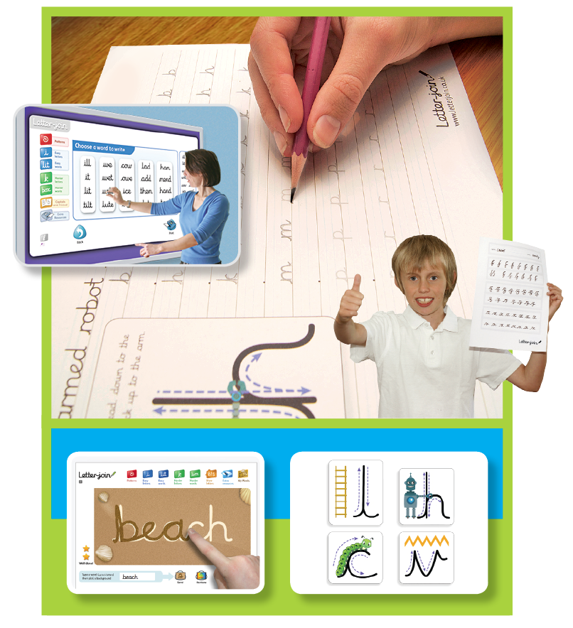

Handwriting Policy

Here at Elmvale Primary we are very proud of our pupil’s handwriting and take particular care in our cursive/joined-up handwriting style. We use Letter-join as the basis of our handwriting policy along with other cursive handwriting resources. The log in details for Letter-join are on Our Establishment for each stage.

Handwriting is a basic skill that influences the quality of work throughout the curriculum. At the end of Primary 7 most pupils should have the ability to produce fluent, legible and, eventually, speedy joined-up handwriting, and to understand the different forms of handwriting used for different purposes.

We aim to make handwriting an automatic process that does not interfere with creative and mental thinking.



Handwriting frequency

Handwriting is a cross-curriculum task and will be taken into consideration during all lessons. Formal teaching of handwriting is to be carried out regularly and systematically to embed the skills.

PRIMARY 1

Focus will be on developing letter formation.

* Movements to enhance gross motor skills such as air-writing, pattern making, dancing.
* Exercises to develop fine motor skills such as making marks on paper, whiteboards, blackboards, sand trays, threading, using tweezers and scissors. There should be daily opportunities to develop fine motor skills through play.
* Letter learning to familiarise letter shapes, formation and vocabulary.
* From Term 3 onwards, there should be one formal handwriting lesson per week.

Primary 2

* Gross and fine motor skills exercises daily through play.
* Letter formation should be reinforced during phonics lessons.
* From Term 1, there should be one formal handwriting lesson per week.
* Numerals, capitals and printed letters: where and when to use.

Primary 3

* Pre-cursive letter formation should be introduced at the start of P3.
* When the children know the formation of all the letters, they can be encouraged to join letters together. This should be at the teacher’s discretion.
* One 30 minute handwriting lesson per week. Daily opportunities to reinforce letter formation, for example, during Smart Start or straight after lunch.

Primary 4 - 7

* More advanced handwriting techniques will be taught.
* Cursive handwriting re-enforcement.
* Dictation exercises to teach the need for quick notes and speedy handwriting writing.
* One 30 minute handwriting lesson per week. Daily opportunities to reinforce letter formation, for example, during Smart Start or straight after lunch.

School aims  
We aim for our pupils to develop a neat, legible, speedy handwriting style using continuous cursive letters that leads to producing letters and words automatically in independent writing.

By the end of Primary 5 pupils will understand the importance of neat presentation and the need for different letterforms (cursive, printed or capital letters) to help communicate meaning clearly.

Method  
P1 and P2 teachers should model non cursive letter formation and teachers from P3-P7 are encouraged to use neat, joined-up cursive writing for all handwriting tasks including report writing (when not word-processed), marking and comments. When possible, teachers from P3-P7should include cursive font or writing on their wall displays.

*Consistency throughout the school*   
Pupils should experience coherence and continuity in the learning and teaching of handwriting across all school years and be encouraged to take pride in the presentation of their work. Our aim is to help pupils enjoy learning and developing their handwriting with a sense of achievement and pride.

Correct posture and pencil grip for handwriting

Pupils should be taught to sit correctly at a table, holding a pencil comfortably and correctly.

Sitting position

Paper position for right-handed children



Pull the chair close in to the table

Keep feet flat on the floor

Sit right back in the seat

The table reaches to below elbow height

Sit with a straight back, not leaning over the page

The tripod pencil grip

Both right and left handed children should be encouraged to use the tripod grip which allows the pen/pencil to be held securely whilst allowing controlled movements of the pen/pencil nib.

1) Grip the pencil with your index finger and thumb with the nib pointing away.

2) With your free hand, spin the pencil from underneath.

3) Use your middle finger to support the underside of the pencil.



Left-handed children

Left-handed children may find it difficult to follow right-handed teachers as they demonstrate letter formation (and vice versa). Teachers should demonstrate to left-handers on an individual or group basis.



Paper position for left-handed children

* Left-handed pupils should sit to the left of a right-handed child so that they are not competing for space.
* Pupils should position the paper/book to their left side and slanted, as shown.
* Pencils should not be held too close to the point as this can interrupt pupils’ line of   
  vision.
* Extra practice with left-to-right exercises   
  may be necessary before pupils write   
  left-to-right automatically.

Pens and pencils

Children are encouraged to start handwriting using a soft pencil. When fine motor skills have been established a handwriting pen can be used. More competent pupils can use a ballpoint pen.