Primary News

Dear Parents/Carers
Happy New Year and welcome back! I hope that you all have had a great Christmas break.

Holidays
Monday 15th - 16th & 17 February inservice day.
Reopen 18th February 9am for school and 8.35am for nursery

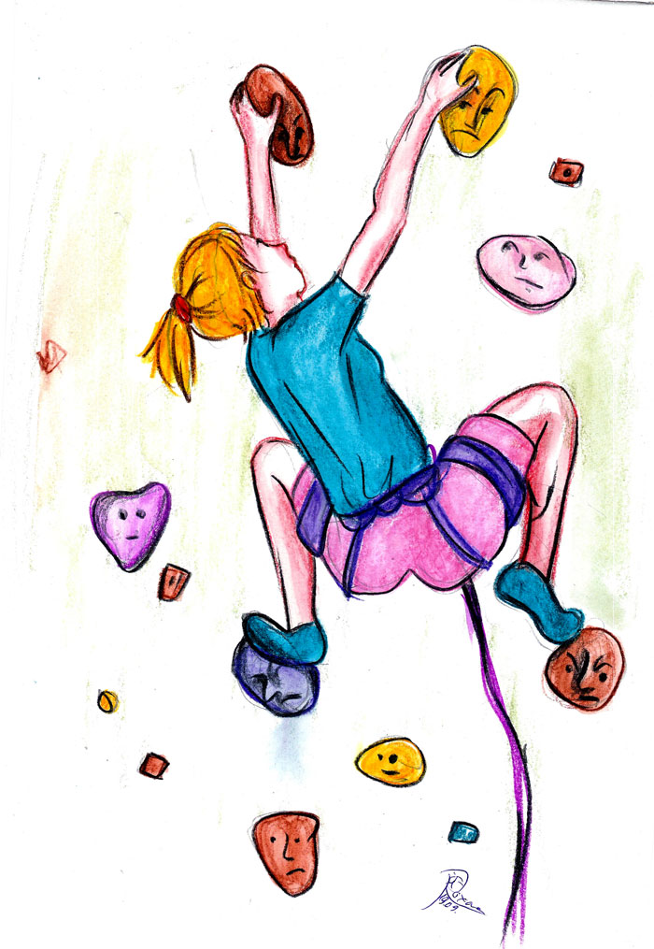
Events
Last week our 24 Primary 7 children had a fantastic experience at Ardentinny Outdoor centre where they experienced gorge walking, climbing, team challenge, abseiling, rock hopping. I hope that you followed them on Twitter.
This week Primary5 visited the science centre where they learned about trout and their eggs.
22 January Primary 7 go to Scotland St Museum

25 January Burns Day. Many of our classes will be celebrating this at assembly. Children can wear something tartan on this day or school uniform as usual.
26 January Caledonian University will be working with all of our Primary 5 children.

The Elmvale Elite Dance Group have made it through to the finals in June. Well done!
Assemblies
We will soon be inviting any available parents to their child’s class assemblies where they will get an idea about the work being carried out in their class.


School Show
Mr Feist and Mrs Higgins along with several other staff and our Parent Council will be working hard to produce the first school show for many years – Alice in Wonderland.
The performance will take place in the evening of Tuesday 17th May.

Staff Changes
Miss McIntyre, Mrs Etherington & Miss Gray will be leaving and they will be replaced by Miss Park and Miss Holmes.
Our new Depute Head Teacher – Mr Allan Fleming – will begin on Monday 1st February. We would like to thank Ms Kytzia for all of her hard work in both the school and the nursery. Ms Kytzia will take over the teaching of Mrs Etherington’s class.
Primary 1 2016-17
It was lovely to meet the parents of our new primary ones for next year. I look forward to seeing them all again at our induction meetings in May/June

Playground snacks
Please remember that coke, lucozade or any fizzy drink / drink with a high caffeine /sugar content eg high energy drinks are not allowed in school. Please remember to send them with fruit or some other suitably healthy snack.
Head Lice
Please check your child’s head every day.
Grant and the Primary Team


Nursery News
Dear Parents/Carers
Happy New Year to you all and I hope that you have had a great Christmas break.
Vision Screening
Most of the pre-school children had their eyes tested when the Orthoptist visited the nursery on 11/1/16. If your child required further assessment you would have

Football
We have been selected to take part in football coaching which I’m sure all of the children will enjoy. This takes place every Friday for the next 4 weeks.
Students
Recently we said ‘goodbye’ to our student, Katrina who has moved to another nursery and we welcome Charlene who will train with us every Monday and Tuesday until June. We look forward to all the exciting activities she will be providing for the children.
Leader of Learning
We welcome Kathy, one of the Leaders of Learning who will be coming to support us every Monday. She takes over from Janice Gall who retired in December. We wish her a long and happy retirement.

Parent Consultation
It was lovely to see our parents enjoying looking through their children’s learning logs. We appreciate all the lovely comments you made. If you missed this opportunity please speak to your child’s keyworker and arrange a suitable time to have a look.

Children’s Learning
The children have been telling us all about the toys they received at Christmas. As this is their current interest we have decided to incorporate this into our planned learning experiences. Our focus is Toys and we will be finding out as much as we can about how things work, what makes it go, does it need batteries etc. The children will be creating lovely art work and acting out being a range of different toys. We will also be celebrating Chinese New Year and Burns Day.

Rhyme of the month
Our rhyme for this month is ‘Let Glasgow Flourish’
Here is the bird that never flew
Here is the tree that never grew
Here is the bell that never rang
Here is the fish that never swam
LET GLASGOW FOURISH!

You can help your child to learn this rhyme at home. You will be surprised how quickly they pick it up Please remember you are always welcome to have a look at our Area Books and your child’s Learning Log as these will show you all the things the children have been learning about in nursery.
Contact Numbers
Please keep us up to date if you or your emergency contacts change your telephone numbers as we need to be able to contact you quickly in case of emergency
Grant and the Nursery Team

