Learning and Teaching Policy

Elmvale Primary
Learning and Teaching is at the heart of the curriculum in Elmvale. We now know much more about how children learn and it’s imperative that we all understand that HOW we teach is as important as WHAT we teach. Elmvale strives to capitalise on ‘what we do well already’ and how we can improve and be more creative in our learning and teaching.
In Elmvale, all children are supported to become leaders of their own learning, either individually or in groups. When they are independent learners, they take responsibility, and are more intrinsically motivated to succeed and deep learning is more likely to take place.
In Elmvale we take into account:
- The child’s background and early experiences.
- The importance of a nurturing approach and health and wellbeing providing the foundations to all other curriculum areas.
- Research and knowledge developed on multiple intelligences, how the brain works, gender in education, learning style preferences and higher order thinking skills.
All staff in Elmvale are committed to lifelong learning as professionals. All staff are continuing to develop approaches to ensure Teaching for Effective Learning and Experiences and Outcomes as outlined in CfE guidance. This document contains information to ensure high expectations are met in Elmvale:
- Appendix 1 - Glasgow Guidance and ‘Accelerated learning/ good lesson’ cycle.
- Appendix 2 - self evaluation/success criteria document
- Teaching for Effective Learning Information (www.goglasgow.org.uk/pages/show/956)
- Active Learning in a Context – See CfE Building the Curriculum 2
- See Appendix 3 - Higher Order Thinking Skills
- See Appendix 4 - Interdisciplinary Approaches
We will continue to focus on the key business of improving learning experiences and pedagogy.

ELMVALE GOOD LESSON
The Journey to Excellence, HGIOS and HIGIOELC quality indicators and Building the Ambition will be used to stimulate reflection, self- evaluation and planning.

Appendix 1 – Learning and Teaching Approaches in Elmvale
- This appendix is taken from Glasgow Online document: ‘Learning and Teaching Strategy: Building on Success, Aiming for Excellence.’ Pages 7-12
Looks like this:

Learning and teaching approaches should be:
- Focused on the learner
- Well-planned, considering outcomes, learners’ interests and prior knowledge
- Enjoyable, relevant and inclusive – enhancing the experience, achievement
and attainment of our most vulnerable children and young people
- Active and fun, allowing young people to solve problems in a supportive and
stimulating atmosphere
- Flexible and creative, allowing for personalisation of learning
- Allow for breadth, challenge and application of learning
- Based on up to date educational research
- Collaborative and co-operative, promoting quality social interaction between
children and young people.

When promoting TfEL in the classroom, a variety of key aspects need to be
considered:
- Contextualised learning that is active, collaborative and cognitive
- Good Learning (Glasgow’s model of accelerated learning)
- The learning climate
- A variety of learning approaches
- Thinking routines
- Technologies and the learning to learn toolkit.

Good learning has been developed to help staff deliver lessons that take account of
the ‘big’ messages required for effective learning and teaching.

www.goglasgow.org.uk/Pages/Show/56

Within this framework are the five components of the accelerated learning cycle:

1. Connect the Learning
2. Learning intentions and success criteria
Connect the Learning
3. Active Learning
4. Demonstrate Understanding
5. Review and Recall.
Review & Recall
Learning Intentions & Success Criteria

Demonstrate Understanding
Active Learning

Appendix 2 –

Learning and Teaching Expectations for all Staff, How Good is My Lesson
Classroom Climate | - Learning is well paced and matches learners’ needs so that they are engaged and on-task  - Praise is used frequently but discriminatingly  - We do not rely too much on rewards and sanctions  - Children have the opportunity to work together and discuss their learning  - Learners use appropriate noise levels for differing activities  - Children take responsibility for their own learning and to work independently  - Classroom displays show a good balance between teaching aids and current children’s work with learning intention included on the display  - Our classroom provides an orderly learning environment  - There are clear expectations and procedures for the presentation of work and the use of resources  - Lessons are enjoyable experiences’  - We have a good knowledge of the school arrangements to support vulnerable children (Read transition notes thoroughly as well as pastoral notes etc) | 2.1  2.3  2.4
Connect the Learning | - When introducing a new learning theme/topic we actively involve learners in establishing their prior knowledge  - We help learners to see the relevance of what they are learning and how it connects to other subjects  - We use stimulating and interesting contexts that make learners curious and interested | 2.2  2.3  3.2
Share Learning Outcomes and Success Criteria | - We display the Learning Outcomes and Success Criteria for lessons  - Success criteria indicate what learners have to do to be successful in their learning. It should focus on skills and learning.  Language to be used –  We are learning to be able to…..  The Learning Intention or the heading should be written by the children on their work.  The learning intention should be shared, displayed and visible throughout the lesson.  Success Criteria should be differentiated in Literacy, Maths/Numeracy and IDL – There should be sufficient support and challenge for children.  Success Criteria examples I can, I could, I should, I must etc Infants only use ‘I can..’ | 2.3
Learners are actively involved in their learning | - Our explanations and directions are clear  - We do not talk for too long at start of lessons – take account of guidance in (appendix 5)  - Children get actively involved at an early stage of the lessons  - We take account of learning styles and vary classroom activities  - Classroom activities suit the age group  - Our tasks are differentiated to meet the needs of learners  - We take account of WAPS  - We make good use of other adults to support children’s learning. Support staff are actively involved in supporting individuals/groups in their learning.  - Our questioning allows children time to think about their answers  - Our questioning probes thinking  - We do not step in too soon and let children think for themselves  - We make good judgments about when and how to intervene with individuals or group  - Learners work collaboratively in pairs or small groups  - We teach the skills required for collaborative working  - Learners take on team roles when working together  - When we recognise levels of concentration are flagging we switch tasks or use ‘brain breaks’ to refresh learners  - We ‘chunk –down’- the lesson into manageable tasks  - Adults and children use Smartboards  - We use a range of ICT activities to support learning | 2.2  2.3  2.4
Demonstrate learning | - We use a variety of approaches to let young people demonstrate their understanding and do not rely solely on written responses  - Our questioning encourages discussion with children about their thinking  - We teach thinking routines that allow children to make their thinking visible  - Children are encouraged to think for themselves, ask questions and express views  - We let children present their learning to others  - Children explain their learning to each other and/or the teacher  - Children know how to improve their work  - We give oral feedback to learners during lessons  - We try to correct work with children as part of the lesson  - Children do not spend time over-practising skills they had already overtaken  - Children use self-and peer assessment | 2.2  2.3  2.4
Review and recall | - We can draw learning together in a short plenary at the end of the lesson and during mini plenaries throughout the lesson.  - Every child should have the opportunity to demonstrate their learning.  - We recap the main ideas/key knowledge from lesson  - We get learners to evaluate their performance against Learning Outcomes  - We get children to identify individual/class next steps | 2.3  2.4

Appendix 3 – Higher Order Thinking Skills (HOTS)
In Improving Scottish Education 2005-2008, HMIE states:
“Curriculum for Excellence sets high expectations of rigour. This means that teachers should plan consistently for appropriate pace, challenge, depth and progression, and consciously promote the development of high order thinking skills.”
There are resources in Glasgow Online designed specifically for teachers to use to promote higher order thinking. Question fans and interactive whiteboard templates are easily adapted to meet learner needs. Examples for HOTS plenaries provide opportunities for children and young people to reflect and assess their learning experiences in order to set future targets.
All staff are expected to be familiar with ‘HOTS’:
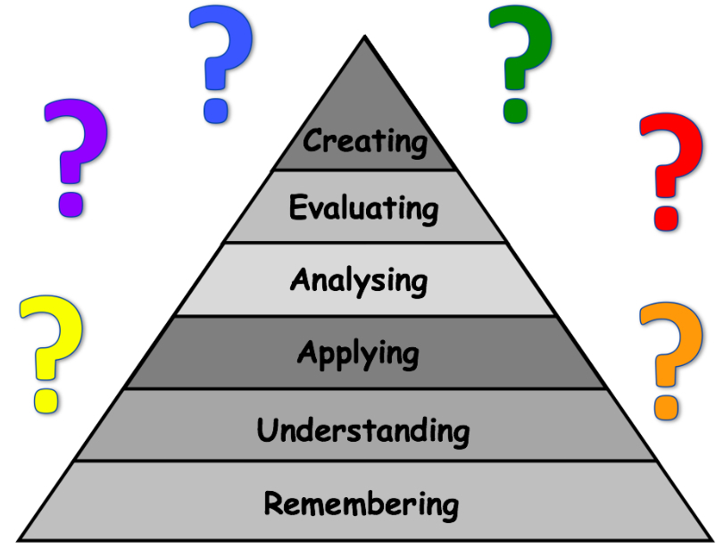
Learning  Skill | Words you might hear or use when thinking and talking about this skill
Remembering | list, memorise, choose, recite, quote, record, match, select, underline, cite, relate, sort, show, locate, give an example, reproduce, quote, repeat, label, recall, outline
Understanding | report, recognise, review, describe, observe, outline, interpret, explain, identify, discuss, research, annotate, translate, give examples, define
Applying | translate, illustrate, make, practise, manipulate, calculate, apply, operate, exhibit, interpret, interview, sequence, show, solve, collect, demonstrate, dramatise, use, adapt, draw, construct
Analysing | distinguish, inspect, inquire, question, examine, research, probe, investigate, calculate, experiment, compare, contrast, survey, test, debate, sequence, relate, categorise, discriminate
Evaluating | judge, predict, assess, determine, prioritise, experiment, check, test, evaluate, defend, conclude, debate, justify, recommend, discriminate, argue, rank
Creating | compose, assemble, organise, invent, compile, forecast, devise, propose, construct, plan, predict, improve, formulate, generate, prepare, develop, design,  imagine, set up, create, produce

Appendix 4 - Interdisciplinary Approaches

What is Interdisciplinary learning (IDL)?
“Effective interdisciplinary learning:
  - can take the form of individual one-off projects or longer courses of study
  - is planned around clear purposes
  - is based upon experiences and outcomes drawn from different curriculum areas or subjects within them
  - ensures progression in skills and in knowledge and understanding
  - can provide opportunities for mixed stage learning which is interest based.”
(BtC3 pg 11)
Please read CfE briefing paper on IDL at: http://www.educationscotland.gov.uk/Images/IDLBriefing_tcm4-732285.pdf

The benefits of well planned and delivered IDL:
- Interdisciplinary learning, based upon groupings of experiences and outcomes from within and across curriculum areas can provide relevant, challenging and enjoyable learning experiences and stimulating contexts to meet the varied needs of children.
- Revisiting a concept or skill from different perspectives deepens understanding, and can also make the curriculum more coherent and meaningful from the learner’s point of view, for example through answering big questions, exploring an issue, solving problems or completing a final project
- Interdisciplinary learning can also take advantage of opportunities to work with partners who are able to offer and support enriched learning experiences and opportunities for young people’s wider involvement in society.

Outdoor learning and IDL
Many experiences and outcomes can be developed through outdoor learning and the use of the wider community. The outdoors can provide challenge and enjoyment, additional health benefits and importantly, can sometimes provide more connected and meaningful experiences than the classroom environment.
In Elmvale, Outdoor Learning (OL) Should occur Daily/weekly to connect learning (these should be planned experiences to ensure breadth, depth and progression). Education Scotland provides information on OL. There are OL resources in Elmvale at the infant door for the use of all staff. (Natural materials, sit mats, resource books for staff)

Themes which provide meaningful and relevant experiences to consider and use in Elmvale:
Enterprise, Citizenship, Sustainable Development, International Education, Creativity

Expectations in Elmvale
In Elmvale, staff must consider IDL across all curriculum areas. Meaningful links and exciting contexts should be sought in literacy, numeracy and health and well-being, as well as other curriculum areas, so that skills are applied in new situations and developed progressively. This may be:
- topic themes lasting a planning block (e.g. Dragon’s Den Enterprise)
- contextualised learning in specific subjects (e.g. Consecutive space themed maths lessons)
- planned IDL stand-alone lessons (e.g. writing a report for science).
Staff must find out about children’s prior learning, themes and topics from previous years (from children/colleagues). Staff should use formative/summative assessment techniques to ensure progression of skills and knowledge. *See assessment guidance.
Staff should use the topic overview grid detailed in the forward plan guidance to ensure breadth, depth and coherence. Consider interests and current events in order to ensure coverage of experiences and outcomes through meaningful and relevant topics. Staff should consider learning intentions first and plan contexts to meet these, (not as in the past topic first and what learning fits around it).

Appendix 5

Time on Task
One of the major criticisms by HMIE is that learners do not get to tasks quickly enough. Time when pupils are involved in tasks should form the bulk of the lesson.
Do not talk for too long at the beginning of a lesson (10/15 mins)
- Make the connecting activity focused, active and brief
  - Eg Think, Pair and Share to recap previous lesson or brainstorm prior knowledge;
- Set out the Learning Outcomes
- Focus Direct Teaching on essential teaching points
  - Teacher talk (to the point and timed)
  - Video
  - Picture
  - Question and Answer
  - Demonstration/Modelling

Get the pupils working on tasks (30+ mins)
- Share the timing of the lesson with learners.
“Are we all clear about the pace of working during this lesson? You will be working as a class with me for 15 minutes and then breaking into pairs to carry out the planning task. You have 15 minutes for this. You should be ready to start working on your own draft at around 9.45. Aim to finish this by10.10 and take 5 minutes to look over your work before we come back together as a class at 10.15 to go over what we have learned.
Keep an eye on the clock/timer and stick to the times. If you get stuck or slowed down let me know”
- A classroom clock is essential. For younger children use timers or put coloured stickers with flashcards around clock

- Make sure everyone understands what they have to do
- Use thumbs or traffic lights to check
- Have a system that allows learners to indicate how they are getting on (especially a signal to show they are stuck)
  - red traffic light circle on desk or similar is better than hand up in air for minutes waiting for teacher
- ‘Work the classroom’ as pupils carry out tasks, intervening as appropriate ( ‘Butt out’ if students are engaged and doing OK)

Finish the lesson with a recall and review of what has been taught and identify next steps/connect to next lesson (10mins)

