Dear Parents/Carers

Fortunately restrictions are easing just in time for Spring, the lighter nights and the better weather. We are more able to admit visitors inside the school building which meant at least 5 authors came to Elmvale for Literacy week. Masks are still expected to be worn when walking between rooms in the building.

Holidays
Saturday 2 April – Monday 18 April
Our school will close at 2.30pm on Friday 1 and will reopen on Tuesday 19 April
2 May holiday
5May holiday – inservice day for staff
27 May holiday
2-3 June Queen’s Jubilee
1pm 24 June – 16 August Summer holiday, children return on 17 August

Events / Dates
March

28 -4 Literacy week with lots of activities & author visits. Children can dress as their favourite book character or dress a potato as their favourite character.
4 P6 released fish into the River Cart
9 P7 & 7/6 Science Centre
24 Football Springburn Park
25 Spelling Bee
31st Easter Creative Bonnet and Egg competition
April
1 Youtube Spring Songs

International Spelling Bee
Luca P4 came second and Eva P3 came first – Well done!!

P6
This class looked after brown trout at early stages of their life cycle in a hatchery through the Clyde in the Classroom program. They were very responsible and motivated in looking after them, checked the water temperature etc.

They are also helping with nursery transitions and take part in Peer Mediation every playtime/lunchtime.
Pedestrian Zone
Thank you to most parents who continue to avoid using Fernbank Elmvale Streets outside the school walls at drop off and home time. You are all helping to keep our children safe.
P7 & P7/6
Rangers coaches have been working from the 21st March for their sense over sectarianism focus.
These classes are running a competition for p4-7s to design Elmvale’s new football strip.
They attended Glasgow Film Theatre as part of Glasgow Film Festival on the 8th of February.
The winners of the sweets in a jar were Jwana from P3H and Michael P1F. P7s have raised just over £100 towards their leavers’ celebration.

Head Lice
Don’t forget to regularly check your child’s as wherever children play together this often happens.

Reminder
Please remember that no toys should be brought to school as they could get lost/damaged.
Children are allowed access to water during lessons but not juice.Twitter
Please check this regularly for updates on events in school @ElmvalePrimary

Grant & The Primary Team
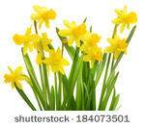
Nursery News
Dear Parents / Carers,
A special welcome to our new children and their parents, they have settled in very well in the Nursery Class. We look forward to working in partnership with you over the next few months to help all children in Elmvale Nursery Class achieve their potential.

A huge thank you to all who supported us through the last few weeks when we had many staff absences. I know most of our children were unable to attend nursery due to this and we’re grateful for your support.
Outdoor learning
Outdoor Learning at Elmvale Nursery Class is important to us and is currently still the safest place for our children and staff to be. All our children are outdoors during part of their session so it is very important that you dress your child according to the weather. The temperature is going up so it is important that your child has sun cream on before they come to nursery.

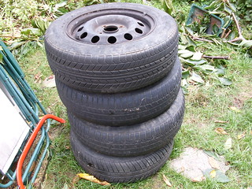
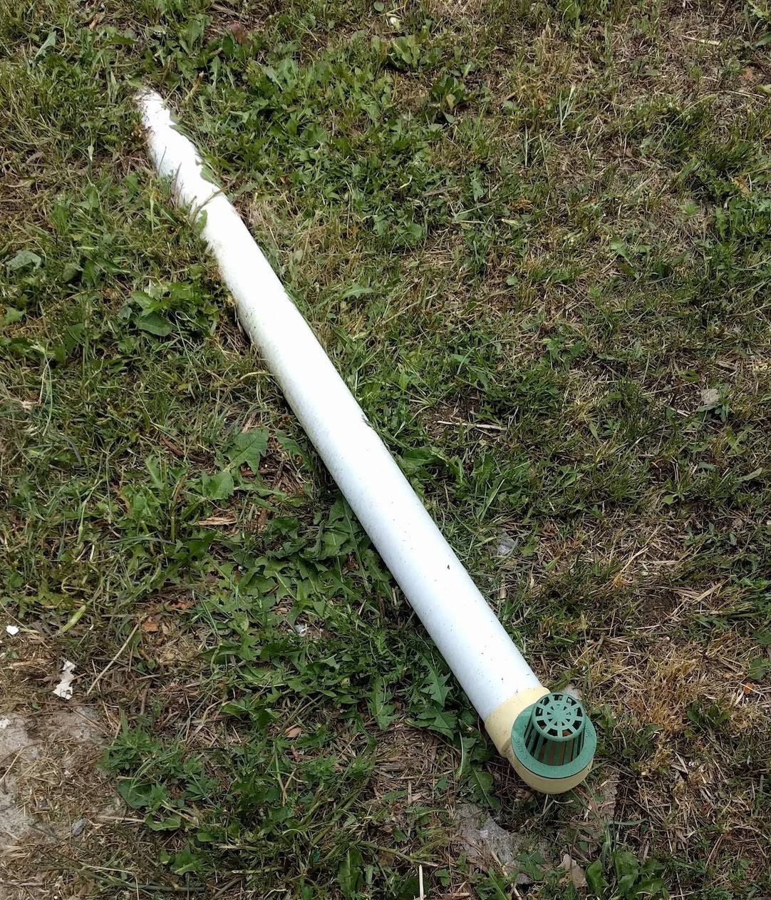
A large amount of money has been spent creating a fun and safe learning environment for our children using natural materials. We have a mud kitchen and lots of different building materials that the children can use and explore. We have recently received funding that has been used to purchase natural outdoor materials and resources for the children to use, but we are always looking for more.
If anyone knows someone who works in environments that would kindly donate materials eg guttering, crates, cable reels, tyres, we would be delighted to accept.
Changes of clothing
Please provide your child with a range of spare clothing to be kept in nursery. Over the last few weeks we have had to call parents/carers and remind them to replace them if your child has had to use their current ones that have been provided. We are still currently not able to provide changes of clothing to children from our nursery selection under covid-19 restrictions. There are no available spares in case of emergency. Your child can get wet from having toilet accidents or spilling milk/water during their snack time or get wet from the water tray.
Cash for Kids Grant
We were fortunate when we applied for Cash for Kids funding and was accepted. We have purchased a variety of food supplies and every child in the nursery will receive a food parcel to take home. This has been a lengthy process in the purchase and delivery of these items and we will get them out to you all as soon as possible.

Easter party
Our Easter party will be on Thursday 31st March during your child’s nursery session.
The nursery will close on Friday 1st April at 2.30pm and reopen on Tuesday 19th April. We hope you have a lovely Spring break and Easter.

Many Thanks
Julieann McHugh

