

Primary News

Dear Parents/Carers

It is great to be back to normality with no Covid restrictions or interruptions to learning.
Our teachers are working very hard to make sure that our children continue to be ‘The Best We Can Be’.

Our focus in school improvement this year will be –
Nurture
Effective Interdisciplinary Learning
Assessment is for Learning
Improvements in these areas will have a direct improvement on all our children’s attainment.

You may have noticed that at 9am, our children no longer stand in a line. This means they can get to their classrooms quicker and drier (if it is raining). We plan to try this for interval, after the October week holiday.
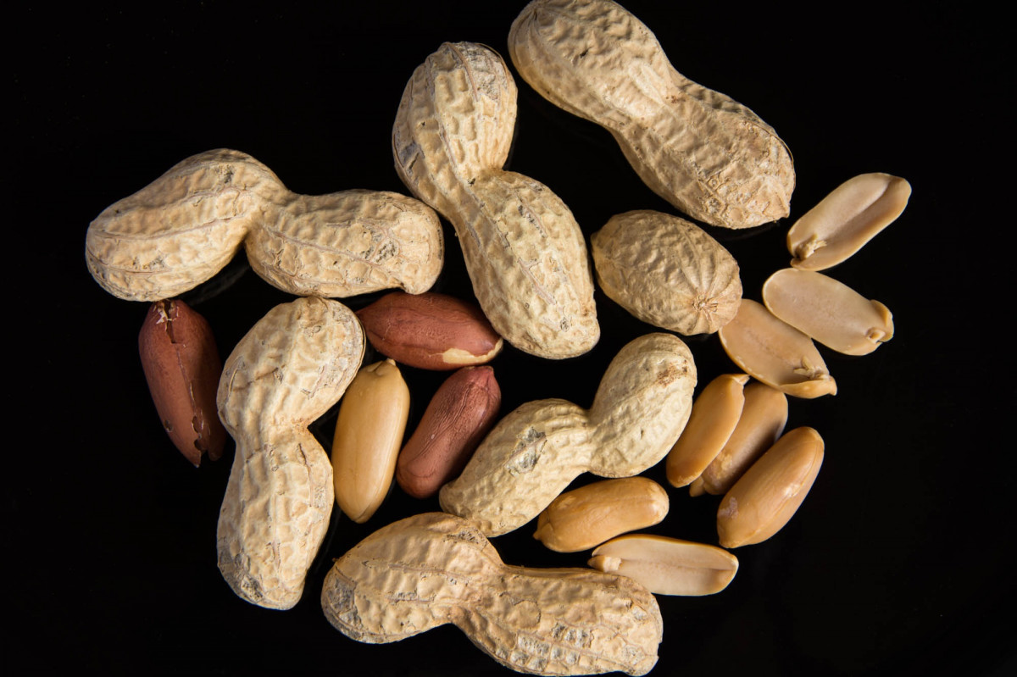
Nuts – Nut free due to severe allergies in our school community (including snacks / packed lunches which contain nuts) There should be no Kinder Bueno, Snickers, Nutella at any time.
Children should have no more than a drink (no fizzy or energy drinks allowed) and one snack for playtime.

We are delighted to announce that Ms McFetridge had a baby boy!

P7 had a very successful enterprise fair. Thank you to all the P7 parents who came along and supported it – they managed to raise £760 which will go towards paying for the P7 Leavers’ Celebration.
Springburn Park Youth Forum worked with our P7s to discuss improvements they would like to see in their local park.

P7 have worked very hard on their setting and character writing this term. Their skills and confidence are both improving and they have produced some excellent pieces of work. We are very proud of their achievements.

P5-7 have already had their first football match at Springburn Park with the P7&P6 team winning every game.
The P7 girls team match was cancelled due to bad weather.

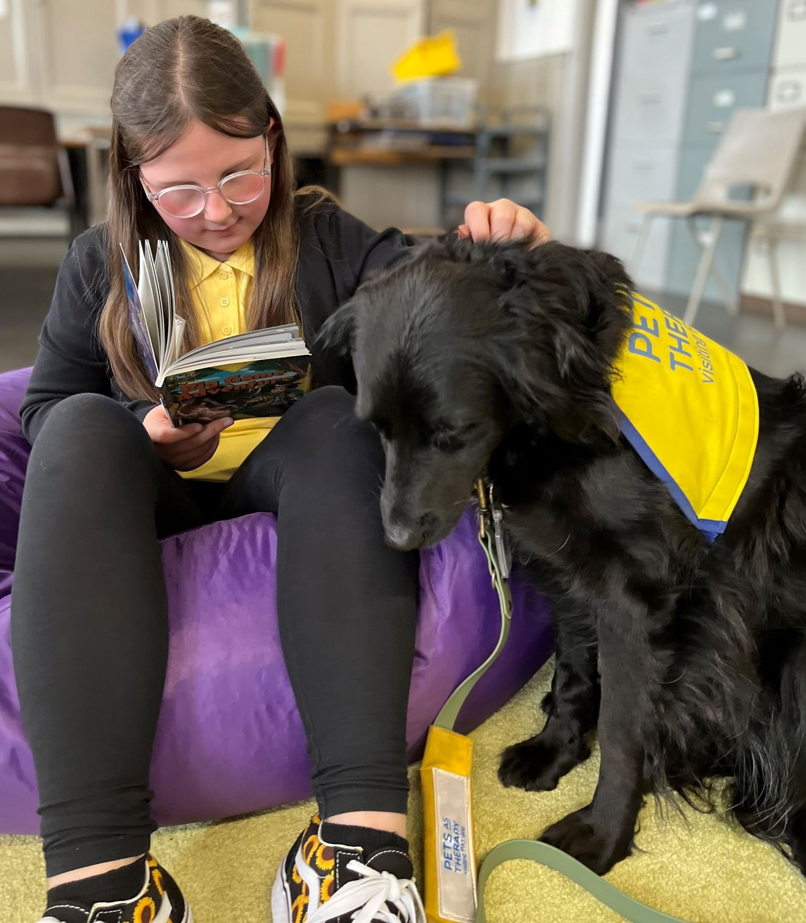
Onyx is our Pet Therapy dog who has been working with the P6 class both this year and last. Many of them love reading to Onyx and their reading skills have significantly improved as a result.

Events
October
10-13 Photographer
26 Flu vaccine
28 Halloween Parade
November
22, 24 Parents’ Night
Holidays
14 October is an inservice day
17-21 October Week
Grant and the Primary Team
Nursery News
Dear Parents/Carers
It is an absolute pleasure to welcome our new and returning children back into the nursery for what I am sure will be a fantastic year/session 2022-2023. We look forward to working in partnership with all our parents and families to ensure your children receive the best possible care.

I would like to draw your attention to staff who are part of your children’s learning journey.

Michelle– Acting Team Leader
Clare – Lead Practitioner of Attainment
Norma – Child Development Officer - red group
Lesley- Child development officer – blue group
Erin – Child development officer – yellow group
George – Child development officer – green group

Our Planning focus of the month includes:

The book of the month is
Car, Car, Truck, Jeep.



Rhyme of the month is
Jack and Jill
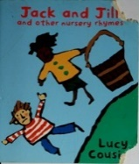


During this plan staff will focus on developing your child’s ability to:

Make new friends, participating in energetic play to develop their movement skills.
Learn about counting and the size of different item’s and objects, building on their numeracy skills.
Learning to listen and take turns, an essential skill for all our children.


Outdoor Play
Please be aware that all children will be accessing the outside area on a daily basis. It is important that all children have the essential outdoor clothes these are:
Jacket Gloves Scarves Hats Wellie Boots.

Could you please also provide spare clothes especially socks as they often get wet when outside.
We ask for all children to leave a pair of indoor shoes in the nursery.

Outdoor plays supports a healthy and active lifestyle offering freedom and movement whilst promoting a sense of wellbeing.


This Photo by Unknown Author is licensed under CC BY-NC

Twitter
Please follow your children’s learning that will be posted daily on twitter @Elmvale Primary & Nursery.

HOME LINKS
Clare our Lead Practitioner of Attainment has provided our children with an activity to do as a family and instructions can be found on the bag provided.
Can I ask if you can please send any pictures of you and your children taking part to our twitter account @Elmvale Primary & Nursery.


Polite reminder


Can parents please ensure they telephone
0141 558-5238 if your child is going to be absent for any reason or if they will be attending any
appointments.

Dates to remember
Diwali – 24th October
October Inservice- 14 October
October week- 17th-21st October
Halloween – 28th October
(details to follow)
Parents Night- Tuesday 22nd November and Thursday 24th
Christmas Holidays -
Thursday 22 December 2.30pm
Until
Tuesday 3rd January


We appreciate your continued support in paying toy fund especially under the current climate. This allows children to enjoy extra experiences and resources.

If you have any further questions please don’t hesitate to contact us on
0141 558-5238
Or
headteacher@elmvale-pri.glasgow.sch.uk

