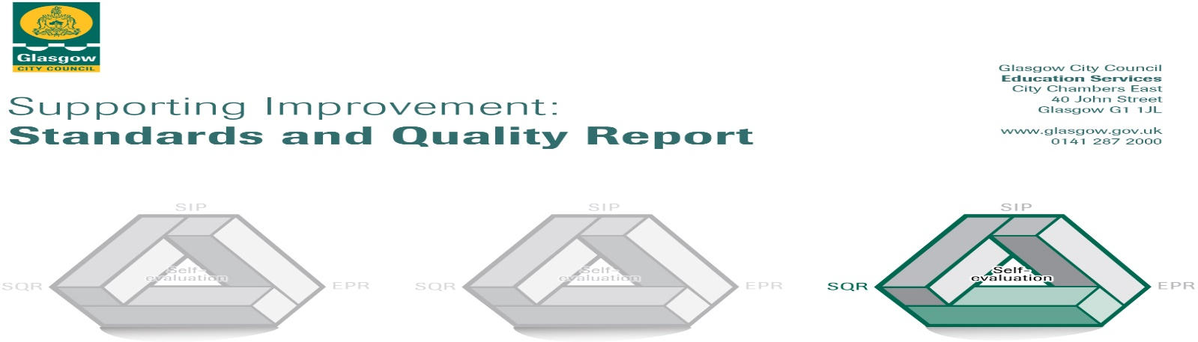

The summary report is provided for parents/careers and partners to outline our achievements this session and our priorities for next session. Throughout this session we have taken forward our priorities as detailed in our school improvement plan. Through our processes of self-evaluation, we have identified how we can improve outcomes for our children and young people.

Our achievements and improvements this year.
We would like to highlight the following improvements/achievements:

- Key developments
Our school values of Teamwork, Responsibility, Kindness, Determination & Respect are very much understood by our children. All children know their Houses and do their best to live these values to earn House Points.
PATHs is being used consistently across the whole school which is helping children with their emotions. There are daily check-ins for emotional wellbeing and thoughts and feelings are regularly discussed in class. Overall behaviour across the school has significantly improved.
All staff are using assessment information more thoroughly enabling them to intervene to assist children’s learning more effectively.
Children are able to take part in a wide range of activities. There are numerous after school clubs and lunchtime clubs. The Health and Wellbeing coordinator ensures that all children are being targeted and have the opportunity to attend a club.

- Developments in learning and teaching and assessment
Staff have had many opportunities to discuss the levels of progress of their children with one another in writing which helped them to agree on standards of work . Many staff have received additional training in helping children to improve their strategies for reading and writing. There have been excellent results and improvement in spelling and children’s confidence has improved in writing. Reading strategies are also now fully implemented and being used consistently throughout the school.
Read, Write Count sessions with parents took place and gave children an opportunity to demonstrate to parents how to effectively use the bags and the activities within them.
. As a result most children are making appropriate progress for their age.
Play based learning is embedded in P1 & P2. This is helping our children to develop their vocabulary as well as their knowledge and understanding.
All of our children have benefitted from a wide variety of educational trips, residential experience for P7 and outdoor activities. The Amazing Loose Ship (container in playground) is providing investigation, creativity, teamwork experiences and the children love it!

- Progress in promoting well-being equality and inclusion
Barnardos is working very well for our school and Vicky has built up strong relationships with some of the parents which has had a positive impact on attendance and children’s progress.
The Nurture Class work with a few children and PATHS assist our children with regulating their emotions. They all support our children’s mental wellbeing enabling them to access the curriculum more readily.
There were many more after school clubs this year covering a wide variety of interests.
Children who have significant additional support needs have regular review meetings with parents and carers to allow those supporting the children to share their views and agree on supports
There have been an increased number of leadership opportunities for our children – House Captains, Digital Leaders etc.
Nursery to P1, P7 – S1, enhanced transitions and children with ASD transitions very effective
Caledonian University work closely with us in Nursery, P2, P5,
Language Communication Friendly Establishment moving towards accreditation.
Seesaw is up and running and being used highly effectively during the COVID19 pandemic. This has been a huge success.
All teachers are using sumdog and children are joining in at home and with competitions set.

- Progress in children’s learning /raising attainment and recognising achievement

Introducing reading interventions such as Reading Wise, Getting Started and 5 minute Box are having a positive impact on raising attainment in Literacy. All classes regularly visit the library.
Nursery Literacy interventions are making a positive impact on childrens understanding of phonics and rhyme.
Improved consistency in helping children with their learning is leading to improved progress across the curriculum

Here is what we plan to improve next year.
Staff will continue to support children develop effective reading, writing and numeracy strategies to support them with their learning.
There will be continued opportunities to develop effective use of digital learning.
Implementation of ‘Developing the Young Workforce’

How can you find out more information about our school?
Please contact us directly if you require further information or if you wish to comment on the report.

The contact e-mail address is: Headteacher@elmvale-pri.glasgow.sch.uk

Our telephone number is: 0141 558 5238

Our school address is: Elmvale Primary School, 712 Hawthorn Street, Springburn Glasgow G22 6ED

Further information is available in: newsletters, the school website http://www.elmvale-pri.glasgow.sch.uk/ , and the school handbook

