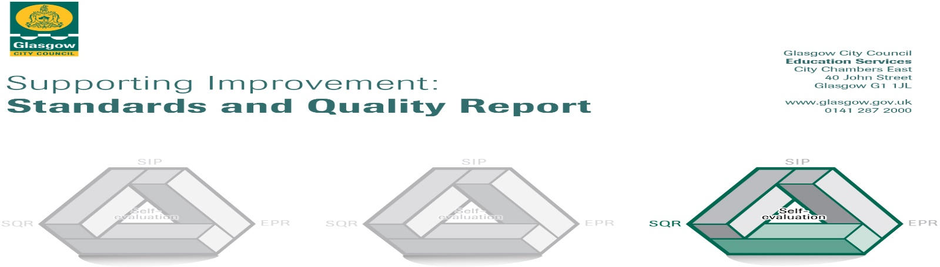

The summary report is provided for parents/careers and partners to outline our achievements this session and our priorities for next session. Throughout this session we have taken forward our priorities as detailed in our school improvement plan. Through our processes of self-evaluation, we have identified how we can improve outcomes for our children and young people.

Our achievements and improvements this year.
We would like to highlight the following improvements/achievements:

Nurture is embedded within the school and there are a variety of effective positive behaviour strategies in place.
Some children supported by school counsellor effectively with their mental well being.
A few Support For Learning Workers deliver targeted Health & Well Being, Literacy & Numeracy interventions leading to improved progress in these areas.
A few children effectively supported to develop resilience and confidence to work with others through Science Technology Engineering Maths lunchtime clubs.
Almost all children showing improvement in Literacy, Numeracy & Maths.
73% of P7s attended a week long free outdoor education residential centre experience.
Road Safety Champions worked on a campaign to limit cars parking on Zigzag lines.
Almost all staff have developed excellent relationships with most children resulting in very good outcomes for children.
Most learners experiences are appropriately challenging and all classes have had the opportunity to lead the learning in assemblies.

Here is what we plan to improve next year.
Continue to support children who have barriers to learning in relation to emotional and behavioural issues through Nurture support, The Spark, Barnardos, Restorative Approaches, PATHs & Brian Donnelly (Orbet)
Greater involvement of children in evaluating their learning experiences and what to do to improve.
CLOL in Literacy to be established and follow a programme in order to raise attainment in Reading.
Ensure consistency of aifl strategies across school
Ensure consistency of Literacy & Numeracy strategies across the school

How can you find out more information about our school?
Please contact us directly if you require further information or if you wish to comment on the report.

The contact e-mail address is:

Our telephone number is:

Our school address is:

Further information is available in: newsletters, the school website, and the school handbook

