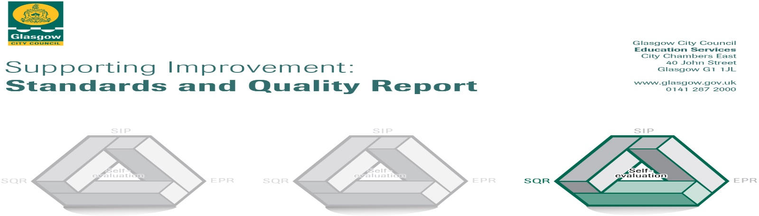

The summary report is provided for parents/careers and partners to outline our achievements this session and our priorities for next session. Throughout this session we have taken forward our priorities as detailed in our school improvement plan. Through our processes of self-evaluation, we have identified how we can improve outcomes for our children and young people.

Our achievements and improvements this year.
We would like to highlight the following improvements/achievements:

- Key developments
Our new school values of Teamwork, Responsibility, Kindness, Determination & Respect have been introduced and are very much understood by our children. All children know their Houses and do their best to live these values to earn House Points.
PATHs has been introduced across the whole school which is helping children with their emotions. This is having a positive impact on overall behaviour in the school.
A few staff have undertaken additional training which has led to improvements in attainment in their classes.
All staff are using assessment information more thoroughly enabling them to intervene to assist children’s learning more effectively.
Most of our children have enjoyed participating in a variety of out of hours clubs. Many of our children have represented our school at city wide sporting events.

- Developments in learning and teaching and assessment
Staff have had many opportunities to discuss the levels of progress of their children with one another in maths which helped them to agree on standards of work . Many staff have received additional training in helping children to improve their strategies for reading and writing. Similar work has been carried out in Numeracy. As a result most children are making appropriate progress for their age.
Alternative activities are planned for children with social, emotional and behavioural difficulties.
Play based learning has been introduced into P1 & P2. This is helping our children to develop their vocabulary as well as their knowledge and understanding.
All of our children have benefitted from a wide variety of educational trips, residential experience for P7 and outdoor activities. The Amazing Loose Ship (container in playground) is providing investigation, creativity, teamwork experiences and the children love it!

- Progress in promoting well-being equality and inclusion
The Spark provides counselling to some children, Barnardos support some children & families, the Nurture Class work with a few children and PATHS assist our children with regulating their emotions. They all support our children’s mental wellbeing enabling them to access the curriculum more readily.
There were many more after school clubs this year covering a wide variety of interests from fencing to football, art, comic club, basketball, netball.
Children who have significant additional support needs have regular review meetings with parents and carers to allow those supporting the children to share their views and agree on supports
There have been an increased number of leadership opportunities for our children – House Captains, Health Committee, Peer Mediators, Digital Leaders etc.
All nursery, P1 & P2 take part in tooth brushing and next year this will be extended to P3.
Nursery to P1, P7 – S1, enhanced transitions and children with ASD transitions very effective
Children worked with the Springburn Regeneration group to produce art work to improve the appearance in the local area.
Caledonian University work closely with us in Nursery, P2, P5, P7 for Science Technology Engineering & Mathematics project, Year Book & reading.

- Progress in children’s learning /raising attainment and recognising achievement

Almost all targeted children who have received additional support, continue to be on track with their learning.
Introducing reading interventions such as Reading Wise, Getting Started and 5 minute Box are beginning to have a positive impact on raising attainment in Literacy. All classes visited the library on a monthly basis.
Nursery Literacy interventions are making a positive impact on childrens understanding of phonics and rhyme.
Maths results show that almost all children are making progress in maths based on previous year. Children who are still significantly below their maths age are targeted for maths intervention
Improved consistency in helping children with their learning is leading to improved progress across the curriculum

Here is what we plan to improve next year.
We are working towards making Elmvale a Language Communication Friendly School
Staff will continue to support children develop effective reading, writing and numeracy strategies to support them with their learning.
There will be continued opportunities to develop effective use of digital learning.

How can you find out more information about our school?
Please contact us directly if you require further information or if you wish to comment on the report.

The contact e-mail address is: Headteacher@elmvale-pri.glasgow.sch.uk

Our telephone number is: 0141 558 5238

Our school address is: Elmvale Primary School, 712 Hawthorn Street, Springburn Glasgow G22 6ED

Further information is available in: newsletters, the school website http://www.elmvale-pri.glasgow.sch.uk/ , and the school handbook

