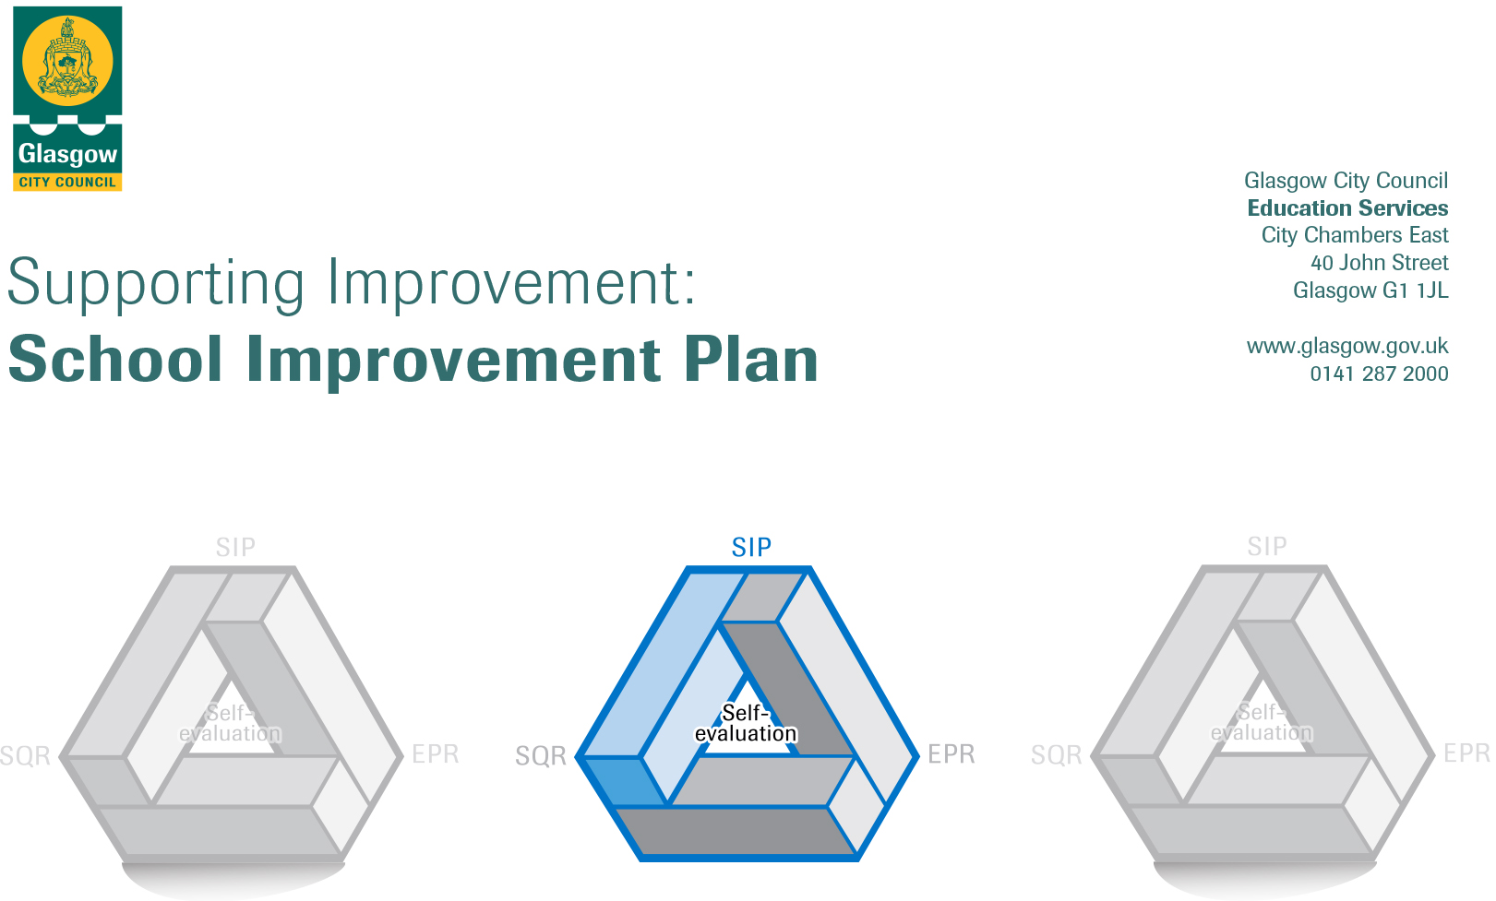

Session: 2018-19

Establishment |  | Elmvale Primary School
Head of Establishment |  | Grant MacLeod
Area/Local Improvement Group |  | NE Lig1

Head of Service
Area Education Officer/  Quality Improvement Officer |  | Andrea Reid / Stephen Watters

CONTENTS
1. Vision, Values and Aims
2. Summary of Self-Evaluation Process / Priorities for Improvement in the current session
3. Action Planning

Action Plan Summary for Stakeholders

1. Our Vision, Values and Aims
Elmvale’s School Values were decided through consultation with Parents / Carers, Children, Staff and Partners in 2018

Responsibility
Teamwork
Kindness
Determination
Respect

Elmvale’s vision – Be the Best that we can Be

Our aims need to be revised.

2. Summary of our self-evaluation process.
Consultation with parents, staff, children and partners , quality assurance activities
Strengths identified:
Almost all children targeted by PEF funded interventions have made progress from prior levels of attainment/social & emotional behaviour
Increasing assessments, recording and analysis of data is helping to target interventions to close the attainment gap.
Increasing quantities of evidence are available to show impact of interventions
Many opportunities have been provided for staff to work closely together and this has led to greater consistency across the school particularly in Numeracy & Maths and using the benchmarks to support judgement
All P1 & P2 staff are providing learning experiences through play and most staff are using aifl strategies to involve children more often in their learning. These approaches are having a positive impact on children’s attainment and helping children to become more independent.
Most children continue to improve their social and emotional behaviour through PATHS, The Spark, Barnardos and most parents have engaged well with the supports.
Children are increasingly able to express their feelings better through PATHS and coaching. All children are able to explain the recently reviewed school values and Houses, helping to embed a positive school ethos.
All staff have a good understanding of our children and their community and use this understanding well to implement alternative interventions.
Reading for enjoyment culture developed throughout the school through heightened promotion and collaborative working, engagement and participation of children and staff all pupils have increased knowledge and confidence understanding in using reading strategies.
Confidence has increased on creating imaginative texts
Increased participation for leadership opportunities – house captains, peer mediators, health committee, digital leaders

Priorities for development:
1: Health & Well Being

2: Literacy, Aifl & Digital Learning

3: Numeracy, Maths, Aifl & Digital Learning

3. Action Planning

No. | Quality Indicator | Priority
1 | 2.3 | To improve how we support and meet the health and wellbeing needs of all of our children.

Tasks to achieve priority | Timescale  and checkpoints | Evidence of Impact > (data, observation, views)
To implement the PATHS programme from Nursery to P7 in order to improve our children’s development of self-control, emotional awareness and interpersonal problem-solving skills. | Inset 1 5hrs  (new staff only) | Inservice Evaluation  Barnardos data  Observation
Introduce PATHS committee (children and SFLW) | Aug 19-Jun20 | Evaluation  Views
Continue to review the social and emotional needs of all our children and families in partnership with The Spark children’s counselling service (play therapy) and our Barnardos Family Support Worker. Promote these initiatives with parents to extend opportunities for more families to become involved. | Spark 2 days per week  Barnardos – Full time  Aug 19- March20 | Spark data  Barnardos data/report  Views of parents & children
Agree Health and Wellbeing practice from Nursery to Primary 7 to have regular dialogue with pupils around their emotions and mental health e.g. a daily emotions check-in, greeting every pupil before entering the classroom, whole-school assemblies explicitly teaching SHANARRI indicators. | Daily Aug19- Jun20 | Views of children, staff
Update aims. | Aug19-June20 | Staff, children and parents understand our aims
Continue to ensure that children (& targeted children) take part in a wide variety of activities & where appropriate involve families. Ensure that staff are recording wider achievements appropriately. Aim for Sports Scotland award. | Aug19-June20 | Records kept of children’s achievements
Establish Healthy Eating Policy | Aug19-June20 | Evaluation, policy in place and children and parents following it.
Continue to extend opportunities for class leadership and enterprise to provide contextualised and relevant experiences for our children to work together, problem solve and use interpersonal skills eg committees, aifl, buddies, clubs | Aug 19-Jun20 | Comments from children in questionnaire, minutes of meetings

Staff leading on this priority – including partners | Resources and staff development
Denise McGroarty (PT), | Barnardos, The Spark

No. | Quality Indicator | Priority
2 | 2.2, 3.2 | To raise attainment in Literacy and English through embedded high quality learning and teaching approaches with appropriate pace, support and challenge for all.

Tasks to achieve priority | Timescale  and checkpoints | Evidence of Impact > (data, observation, views)
Introduce and Implement Glasgow Literacy Pathways and Roots through Writing | Inset 1 11-12.15am | Evaluation
Trial North Lanarkshire Active Literacy approaches and resources in P1-P7 to improve Spelling. Agree practice established. | Inset 2 11-12.15am
Develop consistent talk approaches in line with Glasgow Literacy Programme | Inset 3 | Staff evaluation, children views
Develop a language communication friendly environment from Nursery – P7 in line with the LCFE indicators – School visuals, consistent talking, aifl similar, rules & values, effective questionning | Aug18-Jun19  Inset 2 1-3 , CAT catch ups | Staff evaluation, data
Challenge Leader of Learning (CLOL) modelling/coaching/ team teaching reading/writing/talking & listening strategies in P1-P7 to improve consistency of before, during and after reading strategies. | Aug19-20 | HIGIOP
Embed and develop learning through play in Literacy for P3, P6 & P7. | Term 1 | Staff evaluation
Stay and Play P1-7 | Aug 19-Jun20 | Data
At P1, P4 and P7 develop effective use of national assessments to support diagnostic evaluation of learner progress and identification of next steps (SNSAs). | Aug 19 – Jun 20  Dept CATs catch up | Data, staff evaluation, children views
Moderate teacher professional judgement of Writing at P1-P3 and P4-P7 departmental meetings | Term 2 | Parent views
Introduce and implement word boost across the school | Inset 3 | Data

Staff leading on this priority – including partners | Resources and staff development
Fiona Blevins  Literacy For All | Literacy for All training  Reading Wise programme  North Lanarkshire Resources

No. | Quality Indicator | Priority
3 | 2.2, 3.2 | To raise attainment in Numeracy and Maths through embedded high quality learning and teaching approaches with appropriate pace, support and challenge for all.

Tasks to achieve priority | Timescale  and checkpoints | Evidence of Impact > (data, observation, views)
Maths recovery targeting children who are at least 6mnths behind. Number Talk implemented across the school. | Inset 1 9-10.30 | Staff evaluation
Children leading workshops to support parents with strategies | Aug 19-20 | Staff & children views, data
At P1, P4 and P7 develop effective use of national assessments to support diagnostic evaluation of learner progress and identification of next steps (SNSAs) |  | Staff views
Train all staff to become Apple teachers | Inset3-7 6hrs | Evaluation
Introduce Seesaw in order to share learning with parents | Inset3
Ensure all staff use Sumdog regularly | Inset 1 1-3pm Aug19-20 | Data

Staff leading on this priority – including partners | Resources and staff development
Catriona Fenton (Acting PT), Barnardos family worker  Glasgow Counts | CAT, Inset days

