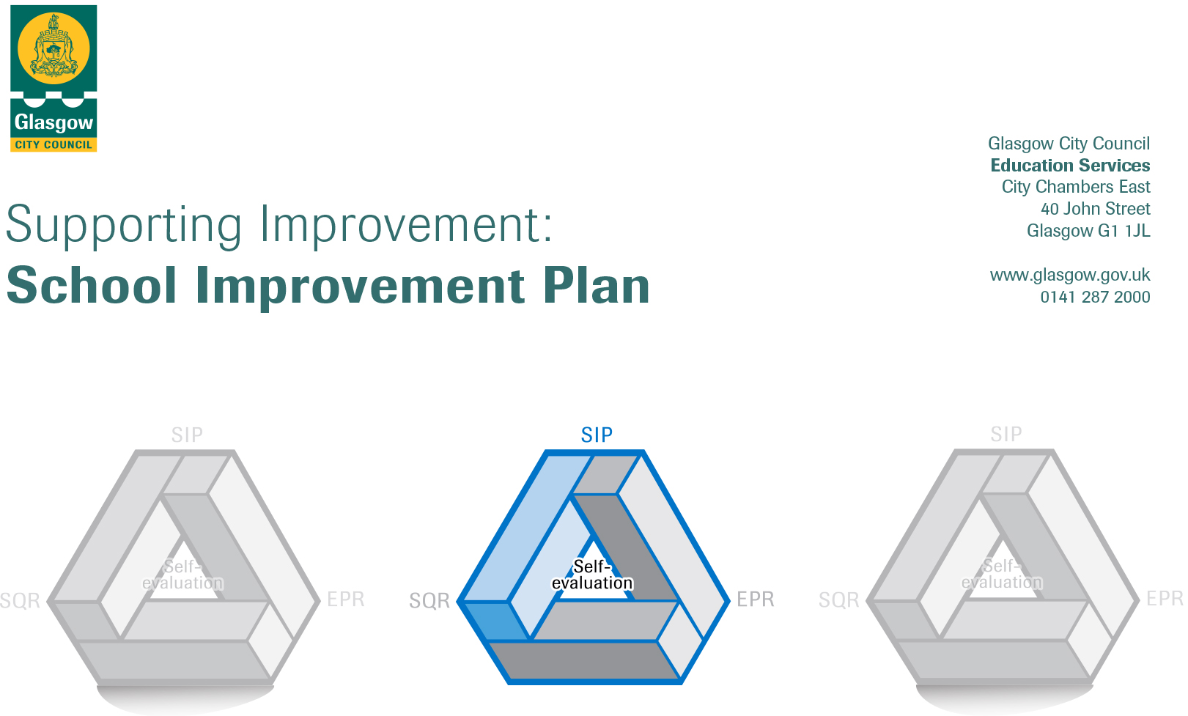

Session: 2020-21

Establishment |  | Elmvale Primary School
Head of Establishment |  | Grant MacLeod
Area/Local Improvement Group |  | NE Lig1

Head of Service
Area Education Officer/  Quality Improvement Officer |  | Andrea Reid / Stephen Watters

CONTENTS
1. Vision, Values and Aims
2. Summary of Self-Evaluation Process / Priorities for Improvement in the current session
3. Action Planning

Action Plan Summary for Stakeholders

1. Our Vision, Values and Aims
Elmvale’s School Values were decided through consultation with Parents / Carers, Children, Staff and Partners in 2018

Responsibility
Teamwork
Kindness
Determination
Respect

Elmvale’s vision – Be the Best that we can Be

Our aims need to be revised.

2. Summary of our self-evaluation process.
Consultation with parents, staff, children and partners , quality assurance activities
Strengths identified:
Almost all children targeted by PEF funded interventions have made progress from prior levels of attainment/social & emotional behaviour
Increasing assessments, recording and analysis of data is helping to target interventions to close the attainment gap.
Increasing quantities of evidence are available to show impact of interventions
Many opportunities have been provided for staff to work closely together and this has led to greater consistency across the school particularly in Numeracy & Maths and using the benchmarks to support judgement
All P1 & P2 staff are providing learning experiences through play and most staff are using aifl strategies to involve children more often in their learning. These approaches are having a positive impact on children’s attainment and helping children to become more independent.
Most children continue to improve their social and emotional behaviour through PATHS, , Barnardos and most parents have engaged well with the supports.
Children are increasingly able to express their feelings better through PATHS and coaching. All children are able to explain the recently reviewed school values and Houses, helping to embed a positive school ethos.
All staff have a good understanding of our children and their community and use this understanding well to implement alternative interventions.
Reading for enjoyment culture developed throughout the school through heightened promotion and collaborative working, engagement and participation of children and staff all pupils have increased knowledge and confidence understanding in using reading strategies.
Confidence has increased on creating imaginative texts
Increased participation for leadership opportunities – house captains, peer mediators, health committee, digital leaders

Priorities for development:
1: Health & Well Being

2: Literacy, & Digital Learning

3: Numeracy, Maths, & Digital Learning

3. Action Planning

No. | Quality Indicator | Priority
1 | 2.3 | To improve how we support and meet the health and wellbeing needs of all of our children.

Tasks to achieve priority | Timescale  and checkpoints | Evidence of Impact > (data, observation, views)
Introduce a number of committees in relation to House Points | Aug 20-Jun21 | Children can confidently talk about their committee and its impact  Evaluation  Views
Update aims. | Aug20-June21 | Staff, children and parents understand our aims
Celebrating Wider achievements | Aug20-21 | Data
Introduce ‘Develop the Young Workforce’ – encourage staff to incorporate it into lessons and raise its profile / importance to all | Sept20-21 | All staff incorporating it in lessons. Children able to discuss and explain the benefits of learning.
Continue to use PATHS to support emotional wellbing |  | Observation of calmer children more able to express feelings

Staff leading on this priority – including partners | Resources and staff development
Denise McGroarty (PT), | Barnardos,

No. | Quality Indicator | Priority
2 | 2.2, 3.2 | To raise attainment in Literacy and English through embedded high quality learning and teaching approaches with appropriate pace, support and challenge for all.

Tasks to achieve priority | Timescale  and checkpoints | Evidence of Impact > (data, observation, views)
Develop consistent talk approaches in line with Glasgow Literacy Programme for the whole school |  | Staff evaluation, children views  Talk for writing is used by a number of teachers and it is having great results in terms of improving writing and the confidence of children.
Develop a language communication friendly environment from Nursery – P7 in line with the LCFE indicators – School visuals, consistent talking, aifl similar, rules & values, effective questionning |  | All staff using same approaches in relation to signage and L & T approaches
At P1, P4 and P7 develop effective use of national assessments to support diagnostic evaluation of learner progress and identification of next steps (SNSAs). | Aug 20 – Jun 21 | Data, staff evaluation, children views
Moderate teacher professional judgement of Writing at P1-P3 and P4-P7 departmental meetings | Term 1, 2, 3 | Staff evaluations, greater confidence in recognising levels, children working with appropriate challenge
Introduce and implement word boost across the school
Collaborative Enquiry Programme | Term 2 | aifl strategies supporting children’s learning effectively
Whole school approach to word aware |  | staff evaluation
Talk for writing across the school |  | Observation of children with improved vocabulary,

Staff leading on this priority – including partners | Resources and staff development
Fiona Blevins  Literacy For All | Literacy for All training  Reading Wise programme  North Lanarkshire Resources

No. | Quality Indicator | Priority
3 | 2.2, 3.2 | To raise attainment in Numeracy and Maths through embedded high quality learning and teaching approaches with appropriate pace, support and challenge for all.

Tasks to achieve priority | Timescale  and checkpoints | Evidence of Impact > (data, observation, views)
At P1, P4 and P7 develop effective use of national assessments to support diagnostic evaluation of learner progress and identification of next steps (SNSAs) | Aug20-21 | Diagnostic information providing greater support to help keep children on track
Collaborative Enquiry Programme | TBC | aifl strategies supporting children’s learning effectively

Staff leading on this priority – including partners | Resources and staff development
Catriona Fenton (Acting PT), Barnardos family worker  Glasgow Counts | CAT, Inset days

