
Primary News

Dear Parents/Carers

We’ve had a very settled start to the new term. We are welcoming our new primary ones along with new children into our nursery class and across the school.
Headteacher Blog / Twitter account – these are updated regularly with news and events.

Most homework will be issued using SeeSaw – please tell your child’s teacher if you have no internet or ICT device.
Annual Update / Photo Consent / Local Trips – Please return the forms to the office as soon as possible
Breakfast Club
This is open from 8am every morning. It is very important to use this service as often as possible. Numbers are currently very low which means that further down the line, it could be discontinued if not used.
Nuts – Nut free school due to sever allergies in our school community (including snacks which contain nuts such as Kinder Bueno, Snickers, Nutella etc)
School Uniform
School uniform is important for many reasons –
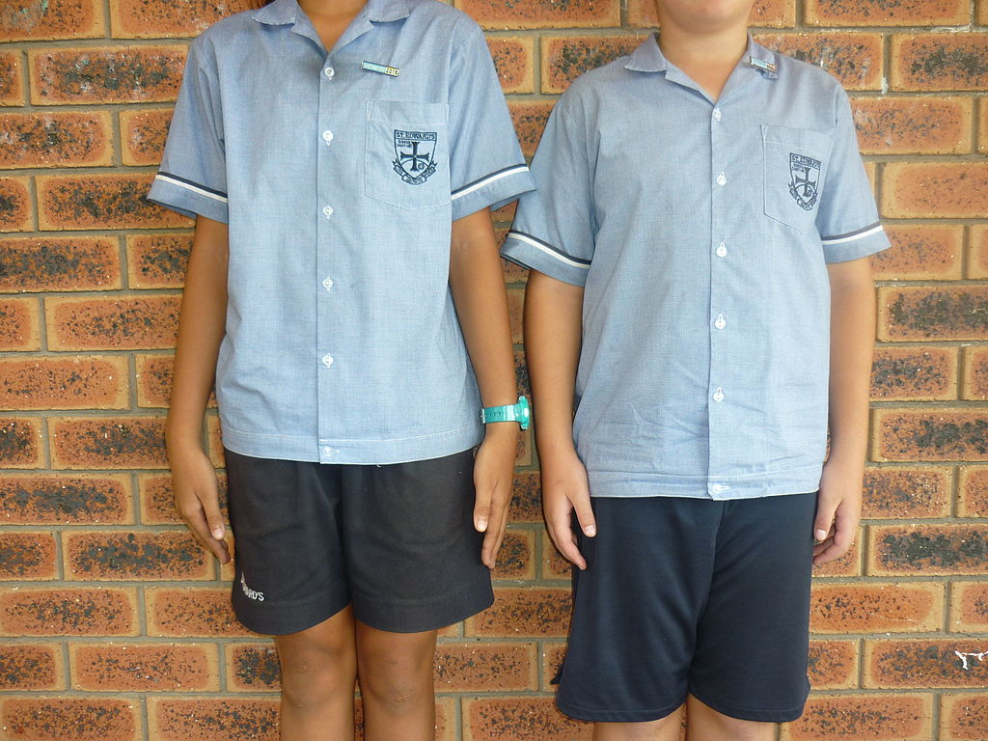
- Your child is safe when on a school trip because they are wearing a school badge / tie - children with uniform will always stand out.
- Children are less likely to make comments about each other’s clothes because they all wear the same clothing
- Our children look very smart and can show that they are proud to be part of the Elmvale family
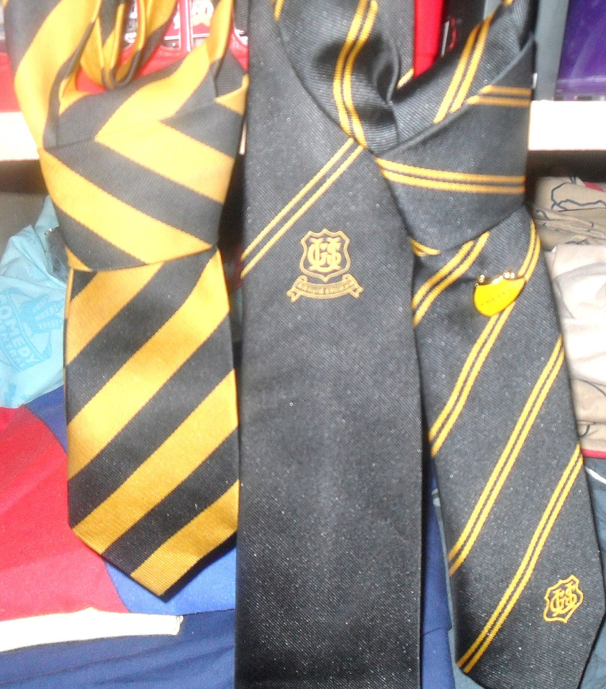
Uniform can be bought online and will be sent to your door info@beuniforms.co.uk or colinwhay@btinternet.com or it can be bought in the St Enoch Centre.
– Free pre-loved uniform available in the foyer – contact Marie or Stacey to access this or speak to staff at the gate. Also we accept donations of uniform in good condition to be passed on to Uniform Bank to be laundered and re-issued
Foodbank – Working with our partners, we have a small selection of fresh produce from Co-Op and groceries from Glasgow Food Initiative. Contact Marie or Stacey to access this or speak to staff at the gate.

Parking
Please avoid using Fernbank St and Elmvale St outside the school gates. These are now pedestrianized areas to keep our roads safe for everyone 8.30-9.15am and 2.30-3.15. The police are due to make unexpected spot checks.
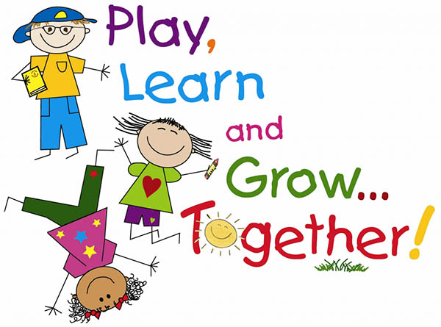
School Meals – Menu is available on website https://www.glasgow.gov.uk/fuelzone Please chat through the options with your child to help them make a selection that they will like.
Holidays
24-27 September included
8-15 October included (8 October is an inservice day)

Grant and the Primary Team
Nursery News
Dear Parents/Carers
Welcome to our first newsletter of the session and a special welcome to our new children and their parents. All children are settling very well in the Nursery Class and we would like to thank parents/carers for their support during this process as we have been using our outdoor space to this. We are looking forward to working in partnership with you over the next few months to help all children in Elmvale Nursery Class achieve their potential.
Outdoor learning
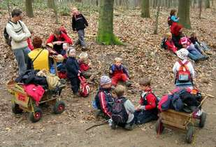
Outdoor Learning at Elmvale Nursery Class is important to us and is currently still the safest place for our children and staff to be. All our children will be outdoors during part of their session at nursery and it is very important that you dress your child according to the weather each day. The nursery has purchased outdoor waterproofs and wellies that are available for your child to use, however, if you prefer your child to use their own please provide these on days required or you can leave them on your child’s peg.

The nursery has spent a large amount of money creating a fun and safe learning environment for our children using natural materials. We have a mud kitchen and lots of different building materials that the children can use and explore by creating their own creations. We are always looking for materials that our children can use in the playground,
If any parents or family members work or knows someone who would kindly donate materials we would be delighted to accept. Types of materials that would be suitable are loose parts, guttering, crates, cable reels, tyres ect.
Changes of clothing
Can I please remind everyone to provide your child with a range of spare clothing to be kept in nursery. Over the last few weeks we have had to call parents/carers and remind them to replace them if your child has had to use their current ones that have been provided. We are still currently not able to provide changes of clothing to children from our nursery selection under covid-19 restrictions which is why this is so important you send in changes of clothing. Your child can get wet from having toilet accidents or spilling milk/water during their snack time or get wet from the water tray.
Staffing
We would like to congratulate Gabby on securing her dream job with the NHS. Unfortunately, this means Gabby will be leaving Elmvale Nursery Class at the end of September. She will be greatly missed as part of our team and I, the staff and the children will miss Gabby but would like to wish her the best of luck in her new role.

Many Thanks
Julieann McHugh

