Social Media Policy

Elmvale Primary

September 2015

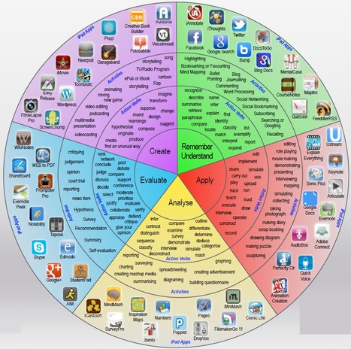



Elmvale Social Media Policy

**Rationale**

The widespread availability and use of social media applications bring opportunities to understand, engage, and communicate in new and exciting ways. It is important that we are able to use these technologies and services effectively and flexibly. However, it is also important to ensure that we balance this with our duties to our school, the community, our legal responsibilities and our reputation.

For example, our use of social networking applications has implications for our duty to

safeguard children, young people and vulnerable adults.

The policy requirements in this document aim to provide this balance to support innovation whilst providing a framework of good practice. They apply to all members of staff at Elmvale Primary and Nursery Class.

The purpose of the policy is to:

* Protect the school from legal risks
* Ensure that the reputation of the school and its staff are protected
* Safeguard all children
* Ensure that any users are able clearly to distinguish where information provided via

social media is legitimately representative of the school

We publish information about our school and communicate with parents / carers in many ways:

* Parents’ evenings
* Informal meetings
* Meet the Teacher
* Newsletters
* Email and text messages
* Our own website
* Social media

We welcome anyone who is interested in the life of our school to follow us and connect with us on the various social media sites that we use. At the moment this includes Twitter. This site allows us to communicate much more about day-to-day life in school; the kind of detail that wouldn’t normally be enough for a newsletter or a meeting.

**Use of Sites**

It’s important for everybody’s safety that we are clear about how we use these sites and what is acceptable behaviour from the people who choose to follow us. We use our social media sites to publish information that is of general interest. We do not believe it is an appropriate place to discuss personal matters that are specific to individual members of our community, whether that be children, parents or staff.

**Privacy**

* We will not publish photographs of children without the written consent of parents / carers
* We will not identify by name any of the children featured in photographs
* We will not allow personally identifying information to be published on our social media accounts

**Respect**

* We will not tolerate any form of bullying on our social media accounts
* We will not allow posts or comments that refer to specific, individual matters between the school and members of its community
* We will not tolerate any comments or posts that are defamatory, rude or abusive towards any member of our school community, whether that be children, parents or staff

**Our Rules**

* Where allowed by the site, we welcome comments on the information we post. However, we reserve the right to delete comments and ban further comments from anyone who breaks the terms of our policy
* We will ban and report anyone who breaks the terms of service of the relevant social media platform. For example, Facebook’s Terms of Service do not permit people under the age of 13 to open an account.

**Definitions and Scope**

Social networking applications include, but are not limited to: Blogs, Online discussion

forums, Collaborative spaces, Media sharing services, ‘Microblogging’ applications, and

online gaming environments. Examples include Twitter, Facebook, Windows Live

Messenger, YouTube, Flickr, Xbox Live, Blogger, Tumblr, Last.fm, and comment streams on

public websites such as newspaper sites.

Within this policy there is a distinction between use of school sanctioned social media for

professional educational purposes and personal use of social media.

**Use of Social Media in Practice**

1. **Personal use of social media**

* School staff will not invite, accept or engage in communications with parents or

children from the school community in any personal social media whilst in

employment at Elmvale Primary and Nursery Class.

* Any communication received from children on any personal social media sites must be reported to the designated person for Child Protection (Headteacher).
* If any member of staff is aware of any inappropriate communications involving any

child in any social media, these must immediately be reported as above.

* Members of the school staff are strongly advised to set all privacy settings to the

highest possible levels on all personal social media accounts.

* All email communication between staff and members of the school community on

school business must be made from an official school email account.

* Staff should not use personal email accounts or mobile phones to make contact with members of the school community on school business, nor should any such contact be accepted, except in circumstances given prior approval by the Headteacher.
* Staff are advised to avoid posts or comments that refer to specific, individual

matters related to the school and members of its community on any social media

account.

* Staff are also advised to consider the reputation of the school in any posts or

comments related to the school on any social media accounts.

* Staff should not accept any current pupil of any age or any ex-pupil of the school under the age of 18 as a friend, follower, and subscriber or similar on any personal social media account.

**2. School‐sanctioned use of social media**

There are many legitimate uses of social media within the curriculum and to support children’s

learning. For example, the school has an official Twitter account (@ElmvalePrimary), and

several classes have piloted a class Twitter page to celebrate success and to share achievements. There are also many possibilities for using social media to enhance and develop

children’s learning.

When using social media for educational purposes, the following practices must be observed:

* Staff should set up a distinct and dedicated social media site or account for

educational purposes. This should be entirely separate from any personal social

media accounts held by that member of staff, and ideally should be linked to an

official school email account.

* The URL and identity of the site should be notified to the appropriate member of the SLT before access is permitted for children.
* The content of any school sanctioned social media site should be solely professional and should reflect well on the school.
* Staff must not publish photographs of children without the written consent of

parents / carers, identify by name any children featured in photographs, or allow

personally identifying information to be published on school social media accounts.

* Care must be taken that any links to external sites from the account are appropriate and safe.
* Any inappropriate comments on or abuse of school sanctioned social media should immediately be removed and reported to a member of SLT.
* Staff should not engage with any direct messaging of children through social media where the message is not public.
* All social media accounts created for educational purposes should include a link in

the About or Info page to the ICT Acceptable Use Policy on the school website.  This will indicate that the account is officially sanctioned by Elmvale Primary and Nursery Class.

**Social Media Policy**

Policy Created:  September 2015

Next review date:  June 2016

Appendices

* 1. Glasgow City Council Social Media Information
  2. GCC Twitter Guidance
  3. Elmvale Class Contract
  4. Using Twitter Pages Rationale
  5. Elmvale Blogging Guidelines
  6. Elmvale Blogging Letter
  7. Elmvale Parent Council Social Media Policy
  8. GCC Internet and Social Media Additional Guidance for Schools

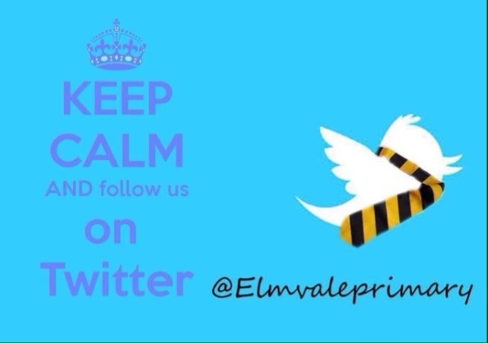



Appendix 1 – Glasgow City Council Social Media Information

**Council policy on use of Twitter**

**Twitter:**

Twitter is a social networking and micro-blogging service that allows users to send and read short text updates (up to a maximum of 140 characters) via an Internet Web site. The updates are known as Tweets and are displayed on the user's profile page and can be read by anyone who has signed up to view them.

Glasgow City Council has developed its own page on Twitter which can be viewed at:

[www.twitter.com/glasgowcc](http://www.twitter.com/glasgowcc)

The council has developed Twitter guidance (please see Appendix 2) for staff who may be posting updates to its Twitter feed.

GCC encourages constructive comments about the services it provides and we believe that all customers have the right to be heard, understood and respected.  We also consider that GCC staff have these same rights.

We retain the right, where we consider comments to be unacceptable, to restrict or change access to our service.

The threat or use of verbal abuse or harassment towards GCC staff on social media Web sites like Twitter is unacceptable behaviour. Incidents may be reported to the police.

[](http://www.glasgow.gov.uk/index.aspx?articleid=9352)[](http://www.glasgow.gov.uk/index.aspx?articleid=9354)[](http://www.glasgow.gov.uk/index.aspx?articleid=9356)[](http://www.glasgow.gov.uk/index.aspx?articleid=9357)

© 2015 Glasgow City Council - City Chambers, Glasgow G2 1DU.  
**Telephone:** 0141 287 2000 (switchboard)

Appendix 2 – GCC Twitter Guidance

**Twitter**

Twitter is a social networking and micro-blogging service that allows users to send and read short text updates (up to a maximum of 140 characters) via an Internet Web site. The updates are known as Tweets and are displayed on the user’s profile page and can be read by anyone who has signed up to view them. Glasgow City Council has developed its own page on Twitter which can be viewed at: www.twitter.com/glasgowcc The service offers the Council the potential to transmit information about new services, developments and news in almost real-time to a potentially wide audience, many of whom will not necessarily find out about the Council through other, more traditional channels, such as the telephone, or face-to-face contact. As this is a new development and service provided by the Council to citizens and staff, the following Twitter usage protocols are proposed:

1. Council staff posting items to the Council’s Twitter site must ensure the information is directly related to services and information provided by the Council. This may include reports from committees; news items; events; emergency information such as a building evacuation, or fire; information about items located on the Council’s primary Web site and cancellations.

2. Postings about personal matters are not permitted, for example personal diaries; opinion; rants or anything not connected to the business of the Council.

3. Profanity is not permitted.

4. Party political content is not permitted.

5. Religious or sectarian content is not permitted.

6. The style of postings should follow that of the Council’s corporate style guidelines, although some abbreviations (for reasons of space) are acceptable.

7. ‘Text speak’ is not permitted – for example we should always spell out ‘you’ and not use ‘u’

8. Updates are to be as frequent as possible – Twitter lives or dies by the quality and quantity of its updates.

9. Pictures can be added, where the picture adds value to the posting.

10. Twitter can be updated via a Blackberry or mobile device – provided a small piece of software is downloaded first.

11. Remember that officers posting to the Glasgow City Council Twitter site are seen as representatives of the Council and its views.

12. Twitter is free to use and, as such, may sometimes be slow to access within the Council’s network.

13. Twitter is intended to be fun, as well as informative.

14. You can hyperlink to items on the World Wide Web for further information. This is encouraged as the character limitations of Twitter mean it is not suitable for posting lengthy and complex information.

Appendix 3 – Elmvale Class Contract

­

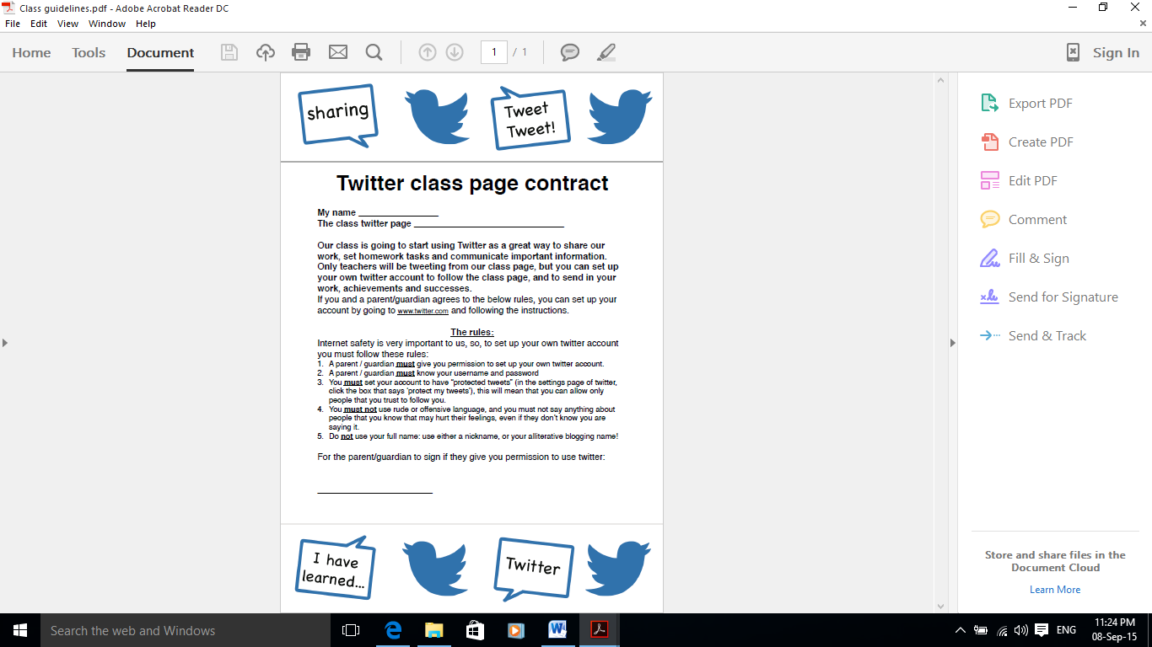

Appendix 4 – Using Twitter Pages Rationale

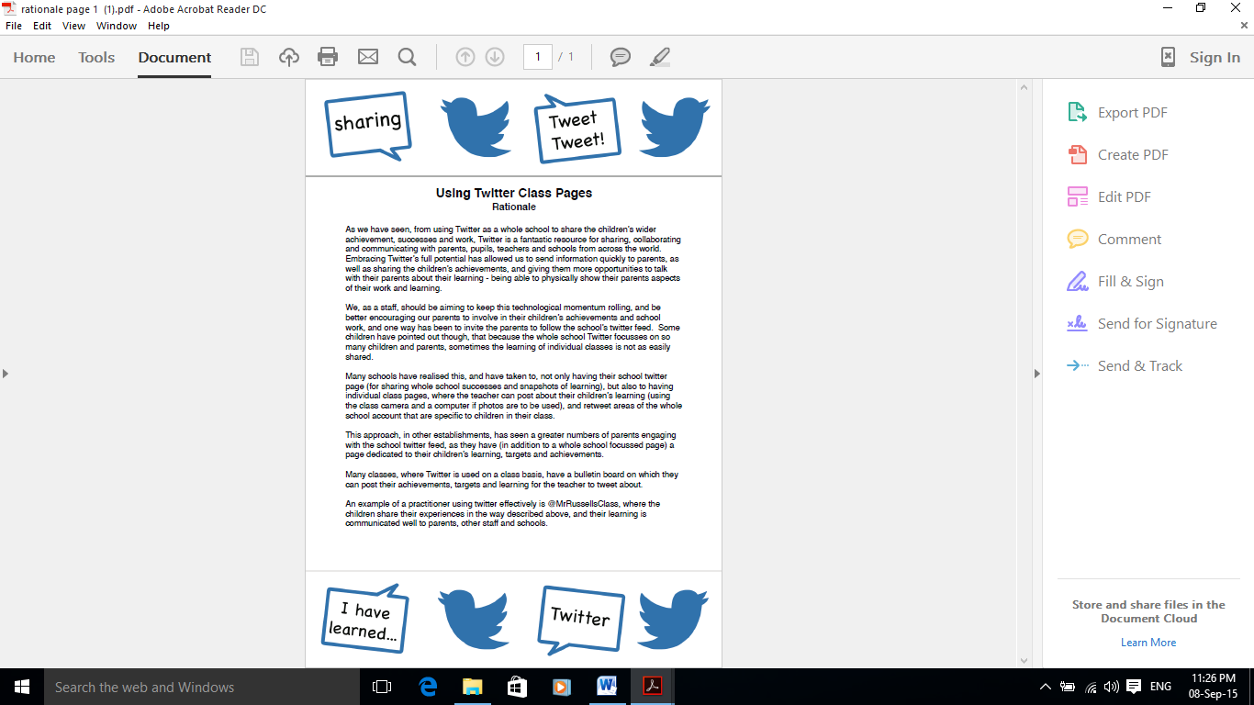

Appendix 4 – Continued

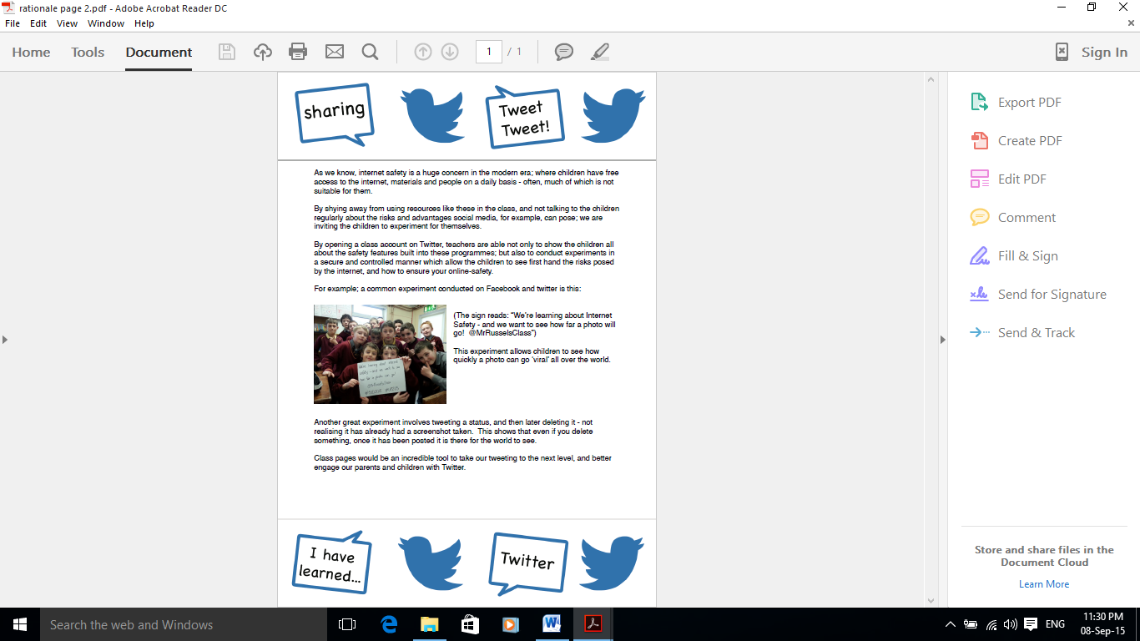

Appendix 5 – Elmvale Blogging Guidelines



#### ****Rules for Blogging****

#### Thank you for allowing us to use blogging to enhance the learning at our school.  Please see a copy of the letter explaining this on Appendix 6.

A blog can be very exciting, it allows people from all over the world to share our learning and make comments.  We need to remember to follow a few simple rules to stay safe and to get the most out of our blog.  It is very important that we understand how to use the blog and the internet in a secure way.  This ties in with Curriculum for Excellence and key ICT skills that the children are expected to learn and apply.

The following guidelines have been established to ensure the safety of our pupils when blogging. The guidelines are also reminders of how to use the blog to improve writing and keyboarding skills.

* **Only use your first name when commenting – no surnames.**
* **Relatives who leave comments are also asked to use their first name only or to post comments as “Reena’s Mum” or “Gary’s Grandfather”.**
* **Keep safe – don’t reveal any personal information.**
* **No text talk – write in full sentences and read your comments back carefully before submitting.**
* **Be polite – don’t post anything that could hurt anyone.**
* **Always show respect  – be positive if you are going comment and always remember that the blog is an extension of our school that the rest of the world is able to see.**
* **All posts and comments are checked by school staff before they are approved.**

If you have any more concerns about the security of the blog then please feel free to have a chat with your child’s class teacher or Ms Kytzia.

Appendix 6 – Elmvale Blogging Letter

Dear Parents and Carers,

Elmvale Primary and Nursery Class are continuing and developing its use of some technology which we hope will continue to help transform our school.  We want you involved!  We are developing our use of blogs, which are websites that can be contributed to by children, staff, parents and others.  This letter is meant to explain the point of blogging in school and to allay any fears you may have about safety.

**What is a blog?**  
Blogs help to create a link between home and school.  Parents and carers are able to see what goes on by looking at the work and information created during the day.  "Blogging" is writing that is done online.  This could be their literacy work, research, or even thoughts about school.  They might ask questions or complete their home learning on the blog.

You can read the blogs and leave a comment - the more the comments the better as they are read by the children and motivate them to write more.

Parents and carers, teachers and in fact anybody else, can comment.  Why not tell them what you like about their work?  You could ask questions or suggest ways that they might make their work better.

Blogs can be used to post links to activities and websites which relate to school.  They help to get children engaged and excited about their learning, and encourage them to think about school in new and interesting ways.  We hope you are as excited as we are!

**Is it safe?**  
Yes.  Blogs are very safe if they are managed carefully.  EVERYTHING that people write on the blog is moderated before it appears.  This means that a member of staff reads and checks things to decide if they are appropriate.  We teach the children that they can only use their first names on the blog, and we do lots of work to ensure that they know how to use it responsibly and safely.  No email addresses, phone numbers or other personal data is allowed on the blog.  Photos/videos of children will never be used along with names, so children cannot be identified through images.  This content will only be published if consent is agreed.

If people do try to write unkind, thoughtless or inappropriate things, they will not appear.  It is very easy for the school to block people from using the blog using something called their I.P. address.  This means that they will never be able to access the blog again.

**What do you think?**  
We would like you to be involved in this project.  We are excited about how the blog helps us improve attainment and engage the children, and your input is crucial.  Please have a look at the blogs, have a look at the parents/carer's section and have a go at leaving a comment.  If you have questions, concerns or comments about this project, please let us know.

**Due to its potential to promote learning and good home links unless we receive in writing telling us otherwise the school assumes that:**

1. You give permission for your child(ren) to use the blog from home. You understand that they must use first names, must not divulge personal details, and must use the blog responsibly.
2. You give permission for photographs and video of your child(ren) to be put onto the blog by staff at Elmvale Primary and Nursery Class.  You understand that this will be carefully monitored and that photographs and video will never be used together with their names.

Thank you in advance for your support and cooperation.

Yours Sincerely,

Ms Vicky Kytzia  
Acting Depute Head

Appendix 7 – Elmvale Parent Council Social Media Policy

**Rationale**

The purpose of this policy is to make us aware of our obligations and responsibilities when using Social Media both towards the school and our children. It is very important that we be made aware of these obligations as Scottish common law states that there is “*an implied duty of trust and confidence* *between the school and the parent council.*” This information should be made available to all parents and carers of the school- in other words, the wider parent forum.

The document acknowledges that Social Media- including sites such as Facebook and Twitter can be a powerful and useful tool in the running of a Parent Council. However, parents and carers are reminded of the risk of posting anything which is negative or emotionally biased.

Here are some of the key issues raised:

* Remember that everything you post is traceable
* Do not name any individuals on social media without their permission.
* Consider the long term consequences of what you post and try to avoid posting in the heat of the moment
* There are procedures for schools to follow when dealing with negative comments on Social Media- this can result in police involvement

We as a Parent Council have agreed to continue using social media as an additional way of communication.

Elmvale Primary School Parent Council has set up a Facebook page and a

Twitter account. This has many benefits, some of which are outlined below.

**BENEFITS OF USING FACEBOOK/TWITTER**

* Easy access to updates via Facebook/Twitter feeds (on smartphones where appropriate)
* It is quick and easy to send out a message via Facebook/Twitter, without cluttering email inboxes.
* It may help engage more Parents.
* Using Facebook/Twitter could allow a more open dialogue between the Parent Council and the Parent Forum - by its very nature, social media allows for more open 2 way conversation.
* We would have additional online presence for any prospective parents looking to move in to the area.
* Further down the line we could use Facebook/Twitter to canvas thoughts and opinions from the Parent Forum and use it to gauge attendance at meetings and fundraising events.
* We are also aware however, that Facebook/Twitter, as in all social media, brings its own possible problems and so we are proceeding in a cautiously optimistic manner. Guidelines for acceptable behaviour, and the proposed way of dealing with offensive behaviour (should it occur) are also outlined below.

**GUIDELINES REGARDING ACCEPTABLE BEHAVIOUR ON FACEBOOK**

We would like to grow the use of Facebook/Twitter as a means of communicating with the Parent Forum but we are aware of how Facebook/Twitter can be abused. While only the administrators can update the status of the page, comments can be written by anyone and while comments are gratefully received and we would love for the Parent Forum to engage more with the Parent Council, we cannot tolerate any comments which are deemed to be abusive, offensive, bullying or threatening. Any such comments will be removed by the administrators and a warning issued to the offender. If there is repeated abuse of the page the offender will be blocked from receiving Parent Council feeds.

If problems continue on an on-going basis then the Parent Council will discuss the use of Facebook/Twitter as a communication tool, and if in agreement, will close the pages.

As always, individual issues or concerns should be raised directly with the school.

So, we would read carefully and ask that everyone thinks about what is being written before posting and ensure that nothing is written in such a way as to bring the group in to disrepute.

**HOW WILL IT WORK?**

Elmvale Parent Council have 1 administrator who is able to post on the Parent

Council Facebook page and 2 administrators who are able to post on Twitter Parent Council page.

Anything that is posted on the Parent Council Facebook/Twitter page is highlighted to the administrator, and weekly reports of usage are shared by Facebook or Twitter.

ONLY information that is in the public domain will be posted on Facebook and

Twitter. Unless otherwise agreed, no names or photographs will be posted.

Anything posted on the Facebook and/or Twitter page will appear in the newsfeed of all those who have 'liked' or 'follow' the page. Examples of posts include: reminders of Parent Council meetings, requests for help, notification of changes to school meals, thanks for help, fundraising updates, community notices, etc.

Finally, it is our responsibility as parents and carers to ensure we demonstrate the same moral examples we expect from our children:

*“Everything our children hear, see and feel is recorded onto a cassette. Guess*

*who is the big star in their movie? You are. What you say and more importantly*

*what you do is recorded there for them to replay over and over again.” (anon)*

**If you use Facebook or Twitter, here is the link to the Elmvale Primary**

**School Parent Council page:**

*https://www.facebook.com/elmvalepc*

To receive newsfeeds from Elmvale Primary Parent Council, please 'like' the

page.

*https://twitter.com/ValersParents*

To receive newsfeeds from Elmvale Primary Parent Council, please “follow” the

page

Approved on the 05/06/2015 by

**Chairperson**

Carol Aljundi

**Vice – Chairperson**

Fiona McMahon

**Treasurer**

Catherine Yuill

**Secretary**

Christine Reilly